ABO血型代码

Rh血型代码

此两个数据元的表示，

1.

CCD HISTP IHE 均在章节模板 Result中表示，

|  |  |
| --- | --- |
| 2.16.840.1.113883.10.20.1.14 (CCD) | HL7 |
| 2.16.840.1.113883.3.88.11.83.122 | HITSP |
| 1.3.6.1.4.1.19376.1.5.3.1.3.28 | IHE |

对比如下



详细资料见《compare- section template compare.xlsx》

2.在台湾的IG中，有如下表单包含了此2项数据元信息

2009年的版本

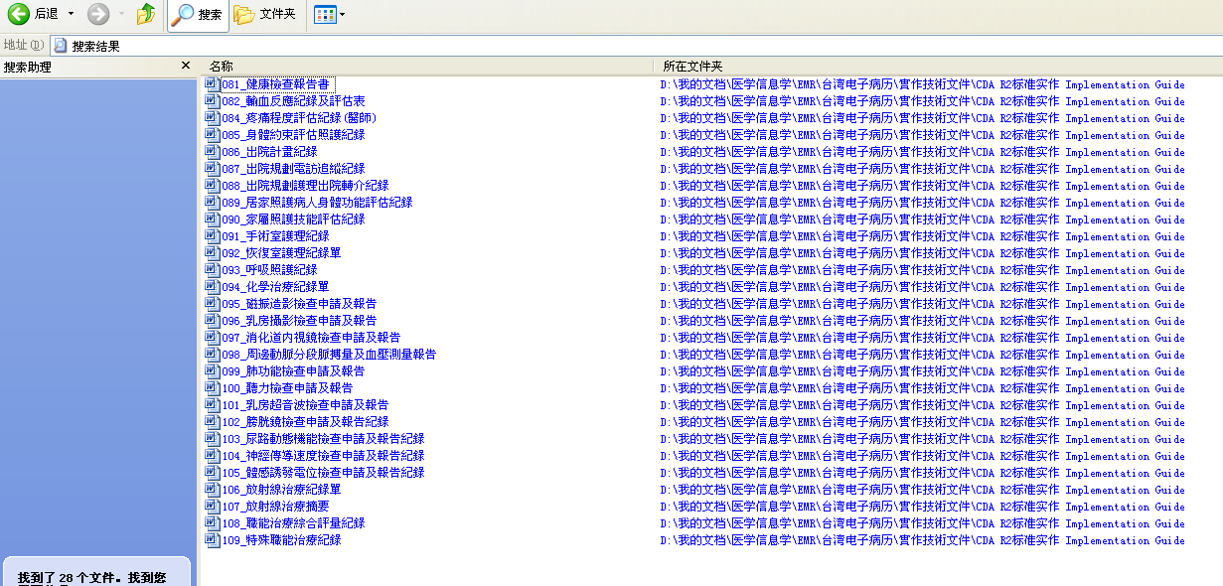

其中之一如下

|  |  |  |  |  |  |  |
| --- | --- | --- | --- | --- | --- | --- |
| **實驗室檢查紀錄Reference lab test results 19146-0**   |  | | --- | | 此Section包含血型、D抗原性等資訊。 | | 1. 實驗室檢查紀錄區段**必須**包含一個section元素，其code是19146-0。 |  * + - 1. **LOINC查表**  |  | | --- | |  | | 圖35：實驗室檢查紀錄區段之LOINC查表範例 |  * + - 1. **xml範例**  |  | | --- | | <!--  實驗室檢查紀錄  ********************************************************  Reference lab test results  ********************************************************  -->  <component typeCode="COMP" contextConductionInd="true">  <section classCode="DOCSECT" moodCode="EVN">  <code code="19146-0" codeSystem="2.16.840.1.113883.6.1" codeSystemName="LOINC" displayName="Reference lab test results" />  <title>實驗室檢查紀錄</title>  <text>  <list>  <item>血型：A</item>  <item>D抗原性：</item>  </list>  </text>  </section>  </component> | | 圖36：實驗室檢查紀錄區段之XML範例 | |

采用了如下的表达

在2011年更新的新增表单中 出现了如下的搜索结果 牙醫門診單CDA R2 執行指引標準書（草案）Visit note Implementation Guide for CDA Release 2 Level 1 ,2 and 3區碼：TW版本0.2

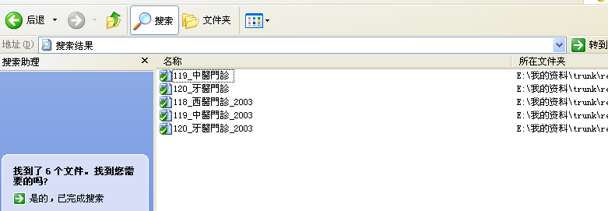

.三份IG中都如下描述了上述2个数据元信息。

|  |  |  |  |  |  |  |  |
| --- | --- | --- | --- | --- | --- | --- | --- |
| 通用服務記錄 History of hospitalizations+History of outpatient visits  46240-8  |  | | --- | | 此Section包含血型、職業、初診日期、戶籍地址、子女數、教育等資訊。 | | 1. 通用服務記錄區段**必須**包含一個section元素，其code是46240-8。 |  **LOINC查表**  |  |  | | --- | --- | | 46240-8 | | | 圖27：通用服務記錄區段之LOINC查表範例 |  **xml範例**  |  | | --- | | <component contextConductionInd="true" typeCode="COMP">  <section classCode="DOCSECT" moodCode="EVN">  <code code="46240-8" codeSystem="2.16.840.1.113883.6.1" codeSystemName="LOINC"/>  <title mediaType="text/plain" representation="TXT">通用服務記錄</title>  <text>  <list>  <!--16.就醫身份 -->  <item>就醫身份:健保</item>  <!--23. 血型-->  <item>血型:A+</item>  <!-- 25.職業 -->  <item>職業:製造業</item>  <!-- 43.初診日期 -->  <item>初診日期:20090901</item>  <!-- 28.病人戶籍地址資料 -->  <item>戶籍地址:24149台北縣三重市環河北路一段20號6樓</item>  <!-- 44.病人子女數 -->  <item>子女數:0</item>  <!-- 45.病人教育程度 -->  <item>教育:大學</item>  <!--76. 醫師囑咐-->  <item>醫師囑咐:禁食冰冷</item>  </list>  </text>  </section>  </component> | | 圖28：通用服務記錄區段之XML範例 | |

出乎我所意料，想不出为什么他们会将其置于LOINC 46240-8HISTORY OF ENCOUNTERS之下，百思不得其解。

3.查LOINC表得到

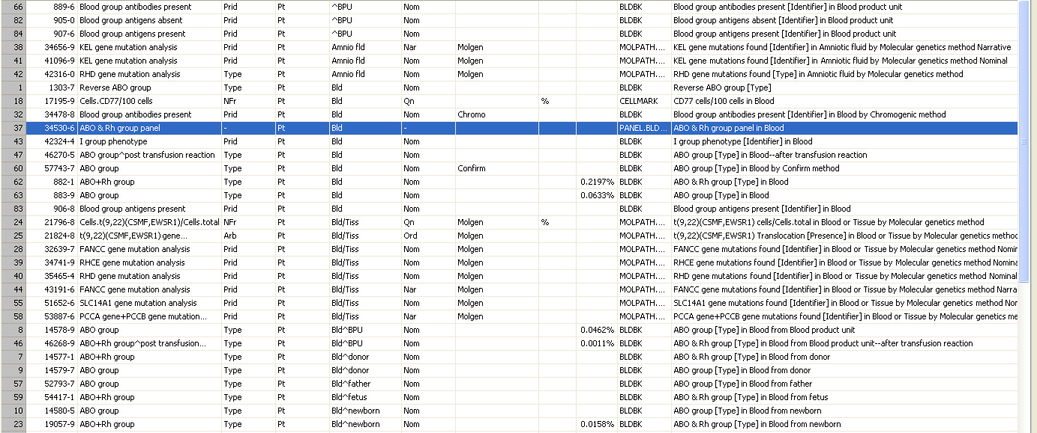

选择其中为bld的几项

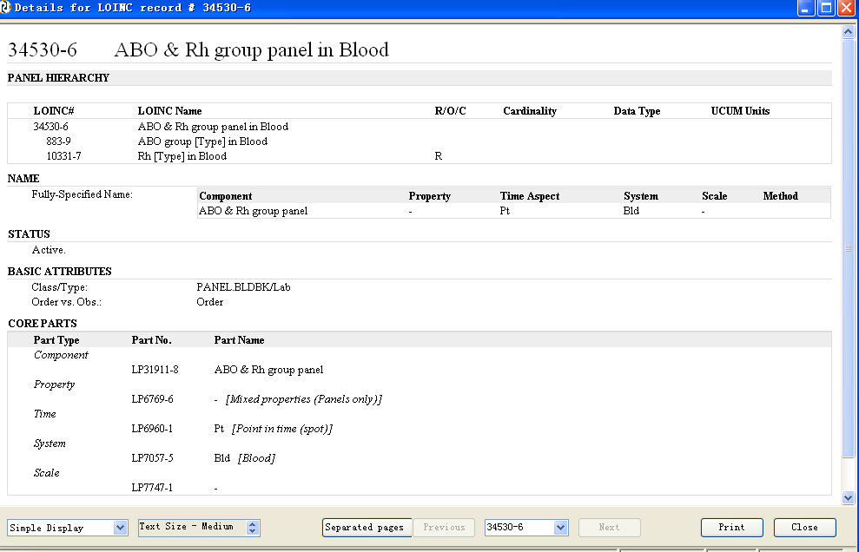

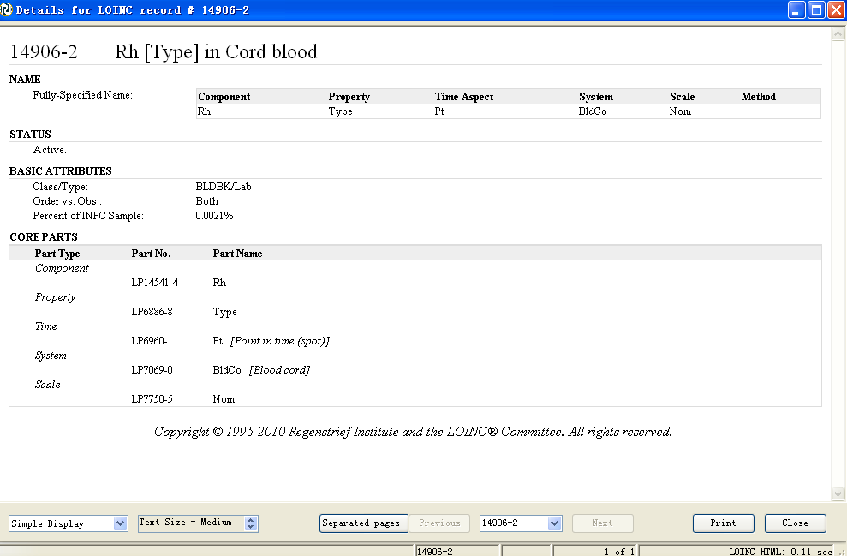

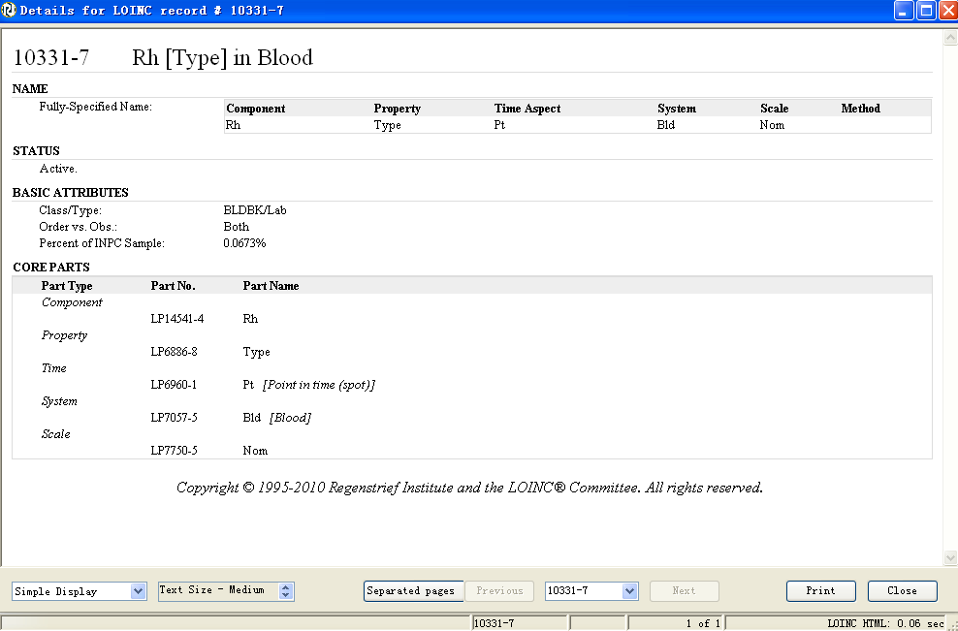

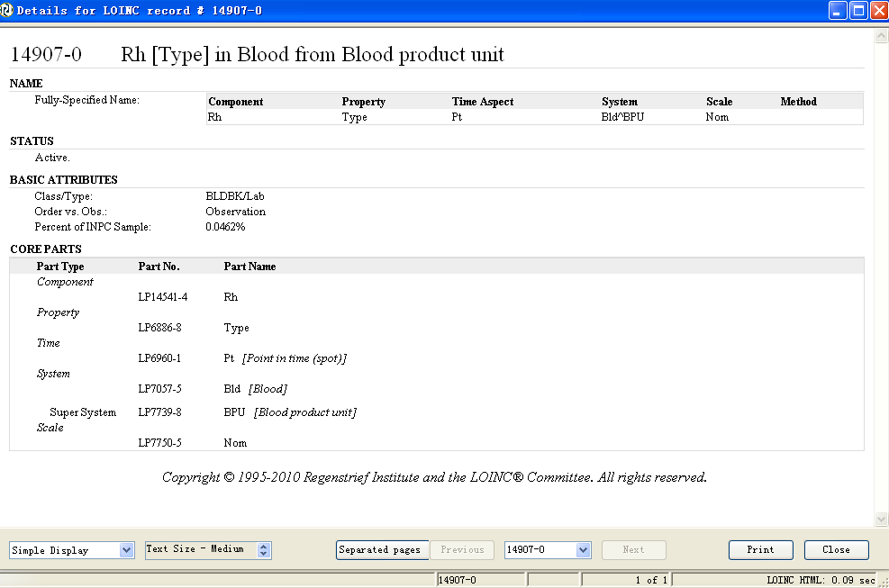

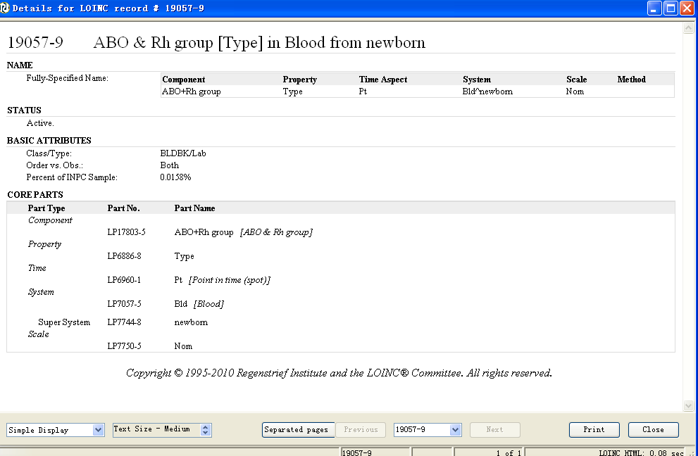

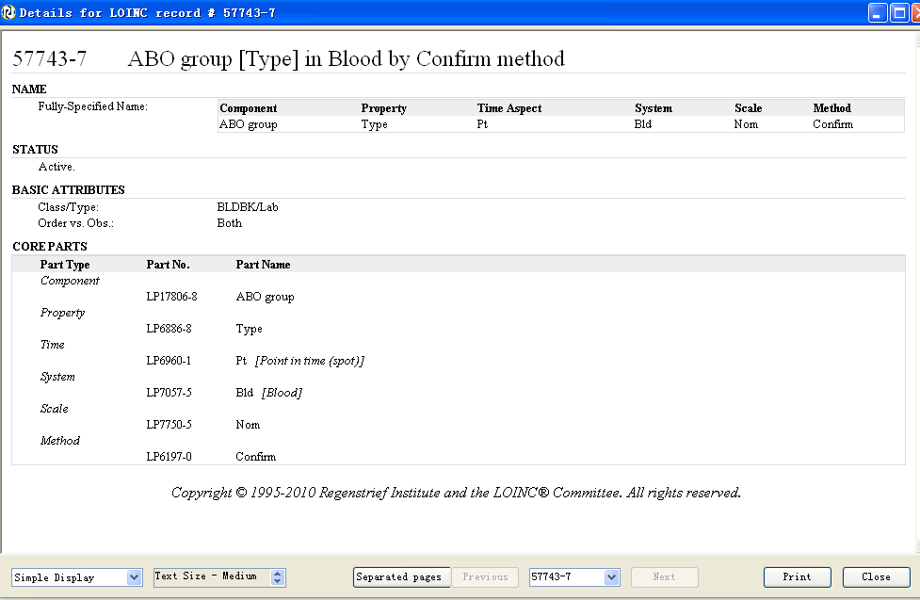

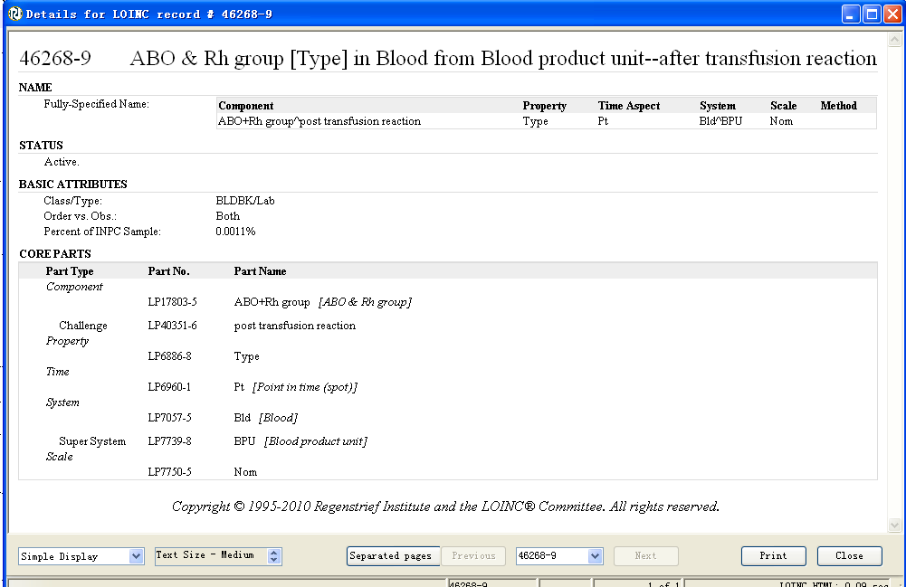

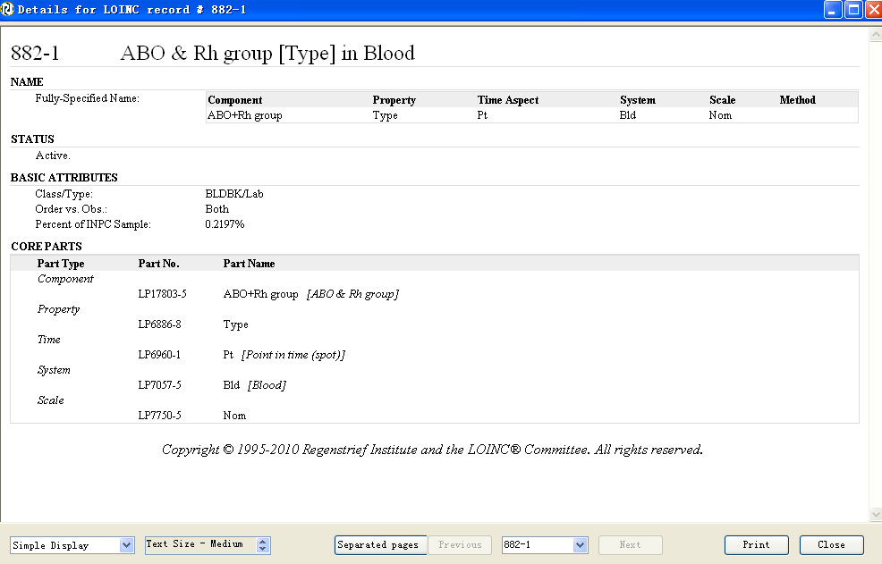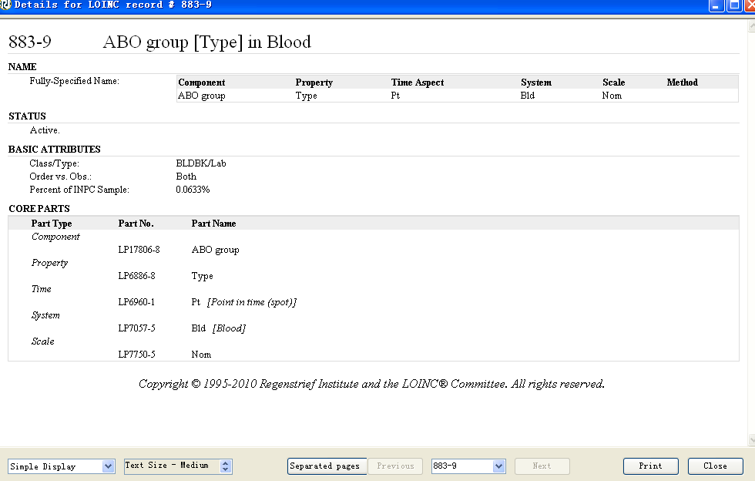

4 解决方案

依据result章节模板，采用30954-2LOINC码 设section/title为血型，构建出血型章节模板Nar和血型章节模板Nom

在血型章节模板Nom中为了表示CDA Body L3的信息，以blood type observation IHE PCC模板为原型，构建出血型代码条目模板。

构建血型模板，code取LOINC=882-1

根据IHE PCC Blood Type Observation (1.3.6.1.4.1.19376.1.5.3.1.4.13.6) 构建血型观察条目模板

其中关于code的问题 ，有如下情况

|  |  |  |  |
| --- | --- | --- | --- |
| 数据元 | 编码 | 编码系统 | 编码系统标识 |
| ABO血型代码 | HDSD00.01.013 | 城乡居民健康档案基本数据集20110802 | EHRDATASET_OID |
| Rh血型代码 | HDSD00.01.014 | 城乡居民健康档案基本数据集20110802 | EHRDATASET_OID |

|  |  |  |  |
| --- | --- | --- | --- |
| 数据元 | 编码 | 编码系统 | 编码系统标识 |
| ABO血型代码 | 883-9 | LOINC | 2.16.840.1.113883.6.1 |
| Rh血型代码 | 10331-7 | LOINC | 2.16.840.1.113883.6.1 |

|  |  |  |  |
| --- | --- | --- | --- |
| 数据元 | 编码 | 编码系统 | 编码系统标识 |
| ABO血型代码 |  | ISBT 128 | 2.16.840.1.113883.6.18 |
| Rh血型代码 |  | ISBT 128 | 2.16.840.1.113883.6.18 |

|  |  |  |  |
| --- | --- | --- | --- |
| 数据元 | 编码 | 编码系统 | 编码系统标识 |
| ABO血型代码 |  | SNOMED CT | 2.16.840.1.113883.6.96 |
| Rh血型代码 |  | SNOMED CT | 2.16.840.1.113883.6.96 |

对于value的取值 强制执行城乡居民健康档案基本数据集数据元允许值里的要求

CV04.50.005 血型代码表

1 A型

2 B型

3 O型

4 AB型

5 不详

和枚举型

1.Rh阳性 2.Rh阴性 3.不详

学历代码

职业类别代码

婚姻状况类别代码

参考标准：

CCR

CCD

在CCR 标准文件的第6页中有如下的描述：

|  |
| --- |
| 5.1.2.7 Social History contains data deﬁning the patient’s occupational, personal (for example, lifestyle), social, and environmental history and health risk factors, as well as administrative data (ADT) such as marital status, race, ethnicity, and religious affiliation. |

第18页

TableA1.1中有如下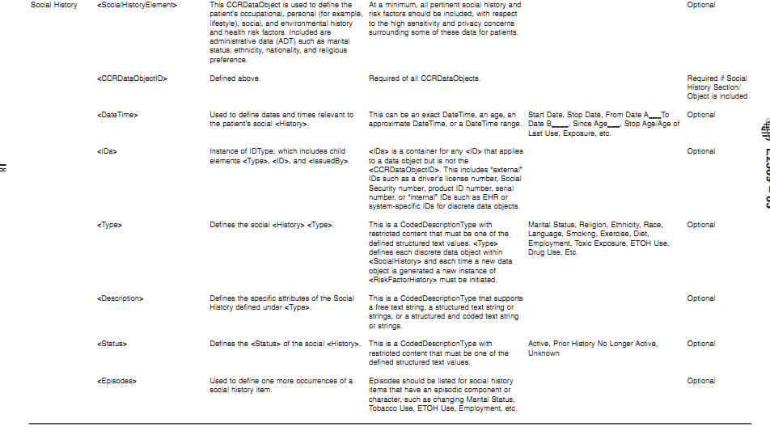

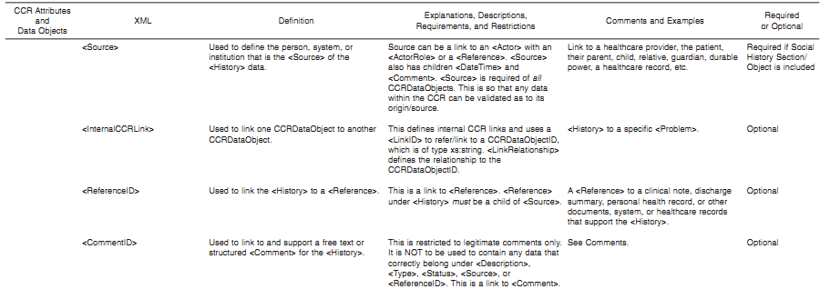

第70页

A.2.5.4.7中

|  |
| --- |
| (1) <SocialHistory> is optional and bound to one instance (0..1). The child element <SocialHistoryElement> is required and unbounded (1..`) and contains data deﬁning the patient’s occupational, personal (for example, lifestyle), social, and environmental history and health risk factors. Within the CCR,items commonly grouped under administrative data (ADT) in other healthcare systems and standards are included in <SocialHistory>, such as Marital Status, Race, Ethnicity, and Religious Affiliation, as all of these have relevance to healthcare and possible preferences, optimization, or restrictions on healthcare interventions, or combinations thereof, and therapeutic options for a speciﬁc patient. In addition, these ADT data are all highly conﬁdential and private data attributes about a patient and require the identical protections afforded all patient healthcare data.  (2) <Type> under <SocialHistoryElement> within <SocialHistory> is a CodedDescriptionType with restricted content that must be one of the deﬁned structured text values. <Type>deﬁnes each discrete data object within <SocialHistory>, and each time a new data object is generated, a new instance of<SocialHistoryElement> must be initiated.  (3) SocialHistoryType is illustrated in Fig. A2.17.  (4) <SocialHistoryElement> is deﬁned in Table A2.10. |

在CCD中

第37页

3.7 Social History

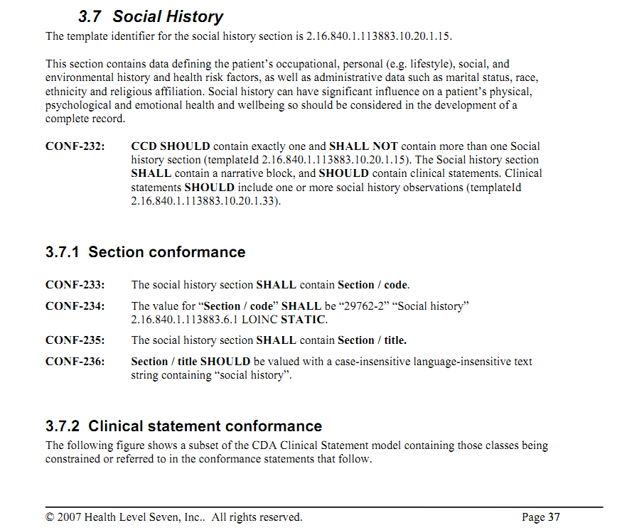

此处在CCR中描述的基础上强调了社交史中信息对个人生理、心理和情绪等健康状况的影响

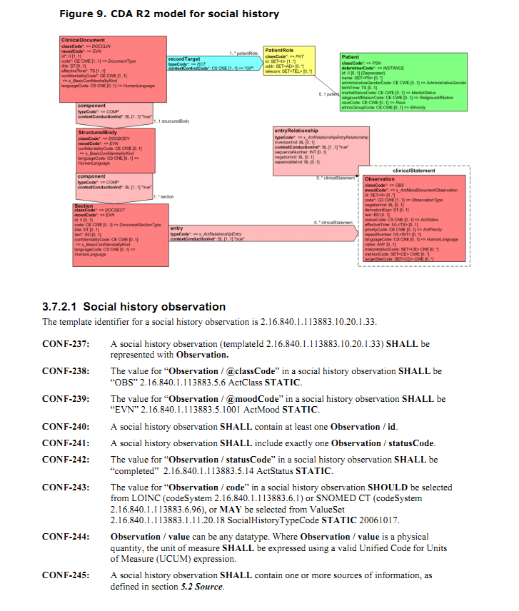

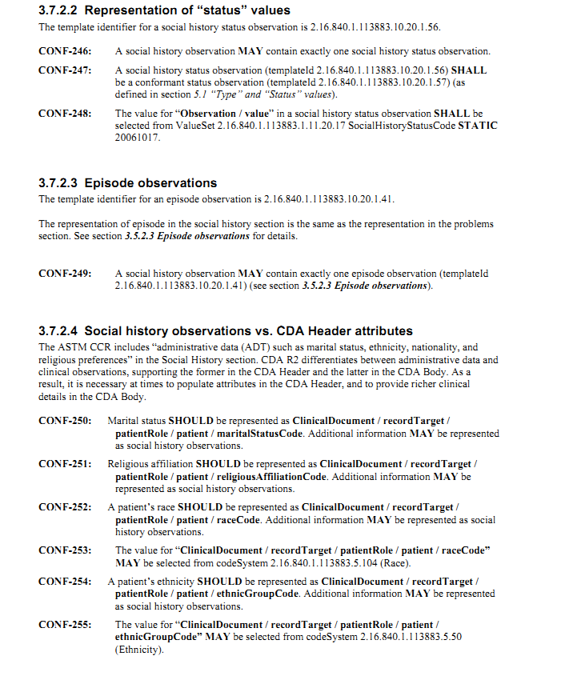

HITSP N154中对social history数据元的定义如下

第32页

2.1.19

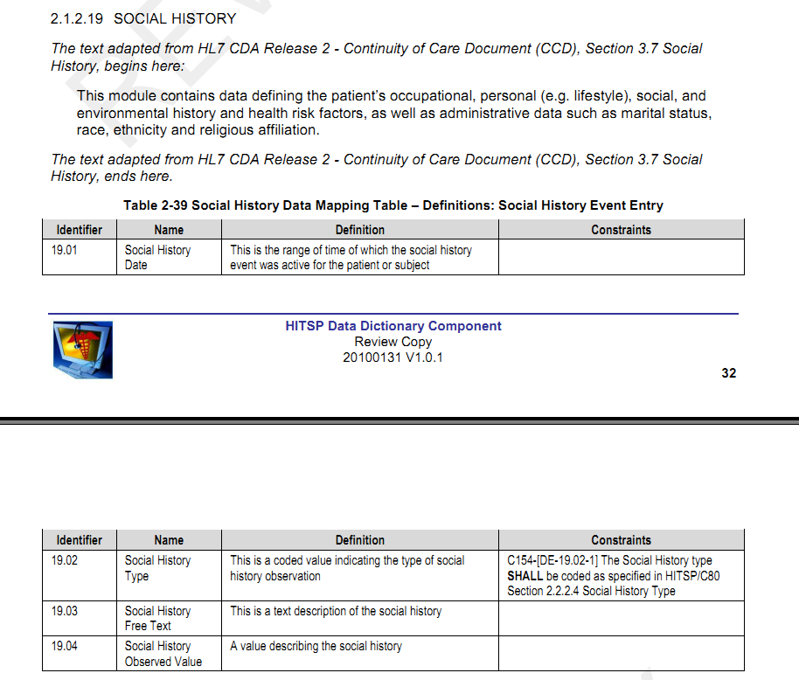

在IHE PCC TF REV6.0 2010-08-30中

第88页

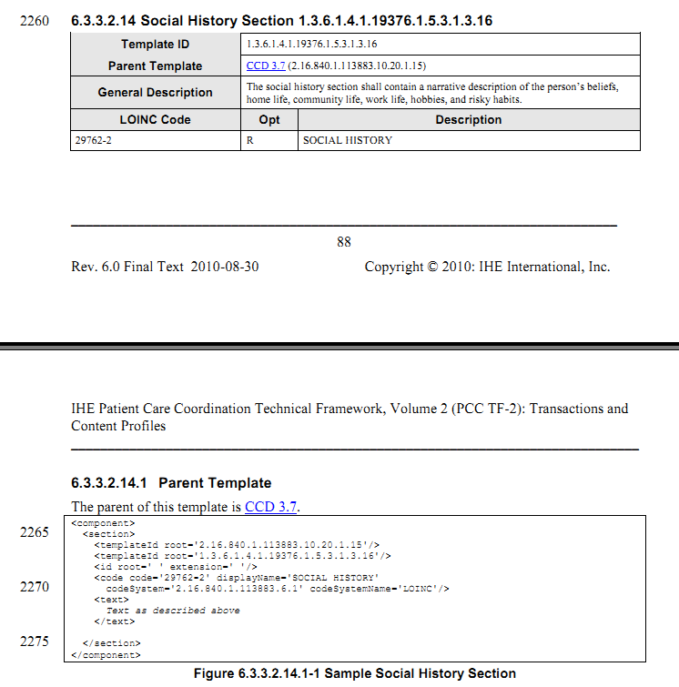

第192页中

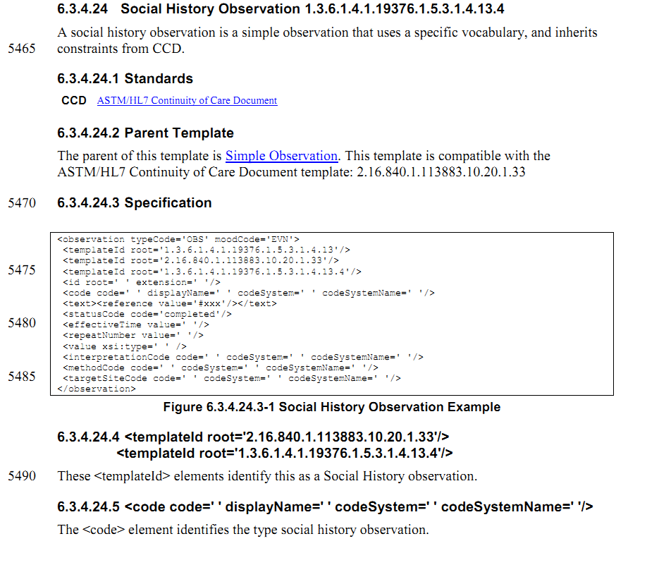

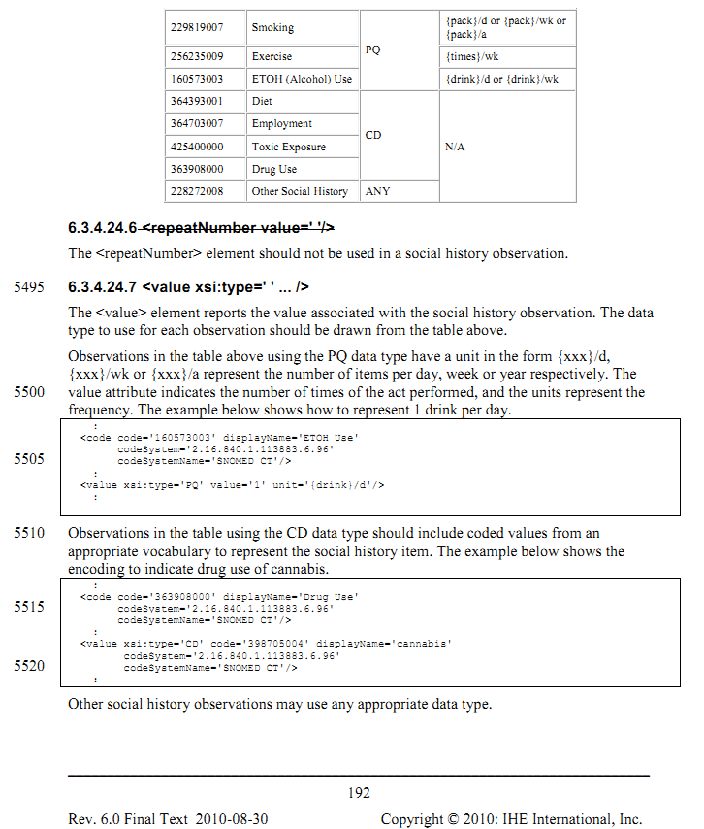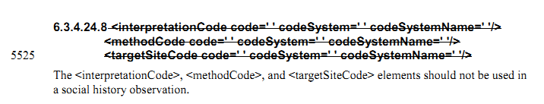

HITSP C83 V2.0 2010中

第22页中

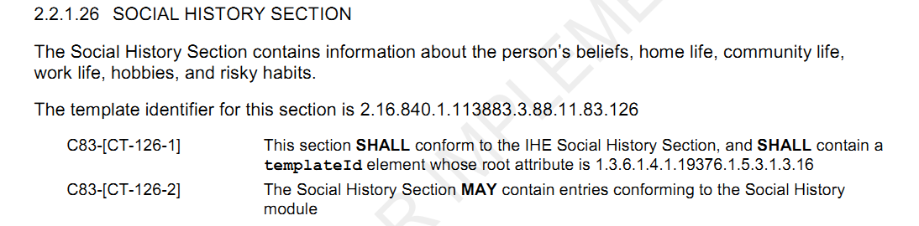

第82页

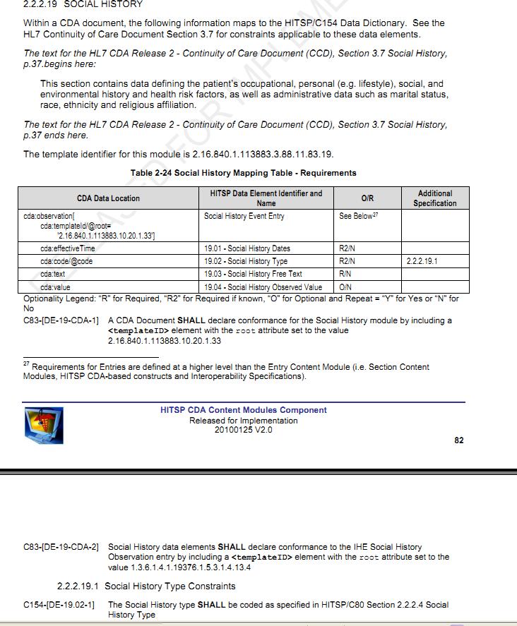

围观了澳大利亚的NEHTA中discharge summary的IG

《08-DS-CDA_Implementation_Guide_Release_1_v1_1_Draft_20091125》

第31页

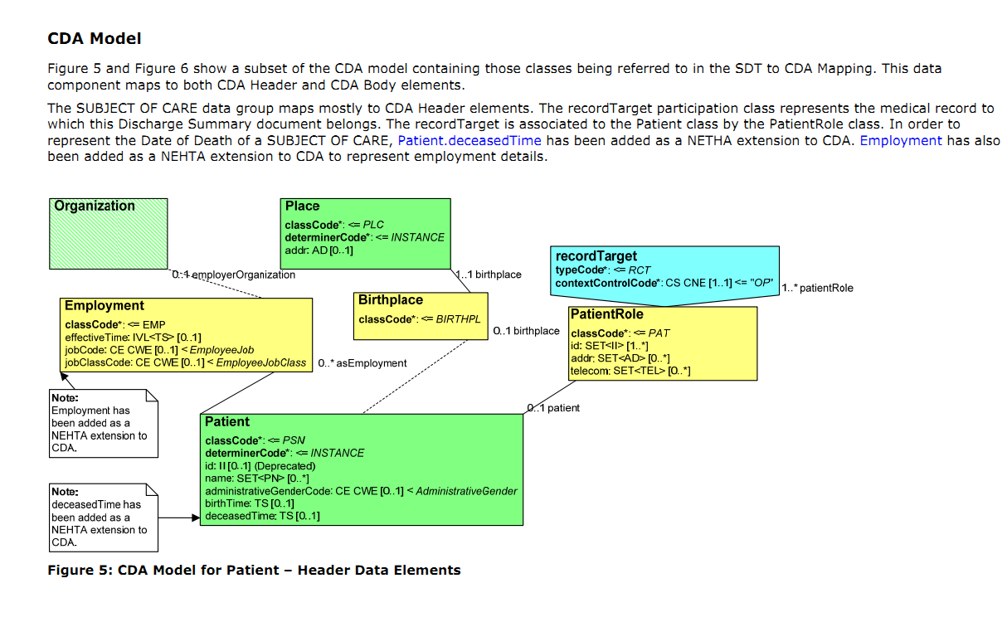

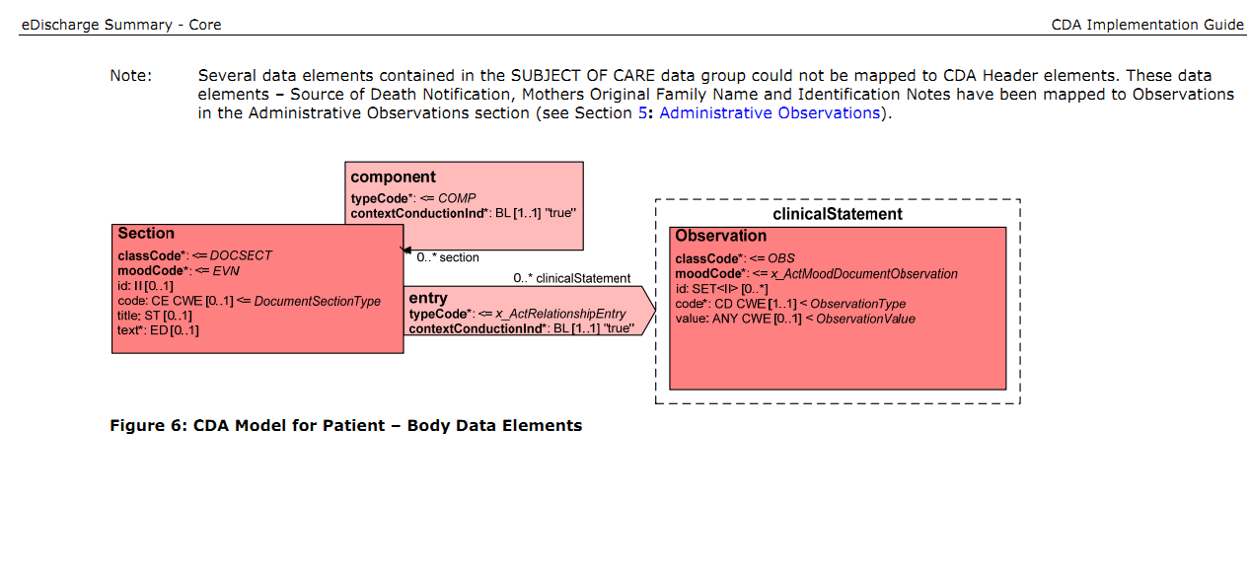

其中对职业使用了CDA Extension，构建了新的类，其余的诸如死亡通知来源、母亲本来的姓氏等被对应到Observation中去了。

围观台湾的 108表单中出现此章节的如下

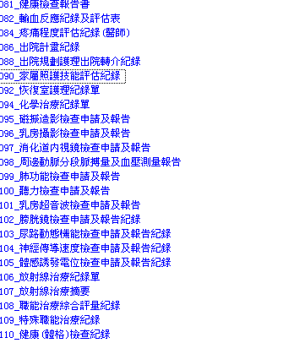

<081健康检查报告单>中

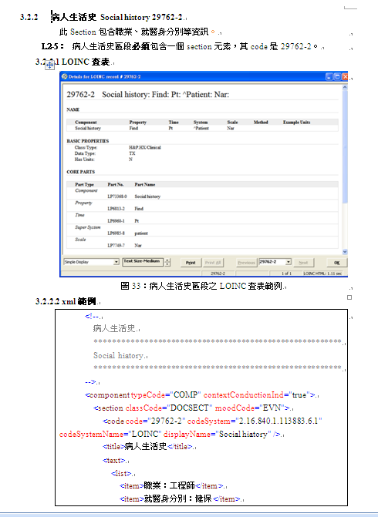

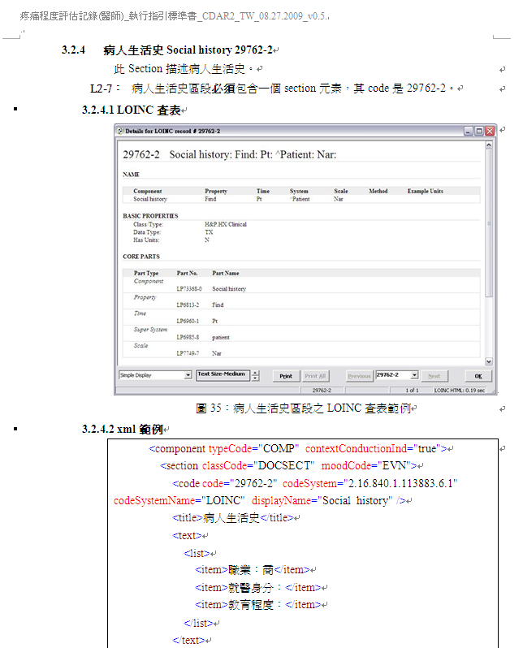

我们的解决方案

1. 学历代码-等同于文化程度 即education level和职业类别代码 occupation

方案一：按照大多数IG中的那样，直接在social history章节中出现，以social history 条目的形式编码，建议使用此种办法。

方案二：按照澳大利亚的方法，添加CDA extension，不用此法。

1. 婚姻状况类别代码 直接表示在CDA HEADER中，不做其他 考虑，如若有额外的附加描述信息(多指主观信息)，则在社交史章节中以条目形式出现。

医疗费用支付方式代码

与医疗费用相关的数据元均列在《卫生信息数据元目录第13部分：卫生费用》中：

|  |  |  |  |  |  |  |  |  |  |  |
| --- | --- | --- | --- | --- | --- | --- | --- | --- | --- | --- |
| |  | | --- | | 个人承担费用（元） | | 门诊费用分类代码 | | 门诊费用分类名称 | | 门诊费用金额（元） | | 收入与支出金额数（万元） | | 医疗费用结算方式代码 | | 医疗费用支付方式代码 | | 住院费用分类代码 | | 住院费用分类名称 | | 住院费用金额（元） | |

参考标准

CCD2007final

HITSPV2.0 2010C83

在CCD标准文件第19页中

|  |
| --- |
| Payers contains data on the patient’s payers, whether a ‘third party’ insurance, self-pay, other payer or guarantor, or some combination of payers, and is used to define which entity is the responsible fiduciary for the financial aspects of a patient’s care.  Each unique instance of a payer and all the pertinent data needed to contact, bill to, and collect from that payer should be included. Authorization information that can be used to define pertinent referral, authorization tracking number, procedure, therapy, intervention, device, or similar authorizations for the patient or provider, or both should be included. At a minimum, the patient`s pertinent current payment sources should be listed.  The CCD represents the sources of payment as a coverage act, which identifies all of the insurance policies or government or other programs that cover some or all of the patient's healthcare expenses. The policies or programs are sequenced by order of preference. Each policy or program identifies the covered party with respect to the payer, so that the identifiers can be recorded. |

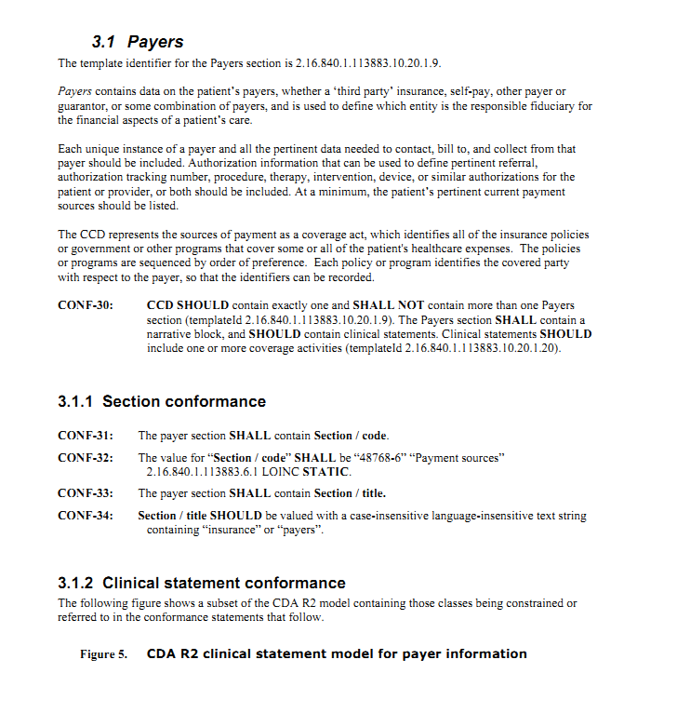

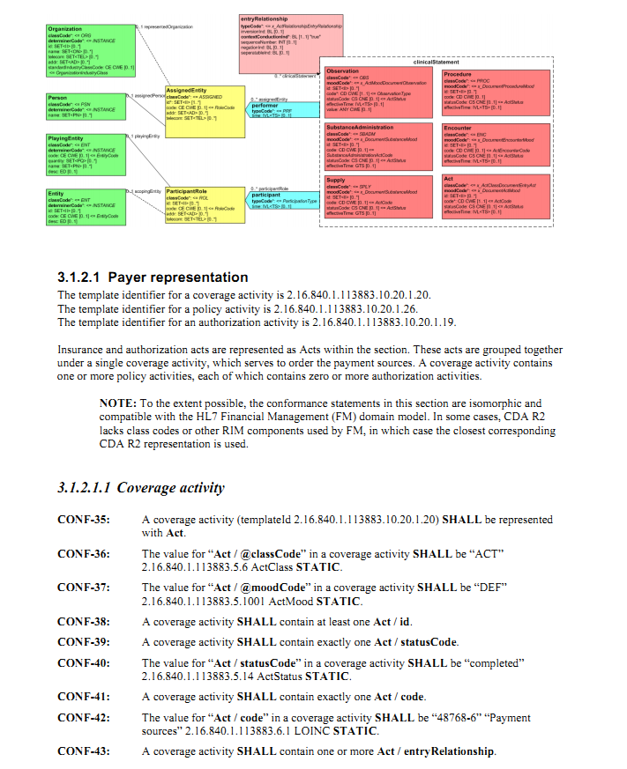

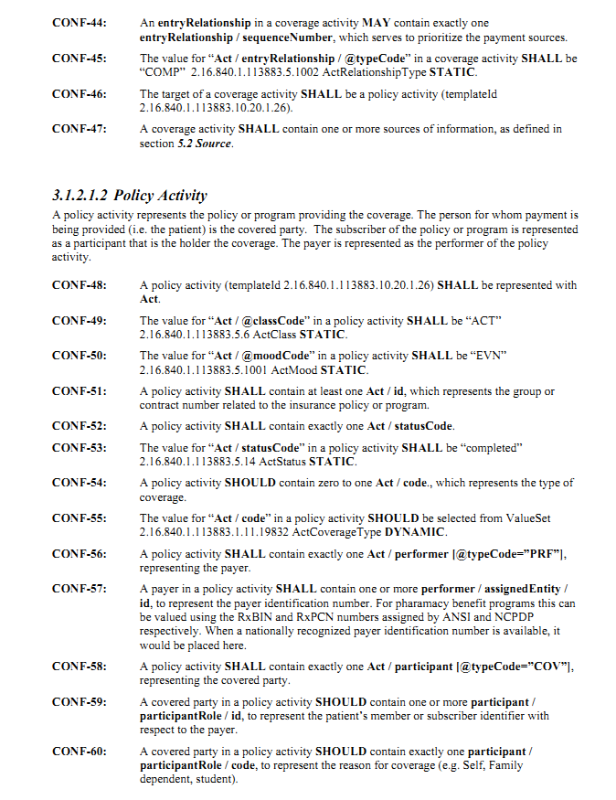 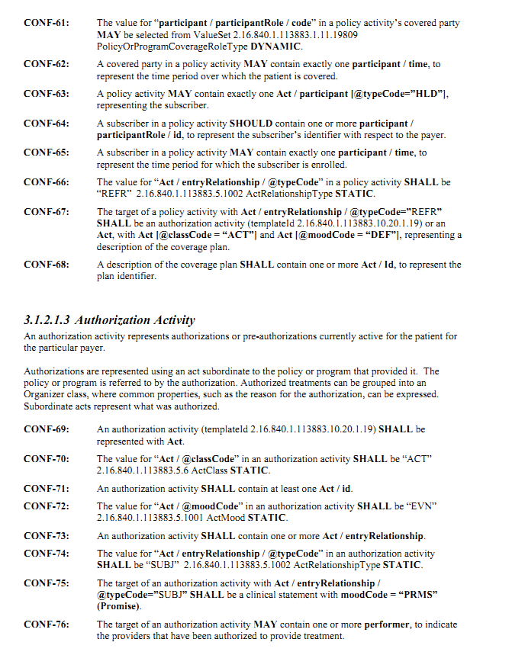

在HITSP规范中 第16页

定义了如下的payer章节模板

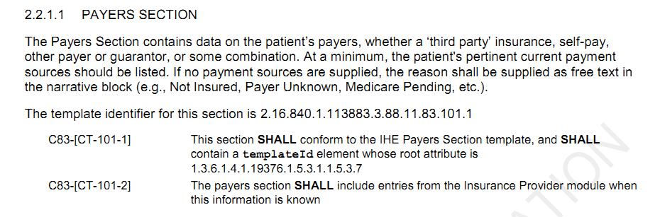

同时在第37页2.2.2.5中

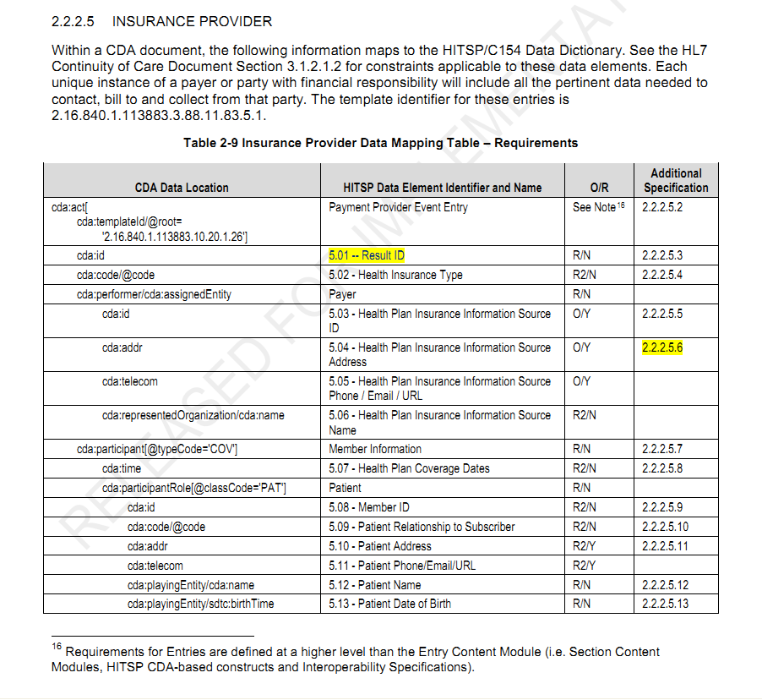

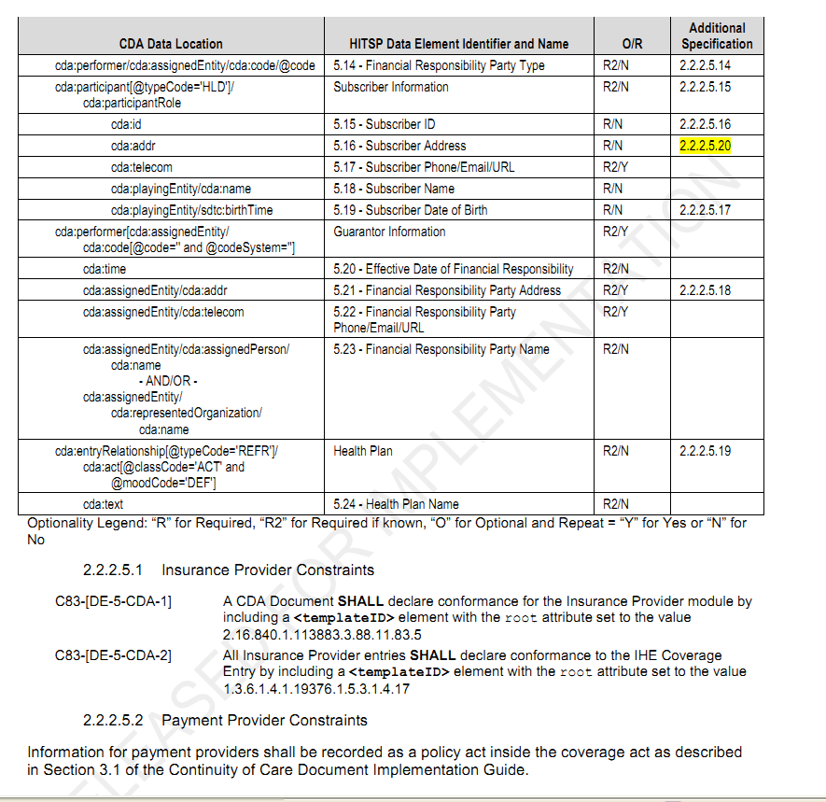



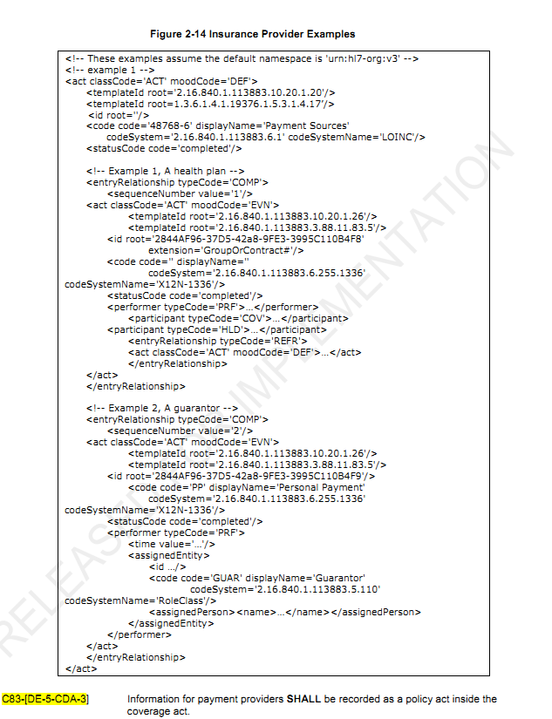

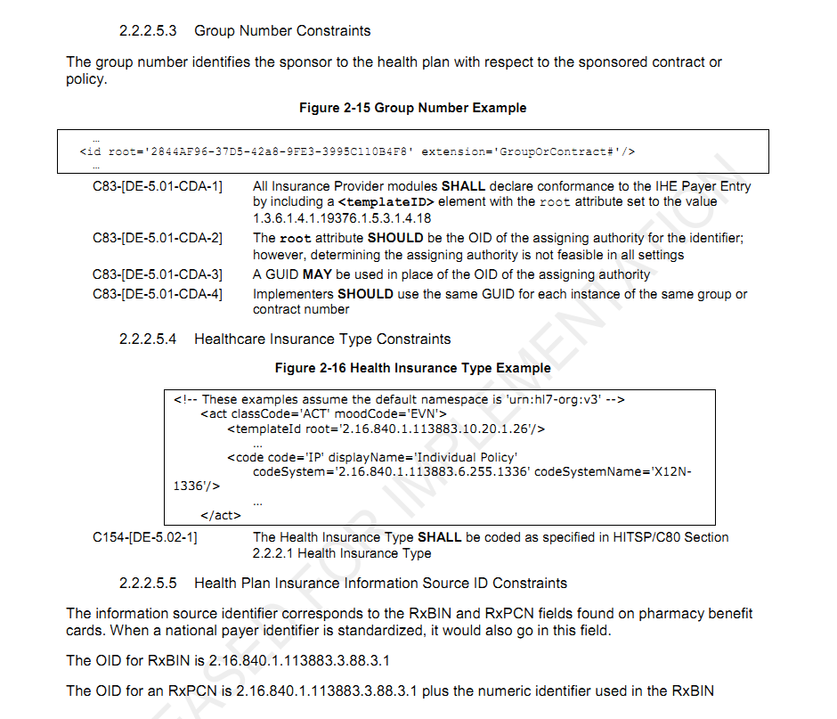

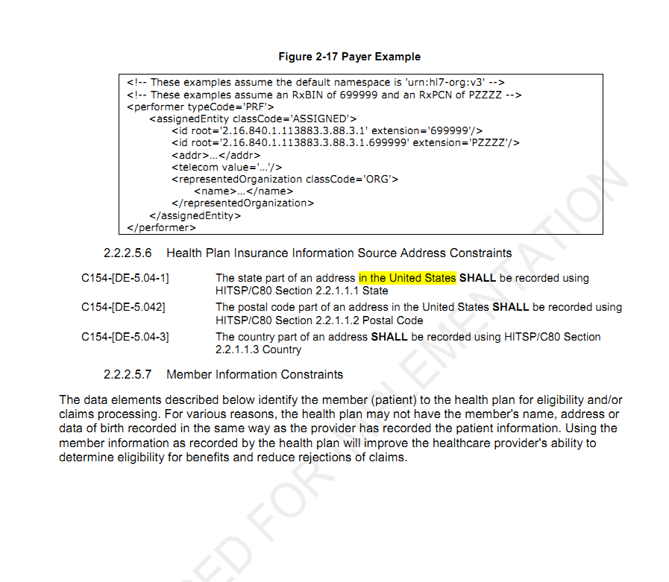

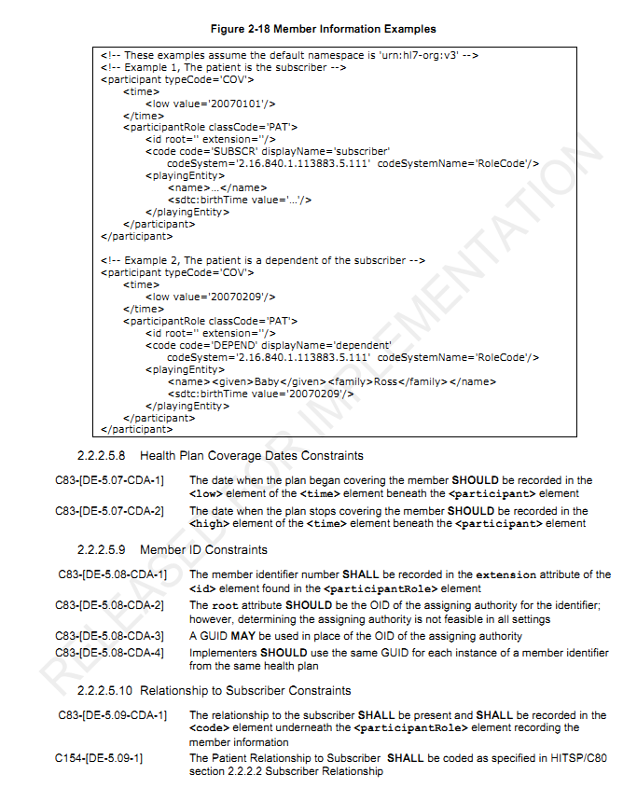 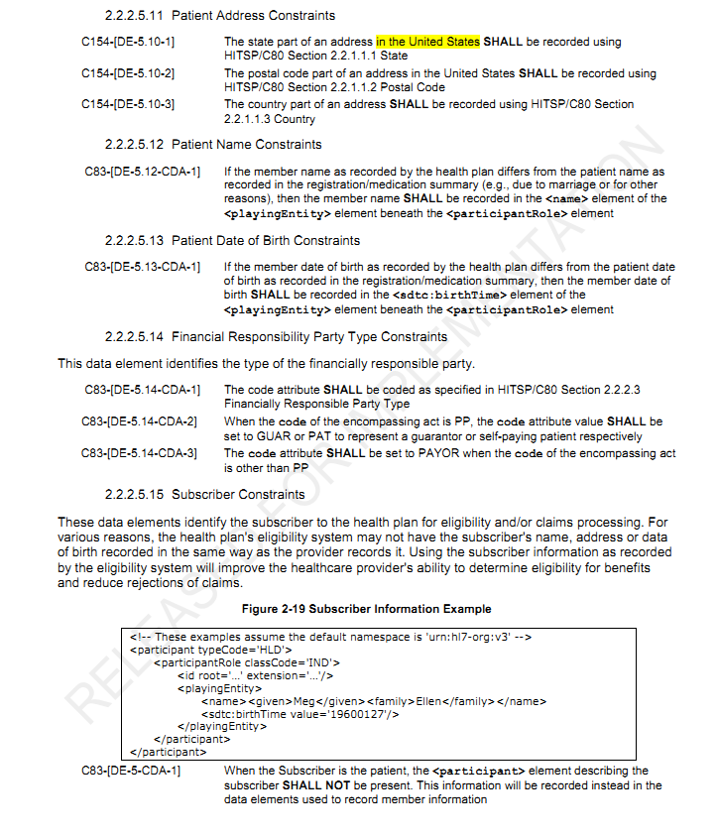 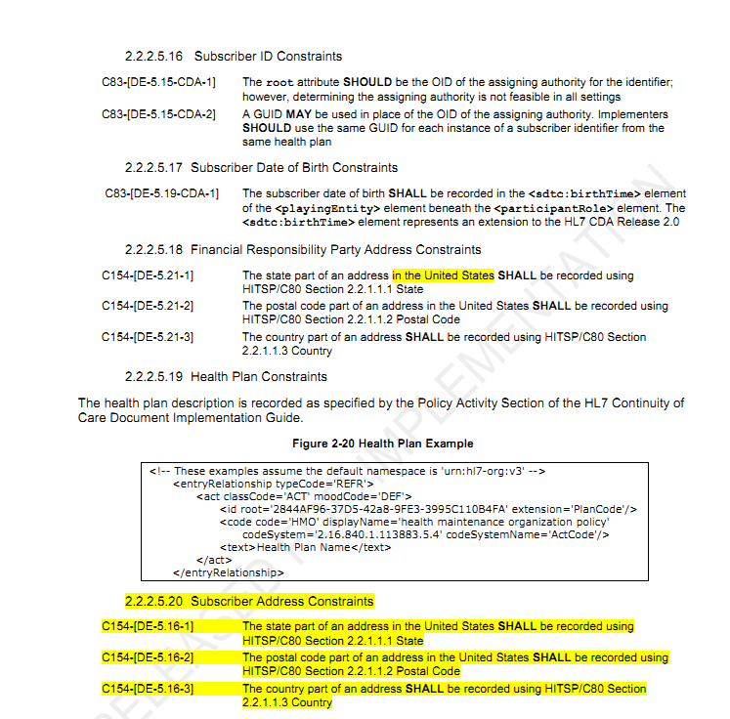

上面提到了HISTP C154中的数据元定义，那么我们来看一看定义了那些数据元

第15页

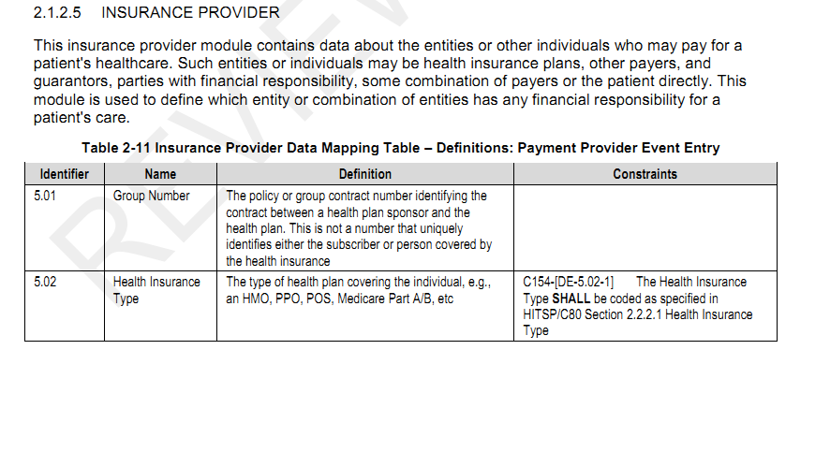

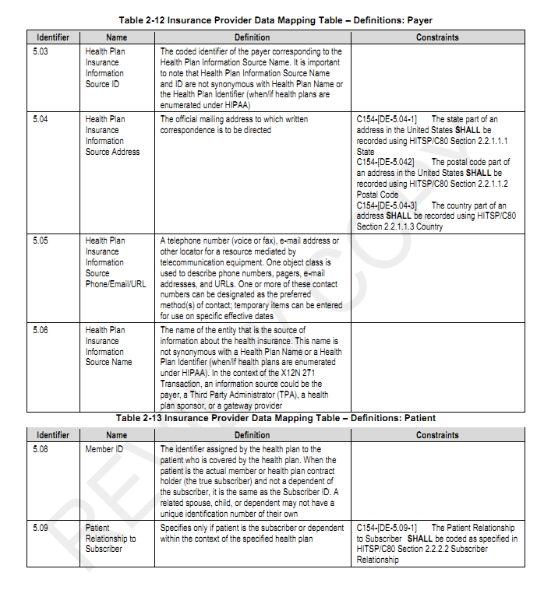 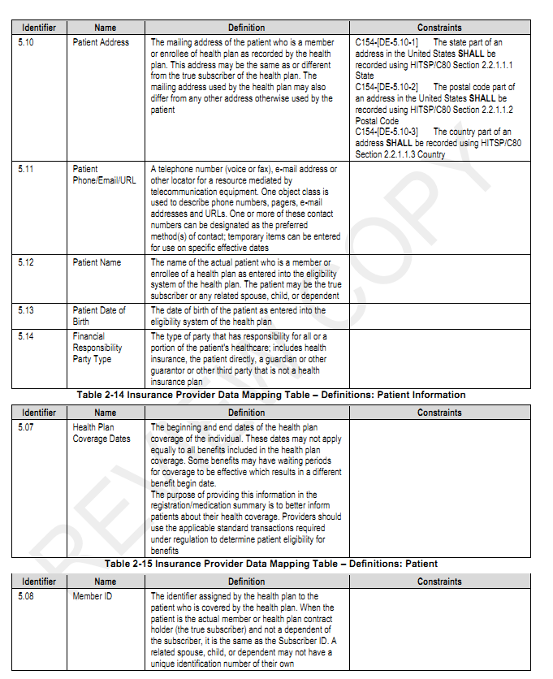 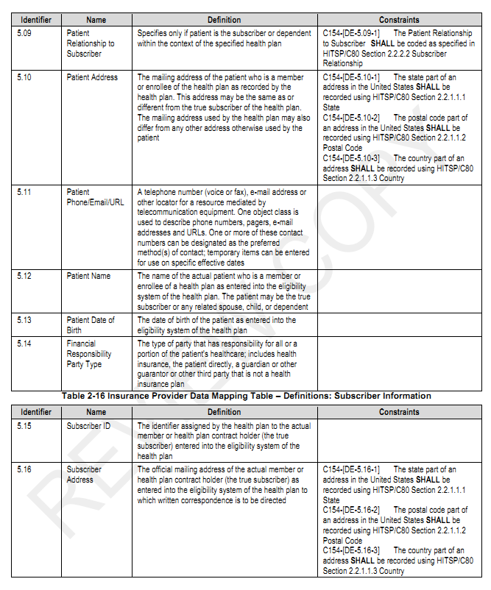 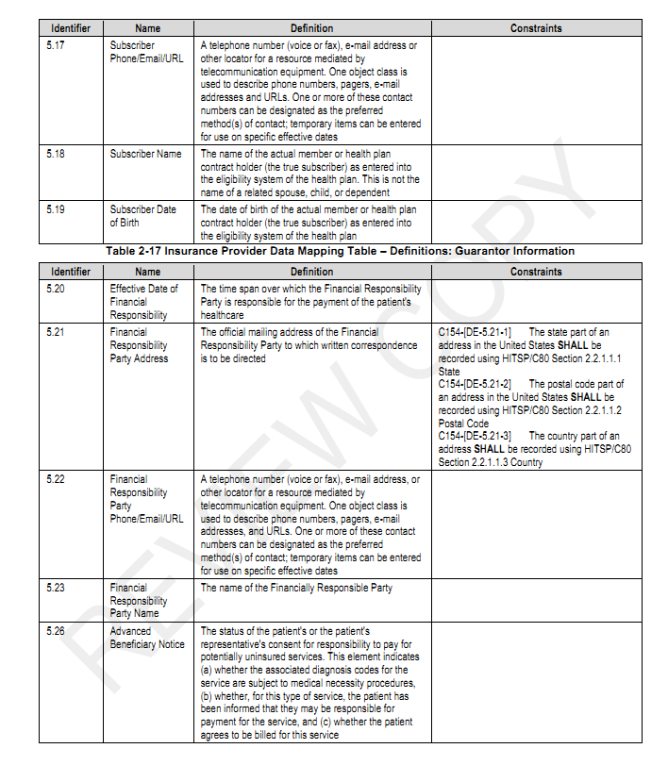 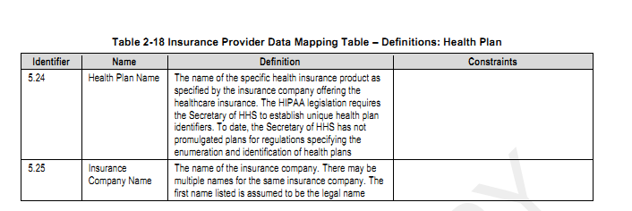

其实这些数据元里有诸多不理解 需要深入的去了解

在IHE PCC TF6.0 2010-0830版中

第127页 6.3.3.7.1中

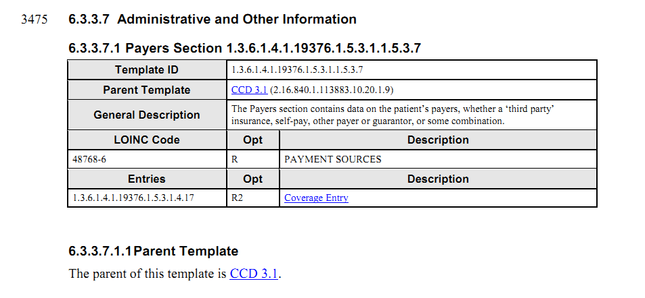

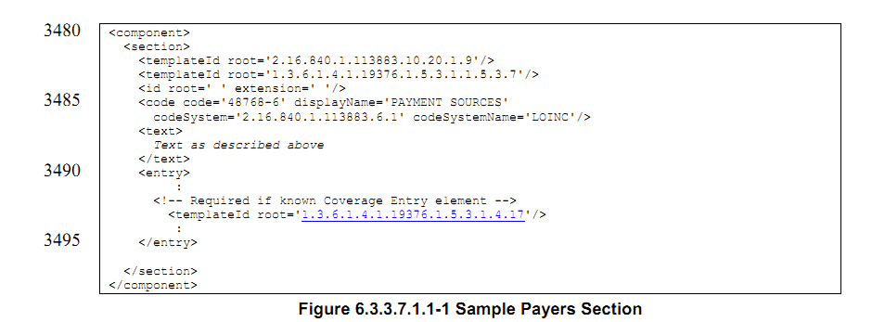

但是此文档中却找不到Coverage Entry 的信息

Google之 得到

电子病历委员会

参考财务章节

最终解决方案

卫生信息数据元标准中涉及到的数据元全部出现在《卫生信息数据元目录第13部分 卫生费用》，如下

|  |  |
| --- | --- |
| DE07.00.001.00 | 个人承担费用（元） |
| DE07.00.002.00 | 门诊费用分类代码 |
| DE07.00.003.00 | 门诊费用分类名称 |
| DE07.00.004.00 | 门诊费用金额（元） |
| DE07.00.005.00 | 收入与支出金额数（万元） |
| DE07.00.006.00 | 医疗费用结算方式代码 |
| DE07.00.007.00 | 医疗费用支付方式代码 |
| DE07.00.008.00 | 住院费用分类代码 |
| DE07.00.009.00 | 住院费用分类名称 |
| DE07.00.010.00 | 住院费用金额（元） |

由于CDA R2中并不包含表示有关医疗费用 财务相关数据的类，但是在正在开发的CDA R3中将会加入这类信息，因此 有2种方案可供选择，

1. 采用扩展的命名空间，加入新的类来处理这些卫生费用数据元
2. 参考已有的CCD IHE HITSP SI中做法，又由于卫生费用共涉及10个数据元，故采用简单的Act类表示

拟采用方法2.

本方案使用二个条目模板：

1．医疗支付（Payment）模板表示（缴付的）费用，基于Act类。其code表示费用支付方式，例如支票、现金等。医疗支付模板中的Act类通过RIM participation和一个RIM Role类相连，表示一个Payer类，即支付者（保险公司、医保、自付等）。医疗支付模板主要包括这二个RIM类（Act和Payer）。在医疗支付模板本身，没有具体费用信息。具体支付的费用用医疗服务费用（Healthcare Service Fee）模板表示。医疗支付模板必须包括至少一个根据医疗服务费用模板创建的元素，表示支付的总金额以及相应的服务。

医疗支付模板支持以下基本数据：门诊费用-支付方式代码，住院费用-医疗付款方式代码，个人承担费用（元）。但它也允许记录基本数据集没有定义但对数据挖掘分析有用的其它数据。

注：医疗支付模板是完全有我们自己定义的模板，没有任何继承模板。它的设计充分考虑和借鉴了HL7 V3财务消息模型，并进行了简化。

2．医疗服务费用（Healthcare Service Fee）模板表示对某项（类）医疗服务具体的费用，基于Observation类。其code表示收费服务分类，value使用MO数据类型，表示收费金额。

医疗服务费用模板支持以下基本数据：门诊费用-分类，门诊费用-分类代码，门诊费用-金额（元/人民币），住院费用-分类，住院费用-分类代码，住院费用-金额（元/人民币）。

注：医疗服务费用模板从IHE简单观察（Simple Observation）模板简单导出。

在HISTP C154Z中，第15页，Insurance Provider数据模块定义中，



此处应该意为医疗费用来源，

又见HITSP C80 2.2.2.1中关于Health Insurance Type的定义，

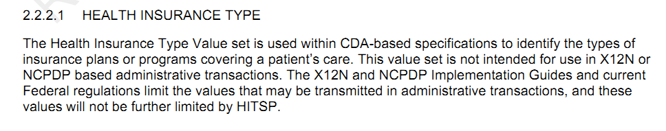

保险计划或项目的类型。

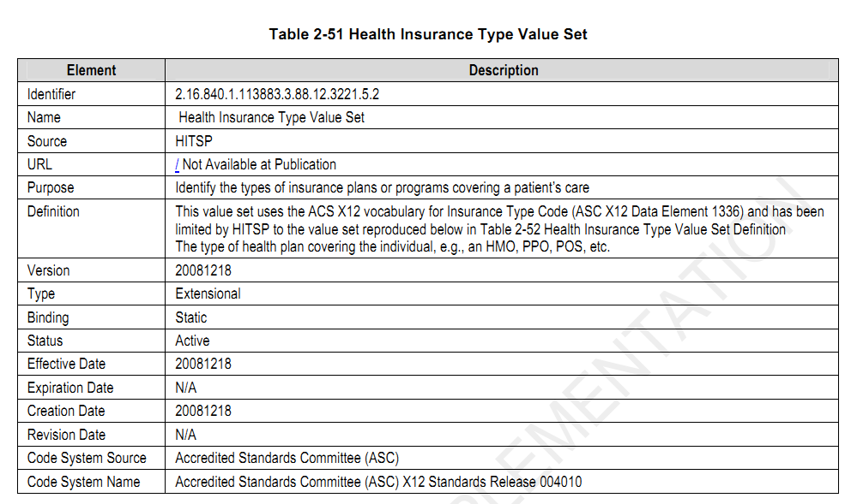

具体的取值

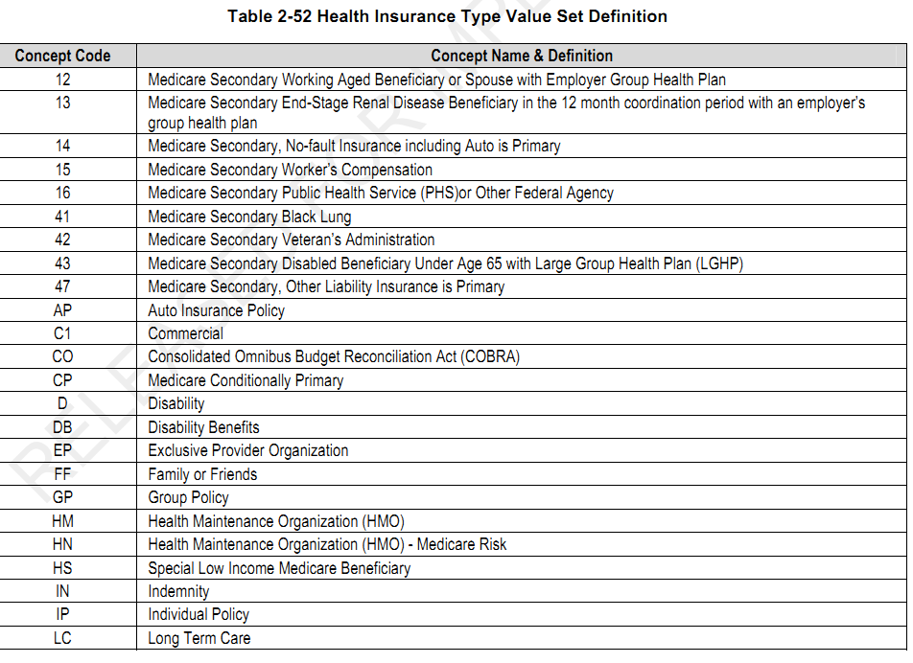

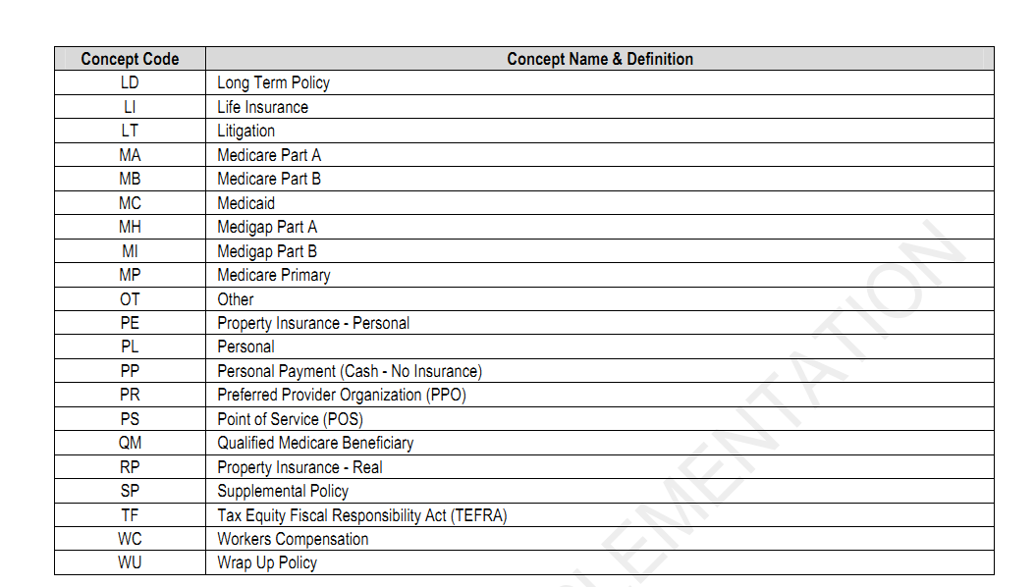.先理一理CCD，payer这个section对应了CCR的Payers

看一看CCR中此部分定义了那些数据元，见CCR标准的第11页 如下图

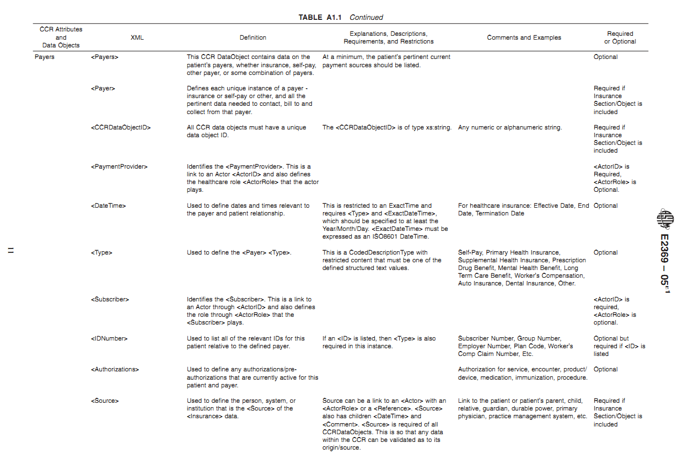

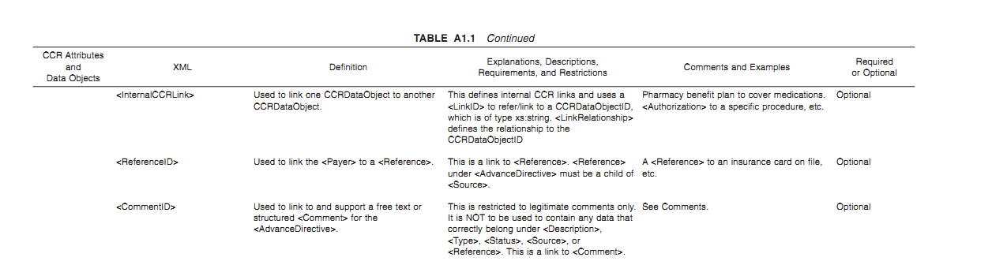

Ccd中就说payer章节就能够表达病人的支付来源相关的信息 不管是自付、第三方保险或者他人担保等等。也就是说定义是谁对病人医疗的财务负责。我觉得解决的仅仅是一个谁来付钱、以什么样的名义来付(其中就包括了 是谁(参保人)参与了怎么样的医保政策，)以及为谁付(受保人)，但是并没有说怎么样来结算 是现金 支票 转账等等，也没有说具体支付了多少，以及产生了多少医疗费用。在这其中，一个coverage act就表示支付方式的集合，就是说 我这个人吧 医疗费用的支付可以选用多种方式。而其又通过entryrelationship与一个policy activity关联起来，当然对于一个人 支付方式可能有多种组合，比方说 (实际可能不是这样) ，医保只能报80%，剩下的通过现金自付。这样就存在两种支付方式，一个policy activity表示一种具体的支付方式，比如贫困救助。在一个policy activity中，要表示支付方式的来源，即到底是谁在背后出钱呢？就用performer来表达，而paticipant通过设置typecode为COV和HLD就可以分别表示受保人和参保人的信息。遗憾的是我们的EHR数据元中目前还不包含此类信息。此外，对于特殊的支付方，可能会有一些授权信息，此类的医保相关信息我也不能很好的理解。而且EHR数据集中亦不存在此类，暂略。

再理一理HITSP

在C154中，定义了INSURANCE PROVIDER module，其中定义了从5.01-5.26这样多个数据元，其下又分为 类，Payment Provider Event Entry(支付方(式)信息)、Patient(受保人 钱是花在谁身上了 和参保人什么关系啊)、Subscriber Information(参保人，出生日期 身份标识 地址等)、Guarantor Information(担保人信息，未作深入了解)

在HITSP C83中，提供了INSURANCE PROVIDER module的对应，

看得出来 它是将CCD中提到的policy activity进行了进一步的约束和C154中提供的数据元进行了对应，为了进一步了解其中这样的一些数据元的含义，举一例

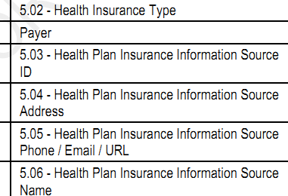

|  |
| --- |
| <!--Payers-->  <section>  <templateId root="2.16.840.1.113883.3.88.11.83.101" assigningAuthorityName="HITSP/C83"/>  <templateId root="1.3.6.1.4.1.19376.1.5.3.1.1.5.3.7" assigningAuthorityName="IHE PCC"/>  <templateId root="2.16.840.1.113883.10.20.1.9" assigningAuthorityName="HL7 CCD"/>  <!--Payers section template-->  <code code="48768-6" codeSystem="2.16.840.1.113883.6.1" codeSystemName="LOINC" displayName="Payment sources"/>  <title>Insurance Providers</title>  <text>  <table border="1" width="100%">  <thead>  <tr>  <th>Payer name</th>  <th>Policy type / Coverage type</th>  <th>Policy ID</th>  <th>Covered party ID</th>  <th>Policy Holder</th>  </tr>  </thead>  <tbody>  <tr>  <td>Good Health Insurance</td>  <td>Extended healthcare / Family</td>  <td>Contract Number</td>  <td>1138345</td>  <td>Patient's Mother</td>  </tr>  </tbody>  </table>  </text>  <entry typeCode="DRIV">  <act classCode="ACT" moodCode="DEF">  <templateId root="1.3.6.1.4.1.19376.1.5.3.1.4.17" assigningAuthorityName="IHE PCC"/>  <templateId root="2.16.840.1.113883.10.20.1.20" assigningAuthorityName="CCD"/>  <!-- Coverage entry template -->  <id root="1fe2cdd0-7aad-11db-9fe1-0800200c9a66"/>  <code code="48768-6" codeSystem="2.16.840.1.113883.6.1" codeSystemName="LOINC" displayName="Payment sources"/>  <statusCode code="completed"/>  <entryRelationship typeCode="COMP">  <act classCode="ACT" moodCode="EVN">  <templateId root="2.16.840.1.113883.3.88.11.83.5" assigningAuthorityName="HITSP C83"/>  <templateId root="2.16.840.1.113883.10.20.1.26" assigningAuthorityName="CCD"/>  <templateId root="1.3.6.1.4.1.19376.1.5.3.1.4.18" assigningAuthorityName="IHE PCC"/>  <!--Insurance provider template -->  <id root="3e676a50-7aac-11db-9fe1-0800200c9a66" extension="Group or Contract Number"/>  <code code="MB" displayName="Medicare Part B" codeSystemName="X12 Insurance Type code" codeSystem="2.16.840.1.113883.6.255.1336">  <translation code="EHCPOL" codeSystem="2.16.840.1.113883.5.4" displayName="Extended healthcare"/>  </code>  <statusCode code="completed"/>  <performer typeCode="PRF">  <time/>  <assignedEntity>  <id root="329fcdf0-7ab3-11db-9fe1-0800200c9a66"/>  <code code="PAYOR" codeSystem="2.16.840.1.113883.5.110" codeSystemName="HL7 RoleClassRelationship"/>  <addr nullFlavor="UNK"/>  <telecom nullFlavor="UNK"/>  <representedOrganization>  <name>Good Health Insurance</name>  <telecom/>  <addr/>  </representedOrganization>  <sdtc:patient>  <sdtc:id root="PatientIdAsKnownToPayor"/>  </sdtc:patient>  </assignedEntity>  </performer>  <participant typeCode="HLD">  <participantRole>  <id extension="SubscriberIDAsKnownToPayor" root="PayorAuthorityID"/>  <addr>  <streetAddressLine/>  <city/>  <state/>  </addr>  <telecom/>  <playingEntity>  <name>Patients Mom</name>  <sdtc:birthTime nullFlavor="UNK"/>  </playingEntity>  </participantRole>  </participant>  <participant typeCode="COV">  <time>  <low nullFlavor="UNK"/>  <high nullFlavor="UNK"/>  </time>  <participantRole classCode="PAT">  <id root="14d4a520-7aae-11db-9fe1-0800200c9a66" extension="1138345"/>  <code code="SELF" codeSystem="2.16.840.1.113883.5.111" displayName="Self"/>  <addr/>  <telecom/>  <playingEntity>  <name>Self</name>  <sdtc:birthTime/>  </playingEntity>  </participantRole>  </participant>  <entryRelationship typeCode="REFR">  <act classCode="ACT" moodCode="EVN">  <templateId root="2.16.840.1.113883.10.20.1.19"/>  <!--Authorization activity template -->  <id root="f4dce790-8328-11db-9fe1-0800200c9a66"/>  <code nullFlavor="NA"/>  <entryRelationship typeCode="SUBJ">  <procedure classCode="PROC" moodCode="PRMS">  <code code="73761001" codeSystem="2.16.840.1.113883.6.96" displayName="Colonoscopy"/>  </procedure>  </entryRelationship>  </act>  </entryRelationship>  <entryRelationship typeCode="REFR">  <act classCode="ACT" moodCode="DEF">  <id root="f4dce790-8328-11db-9fe1-0800200c9a66"/>  <code nullFlavor="UNK"/>  <text>Health Plan Name<reference value="PntrToHealthPlanNameInSectionText"/>  </text>  <statusCode code="active"/>  </act>  </entryRelationship>  </act>  </entryRelationship>  </act>  </entry>  </section> |

可是其中并没有涉及到Guarantor information相关的信息，需求助。

再来看看 IHE

在IHE_PCC_Suppl_CDA_Content_Modules_Rev2-1_TI_2011-09-02 第117页找到 Coverage Entry

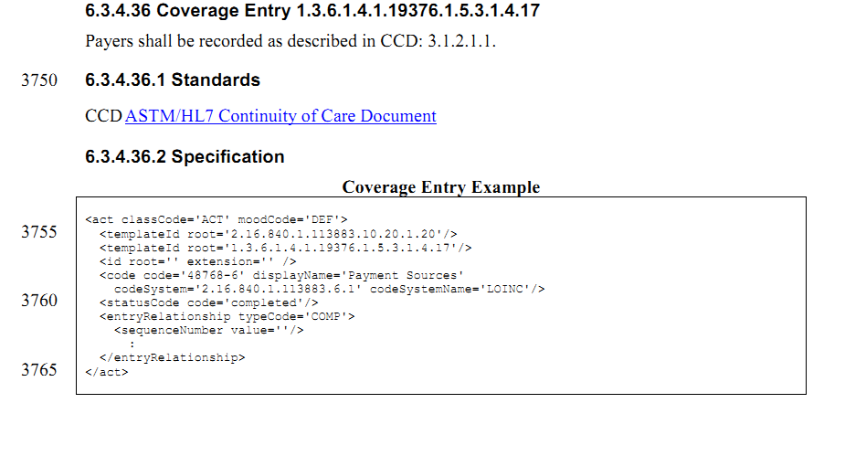

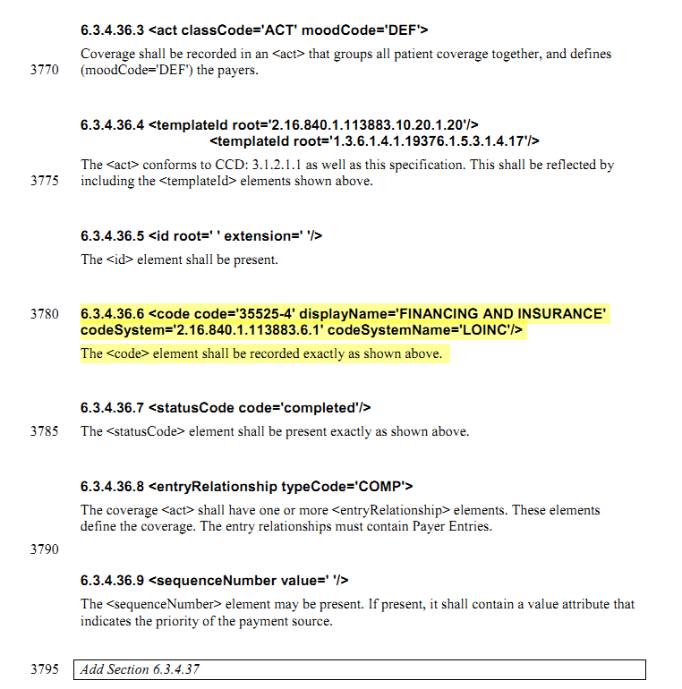

其中高亮的部分将code从原来的'48768-6' displayName='Payment Sources' 更改为 code='35525-4' displayName='FINANCING AND INSURANCE' 个人觉得此处的code 应该保留 而新的35525-4应该设置为卫生费用章节的code

同时 在6.3.4.37中出现了payer entry 它继承了CCD的policy activity。

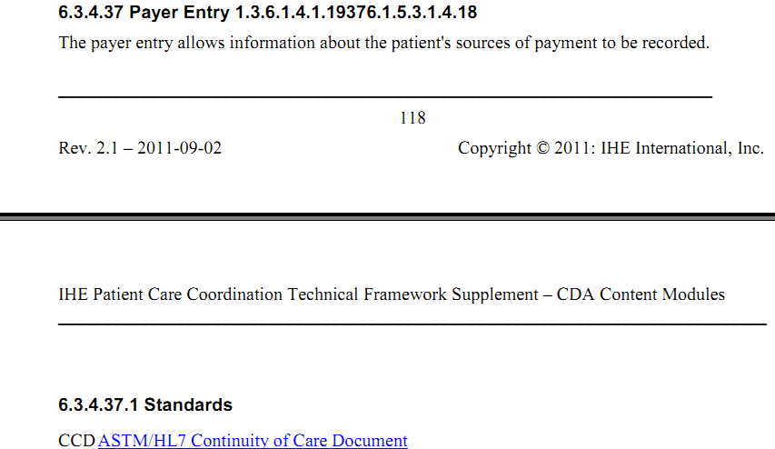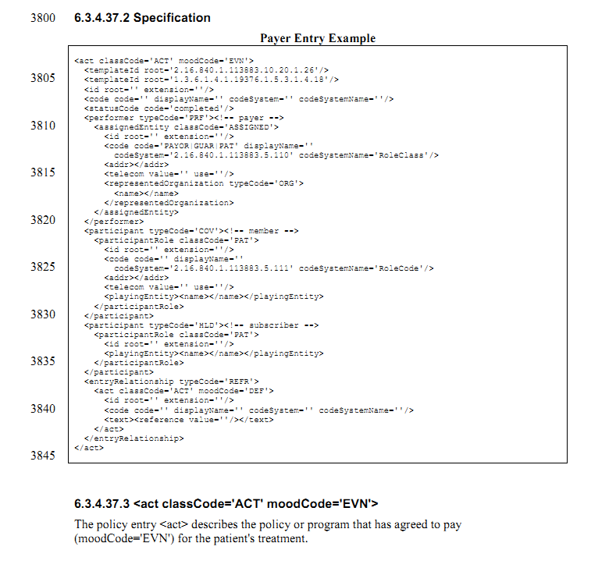

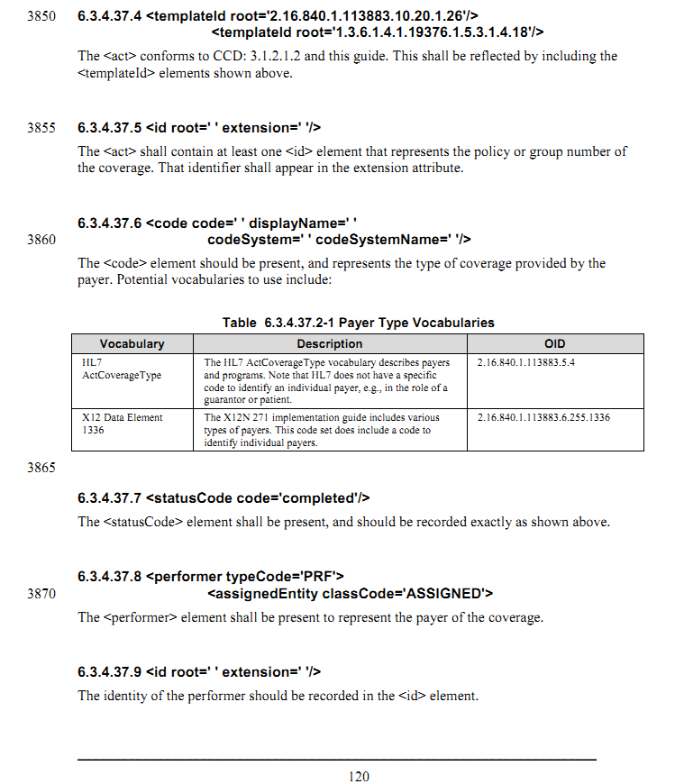 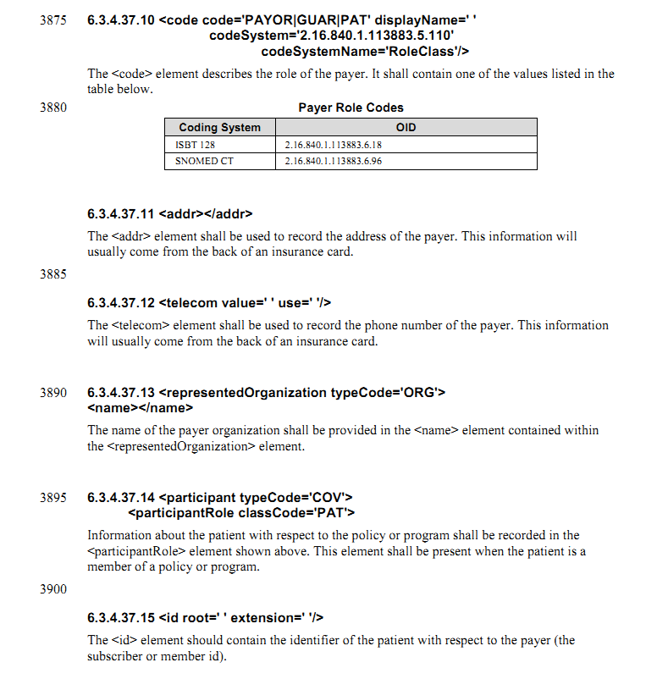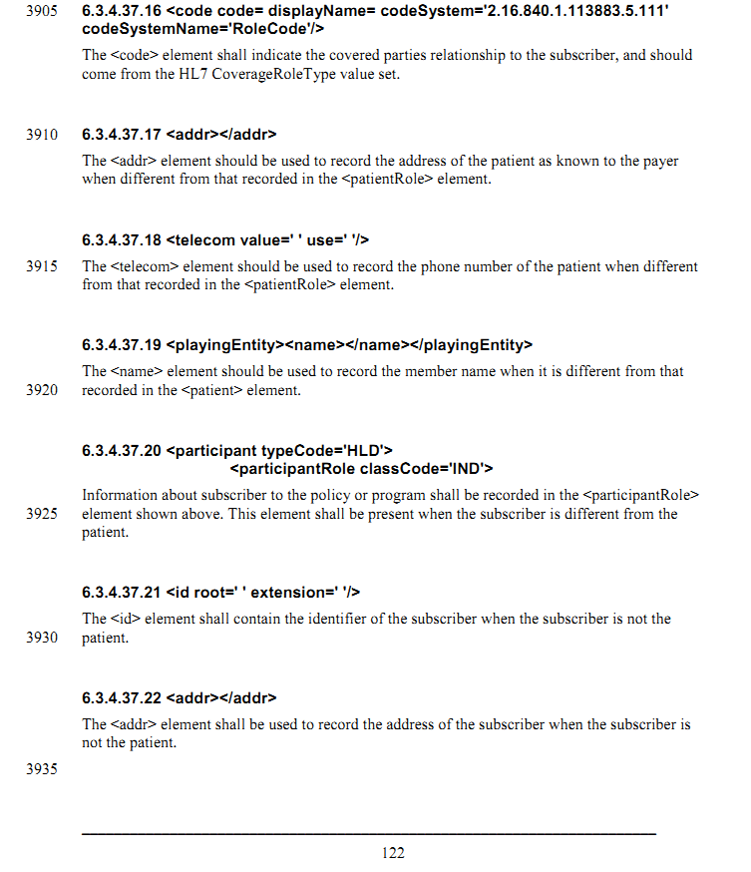

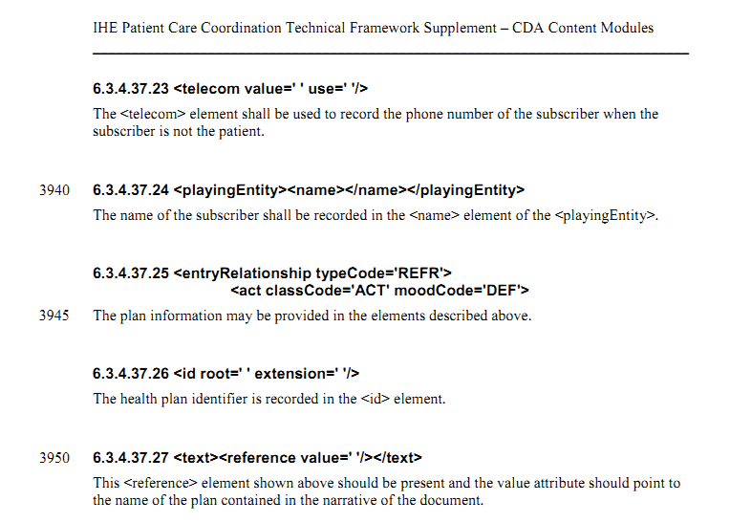

因此 得出结论

我们数据元大致可以分为3类，

支付方式和结算方式

住院/门诊费用类型代码/名称

费用金额

In the section 5.11 Coverage Activity中

NO 2

|  |
| --- |
| SHALL contain exactly one [1..1] @moodCode="EVN" Event (CodeSystem: ActMood 2.16.840.1.113883.5.1001) (CONF:8873). |

Then in the example “Figure 161: Coverage activity example”

|  |
| --- |
| <act classCode="ACT" moodCode="DEF">  <templateId root="2.16.840.1.113883.10.20.22.4.60"/>  <!-- **** Coverage activity template **** -->  <id root="1fe2cdd0-7aad-11db-9fe1-0800200c9a66"/>  <code code="48768-6" codeSystem="2.16.840.1.113883.6.1"  codeSystemName="LOINC" displayName="Payment sources"/>  <statusCode code="completed"/>  <entryRelationship typeCode="COMP">  <act classCode="ACT" moodCode="EVN">  <templateId root="2.16.840.1.113883.10.20.22.4.61"/>  <!-- **** Policy Activity template **** -->  ...  </act>  </entryRelationship>  </act> |

At the same time in the 4.37 section

The example provided is as follows

|  |
| --- |
| <section>  <templateId root="2.16.840.1.113883.10.20.22.2.18"/>  <!-- ******** Payers section template ******** -->  <code code="48768-6" codeSystem="2.16.840.1.113883.6.1"  codeSystemName="LOINC" displayName="Payments"/>  <title>Insurance Providers</title>  <text>  <table border="1" width="100%">  <thead>  <tr>  <th>Payer name</th>  <th>Policy type / Coverage type</th>  <th>Policy ID</th>  <th>Covered party ID</th>  <th>Policy Holder</th>  </tr>  </thead>  <tbody>  <tr>  <td>Good Health Insurance</td>  <td>Extended healthcare / Family</td>  <td>Contract Number</td>  <td>1138345</td>  <td>Patient's Mother</td>  </tr>  </tbody>  </table>  </text>  <entry typeCode="DRIV">  <act classCode="ACT" moodCode="DEF">  <templateId root="2.16.840.1.113883.10.20.22.4.60"/>  <!-- **** Coverage entry template **** -->  ...  </act>  </entry>  </section> |

Is this just a typographical error? Or I think the DEF is more appropriate for this case .

OK there is something missing in the 5.39 section

1.

In Table 200:Under Contains Entries: add Authorization Activity2.policy activity template:

|  |  |  |  |  |  |  |
| --- | --- | --- | --- | --- | --- | --- |
| health Insurance Type | code | 0..1 | SHOULD | CE | 8904 | 2.16.840.1.113883.3.88.12.3221.5.2 (Health Insurance Type Value Set) |

But in the example

|  |
| --- |
| <code code="SELF" codeSystemName="HL7 RoleClassRelationship" codeSystem="2.16.840.1.113883.5.110"> |

I do believe this code represent the policy/contract type which the subscriber has with the insurance company or other organizations.

3 in this template:

|  |  |  |  |  |  |  |
| --- | --- | --- | --- | --- | --- | --- |
| payer | assignedEntity | 1..1 | SHALL |  | 8908 |  |
| healthPlan Insurance Information SourceId | id | 1..* | SHALL | II | 8909 |  |
|  | code | 0..1 | SHOULD | CE | 8914 |  |
|  | code | 1..1 | SHALL | CE | 8915 | 2.16.840.1.113883.1.11.10416 (HL7FinanciallyResponsiblePartyType) |

In the example

|  |
| --- |
| <code code="PAYOR" codeSystem="2.16.840.1.113883.5.111" codeSystemName="HL7 RoleCode"/> |

What does this mean?

to me, HL7FinanciallyResponsibleParty is to define the role type payer(who really pay for the expense, for example, an insurance company or self-pay ) playing.

4.

|  |  |  |  |  |  |  |
| --- | --- | --- | --- | --- | --- | --- |
| member Information | @typeCode | 1..1 | SHALL |  | 8917 | 2.16.840.1.113883.5.90 (HL7ParticipationType) = COV |
| healthPlan CoverageDates | time | 0..1 | SHOULD | IVL<TS> | 8918 |  |
|  | low | 0..1 | SHOULD | TS | 8919 |  |
|  | high | 0..1 | SHOULD | TS | 8920 |  |
| patient | participantRole | 1..1 | SHALL |  | 8921 |  |
| memberId | id | 1..* | SHALL | II | 8922 |  |
|  | code | 0..1 | SHOULD | CE | 8923 |  |
| patient Relationship ToSubscriber | code | 1..1 | SHALL |  | 8924 | 2.16.840.1.113883.1.11.18877 (Coverage Role Type Value Set) |

|  |
| --- |
| <!-- Health plan ID for patient. -->  <code code="SELF" codeSystem="2.16.840.1.113883.5.111" displayName="Self"/> |

This really confused me. This template try to deliver the information the person A make a contact/policy (pay money to B)with company B, then C is falling ill and B is paying for C ,

and this code is to describe the relationship between person A and C

but when I came to Coverage Type Value Set ,is there another value set for Coverage Role Type Value Set

the following value set obviously describe the policy type or contact type.

Table : Coverage Type Value Set

| **Value Set: Coverage Role Type Value Set 2.16.840.1.113883.1.11.18877 DYNAMIC** | | |
| --- | --- | --- |
| **Code System(s):** | **RoleCode 2.16.840.1.113883.5.111** | |
| Code | Code System | Print Name |
| **FAMDEP** | **RoleCode** | **Family dependent** |
| **FSTUD** | **RoleCode** | **Full-time student** |
| **HANDIC** | **RoleCode** | **Handicapped dependent** |
| **INJ** | **RoleCode** | **Injured plaintiff** |
| **PSTUD** | **RoleCode** | **Part-time student** |
| **SELF** | **RoleCode** | **Self** |
| **SPON** | **RoleCode** | **Sponsored dependent** |
| **STUD** | **RoleCode** | **Student** |

But still the same problem, if all of this is OK, it still could not solve the problem. We could solve the policy type of the subscriber make with a insurance company, the relationship between subscriber and the patient who benefit from the policy. but How much money does the payer pay for patient? How to describe The expense of patient and the exact healthcare service type producing the expense ?

HDSD00.01.019 DE05.01.022.00 药物过敏史标志

HDSD00.01.020 DE05.01.022.00 药物过敏源.

在国标中进行了搜索之后，只有个人基本信息中出现了这两个数据元 亦并没有关于过敏症状、开始日期等的详细描述的数据元

参考标准

CCD

PCC

HITSP C83 C154

在HISTP V1.0.1 2010C154中，第20页，2.1.2.6

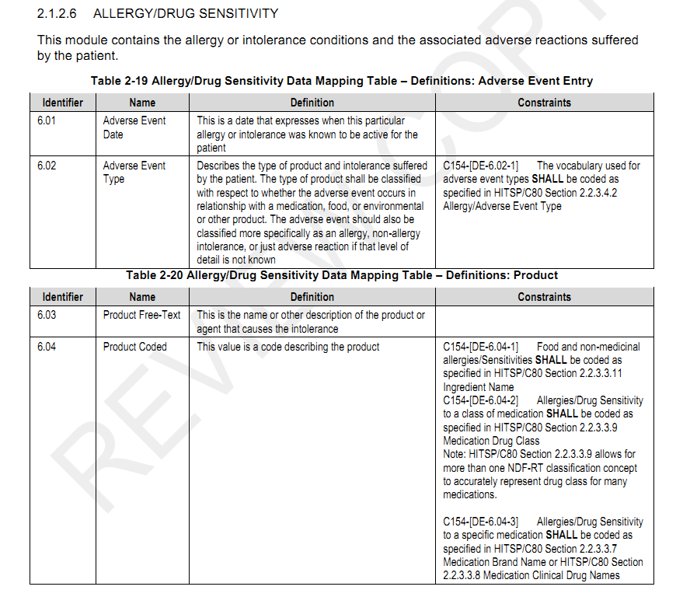

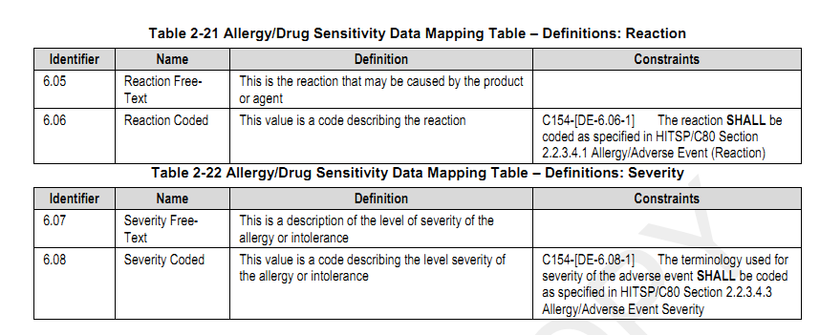

在HITSP_V2.0 2010C83中，第16页 2.2.1.2

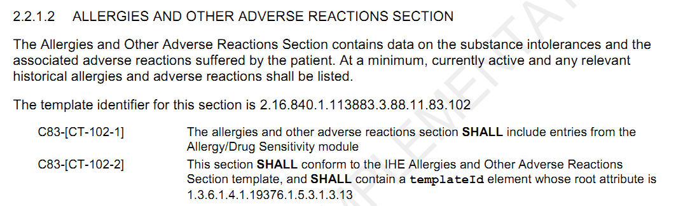

第44页 关于过敏的条目模板

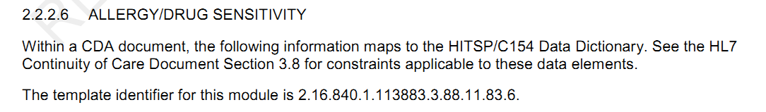

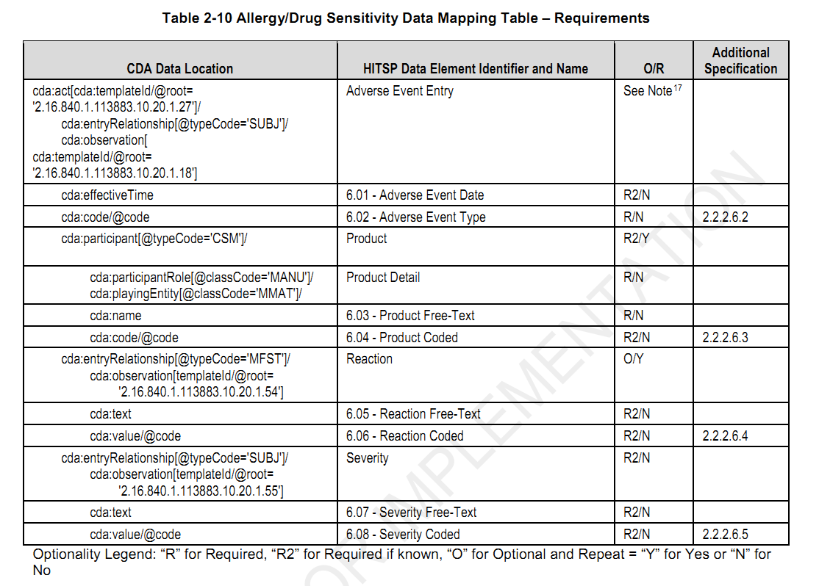

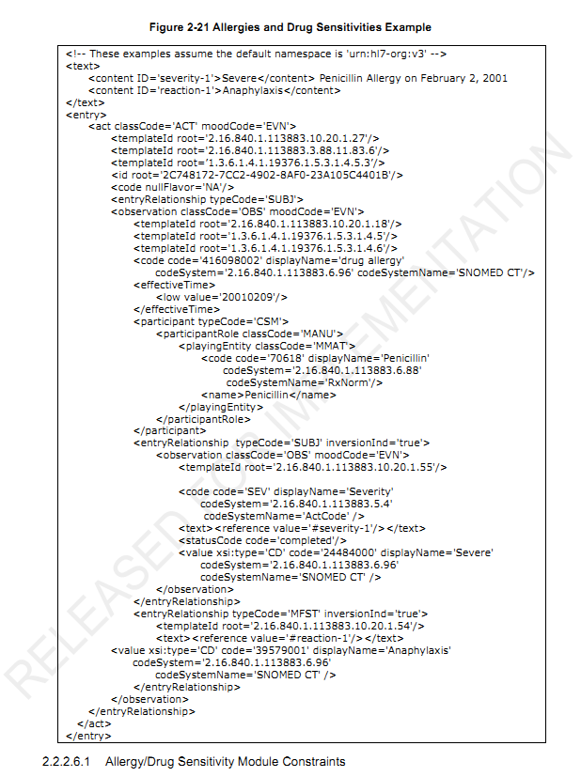

既往疾病史

涉及数据元

HDSD00.01.022 DE02.10.021.00 既往患病种类代码 本人既往所患疾病种类的代码

HDSD00.01.023 DE05.01.035.00 既往患病确诊日期 对本人既往所患疾病作出明确诊断的公元纪年日期

参考标准

HITSP V2.0 2010 C83

HL7 History and Physical Note and HL7 Consultation Note implementation guide

IHE Patient Care Coordination (PCC) Technical Framework Volume 2 Revision 6.0 2010 0830

在HITSP V2.0 2010 C83第16页

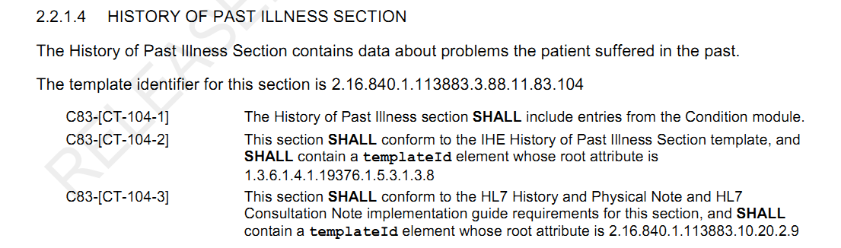

其中提到condition entry出现在47页

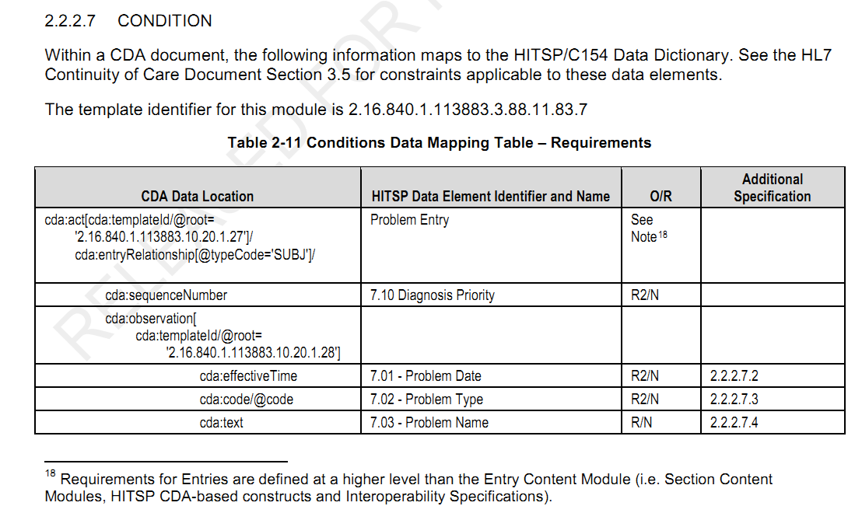

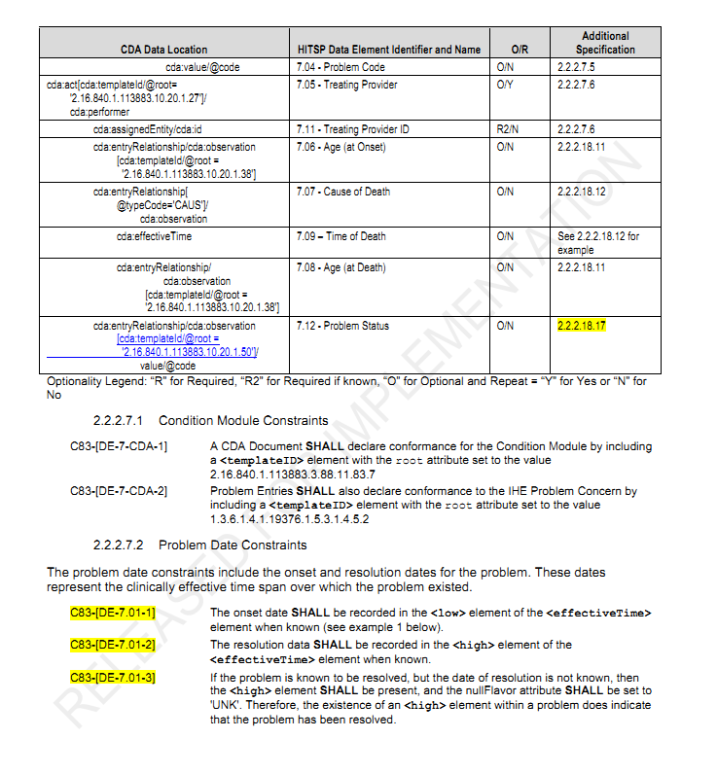

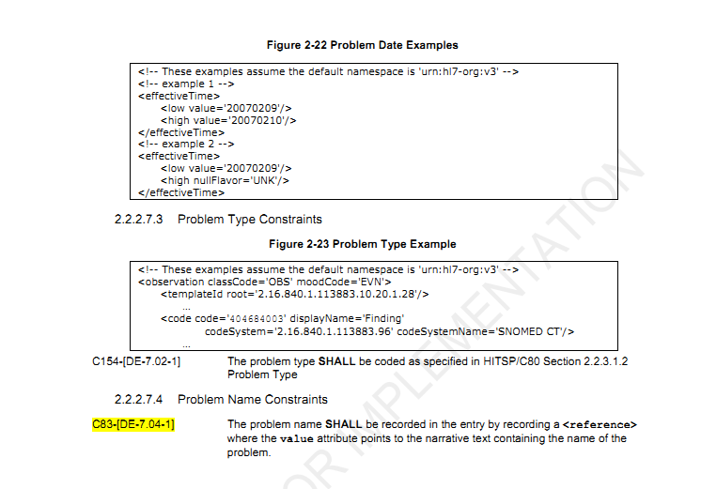

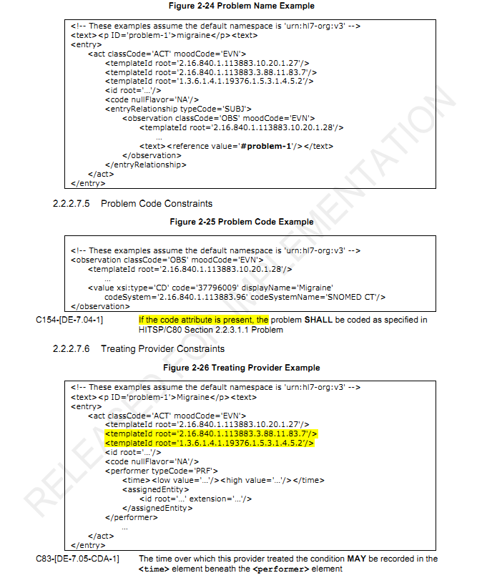 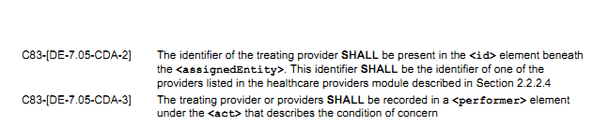

如上涉及的数据元如下

出现在HITSP C154 第21页

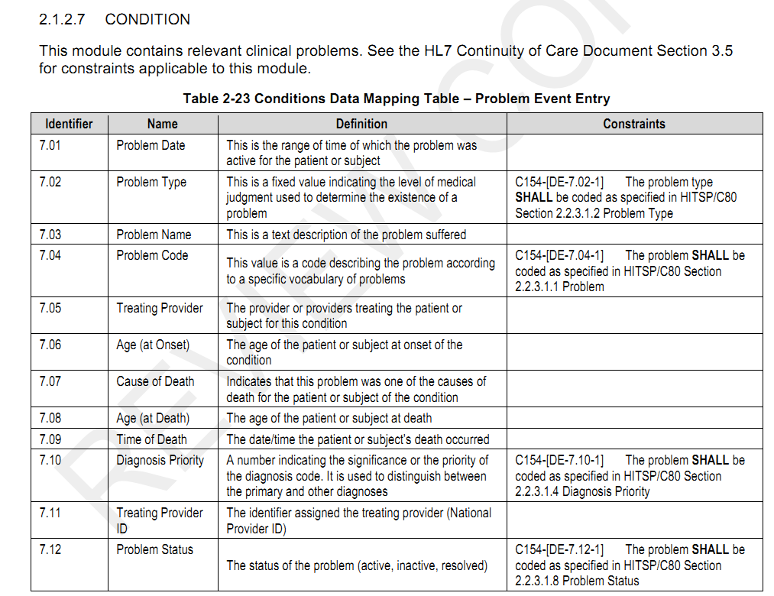

在IHE PCC第82页，

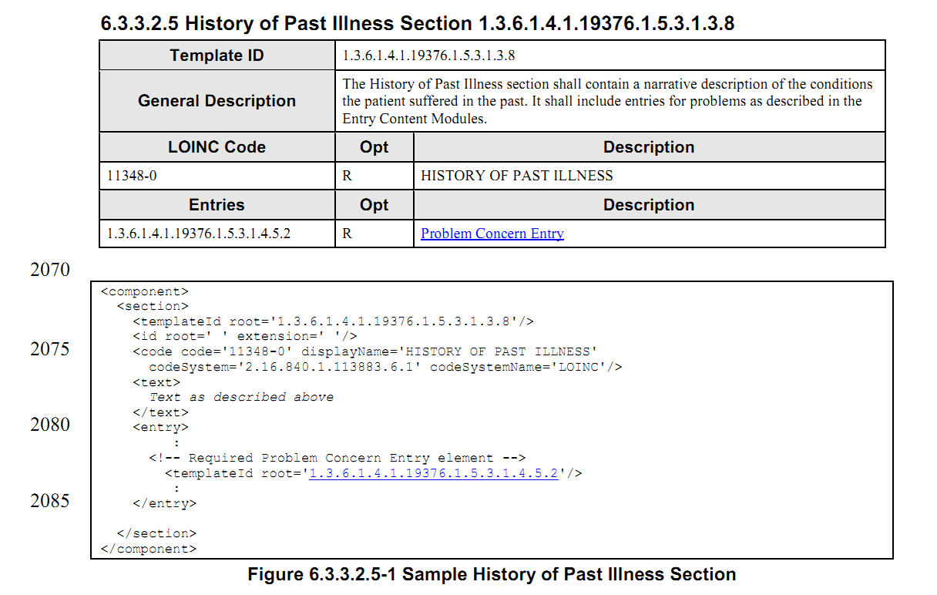

其中所出现的problem concern entry则出现在152页

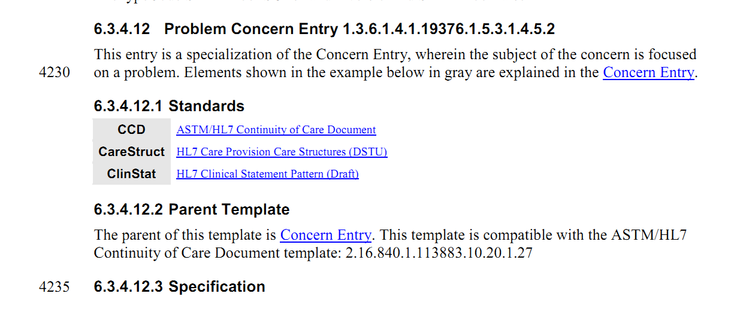

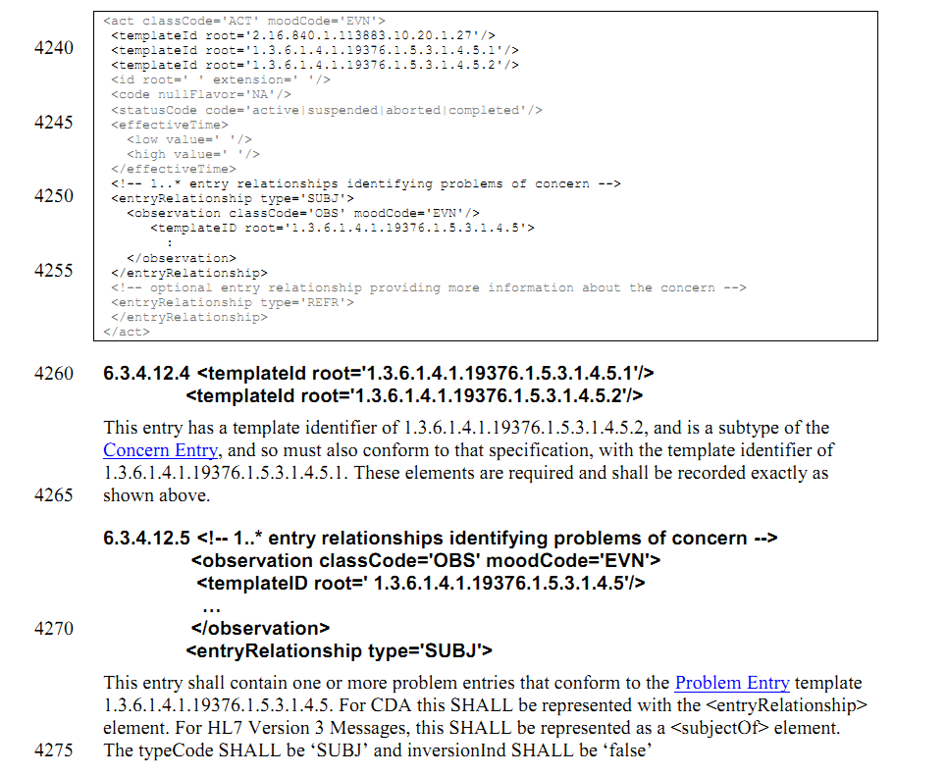

上面提到的problem entry如下 出现在154页中

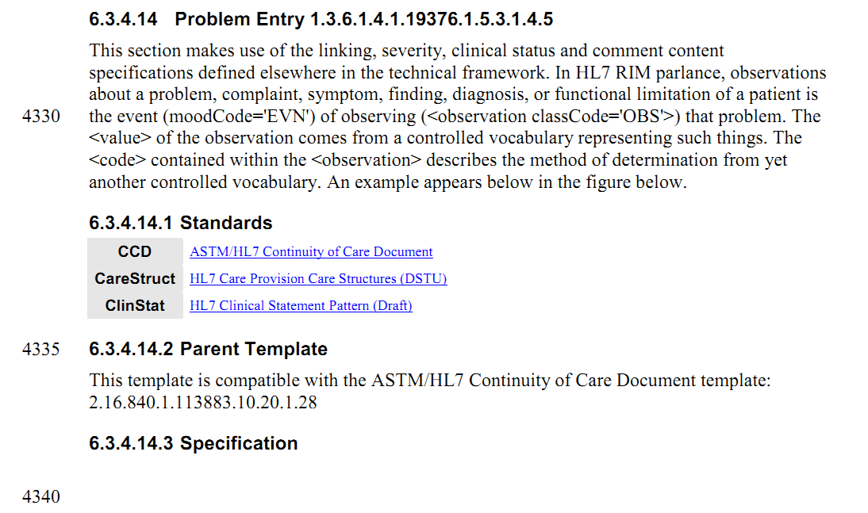

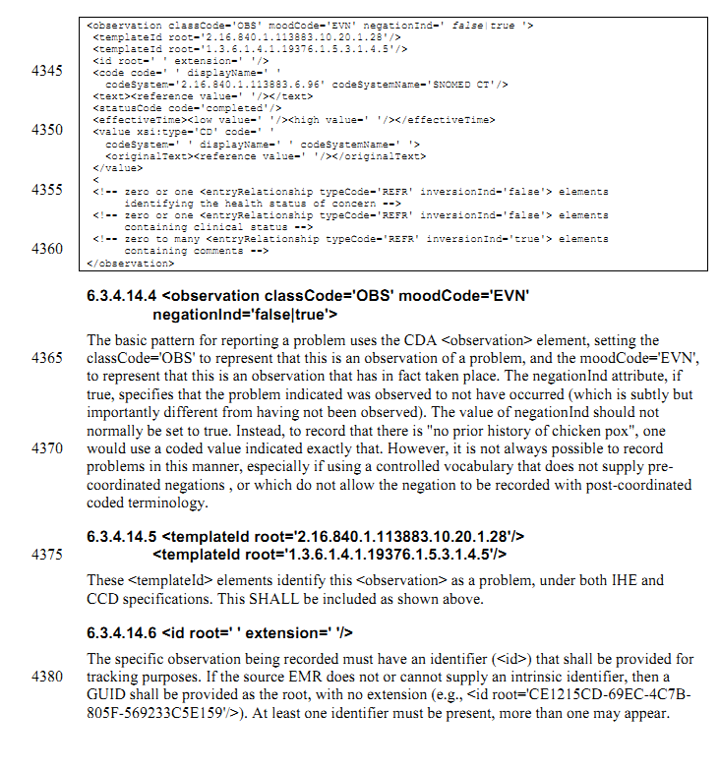

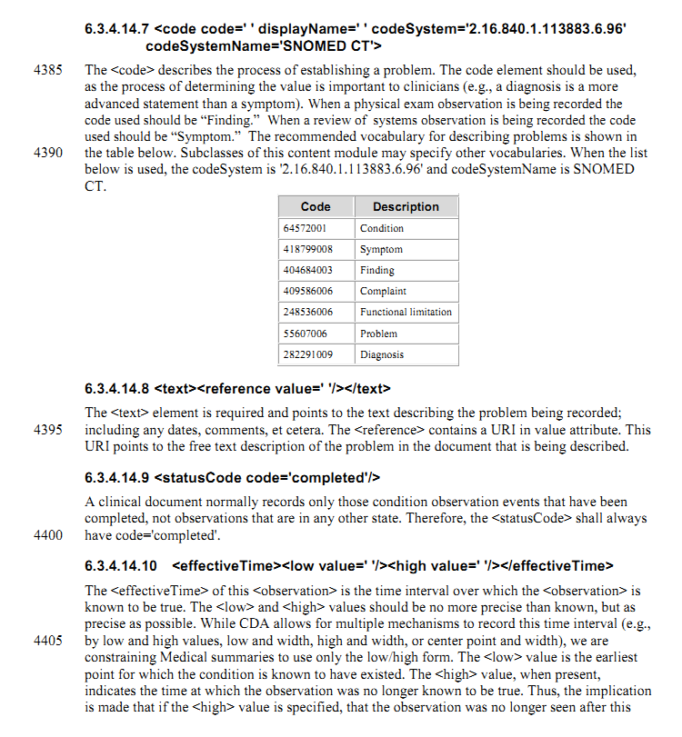 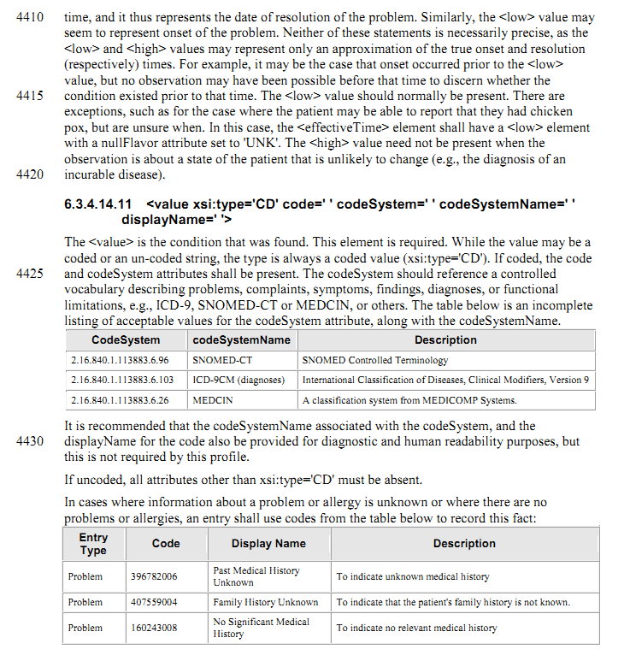

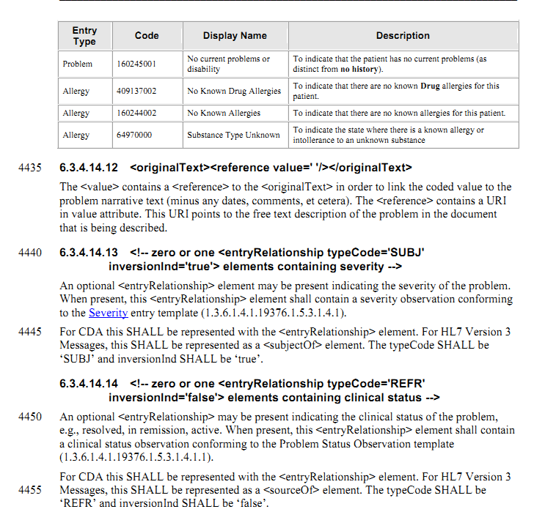 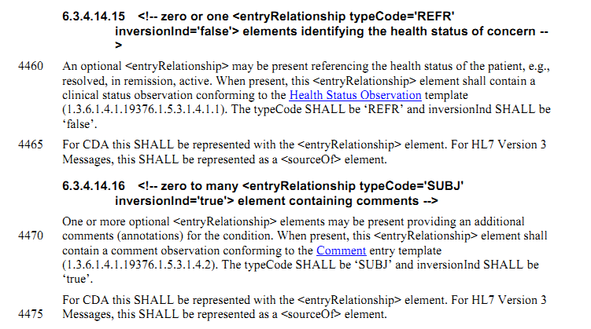

在History and physical notes 第44页

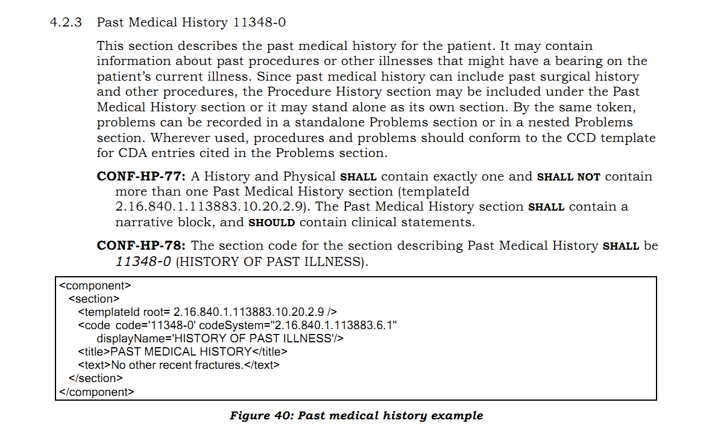

在HL7 Implementation Guide for CDA R2 Consultation Notes – (U.S. Realm)第33页中

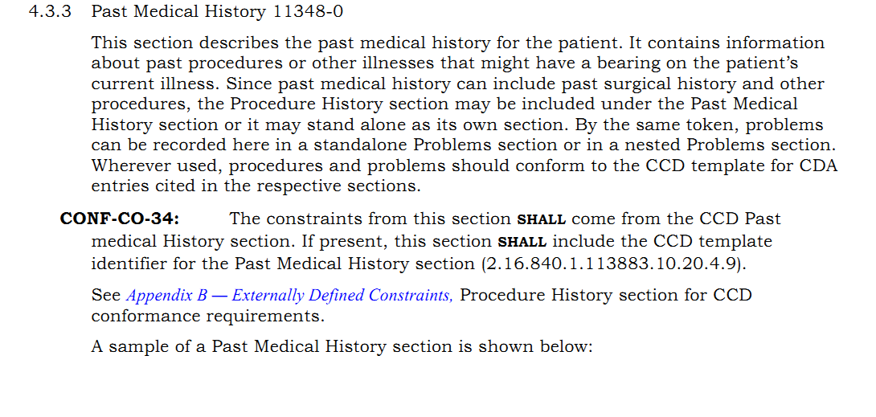

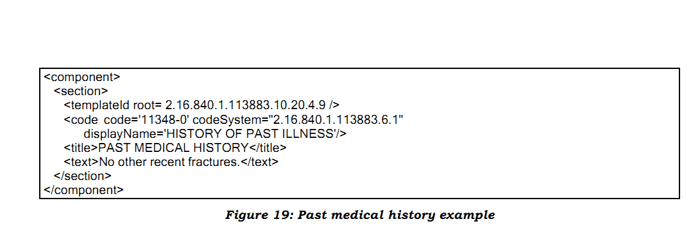

此2个数据元用history of past illness章节来表示

关于问题条目

CCD中对应problem act

A problem is a clinical statement that a clinician is particularly concerned about and wants to track. It has important patient management use cases (e.g. health records often present the problem list as a way of summarizing a patient`s medical history)

Note: the HL7 Patient Care Technical Committee is developing a formal model for condition tracking. In that model, observations of problems or other clinical statements captured at a point in time are wrapped in a “Concern” act which represents the ongoing process tracked over time. This allows for binding related observations of problems. For example, the observation of “Acute MI” in 2004, can be related to the observation of “History of MI” in 2006 because they are the same concern. The conformance statements in this section are compatible with the evolving Patient Care model and define an outer “problem act”（representing the “Concern”）which can contain a nested “problem observation” or other nested clinical statements.

根据上面的论述就出现了CCD中将condition tracking相关信息记录在problem act和problem observation条目中的情况

再来看看IHE

在6.3.3.2.5中

The History of Past Illness section shall contain a narrative description of the conditions

the patient suffered in the past. It shall include entries for problems as described in the

Entry Content Modules.

说既往病史是对患者既往健康状况的描述。而其条目模板直接就是

1.3.6.1.4.1.19376.1.5.3.1.4.5.2 R Problem Concern Entry

Problem Concern Entry 是个什么样的条目呢

6.3.4.12中如下描述

This entry is a specialization of the Concern Entry, wherein the subject of the concern is focused

on a problem. Elements shown in the example below in gray are explained in the Concern Entry.

说Problem Concern Entry是Concern Entry的一个子类，Concern关注的对象只是problem。

也就是说Concern关注的对象可以不只是problem。

引

|  |
| --- |
| 4330  In HL7 RIM parlance, observations  about a problem, complaint, symptom, finding, diagnosis, or functional limitation of a patient is  the event (moodCode='EVN') of observing (<observation classCode='OBS'>) that problem. The  <value> of the observation comes from a controlled vocabulary representing such things. The  <code> contained within the <observation> describes the method of determination from yet  another controlled vocabulary. An example appears below in the figure below.  The <code> describes the process of establishing a problem. The code element should be used,  as the process of determining the value is important to clinicians (e.g., a diagnosis is a more  advanced statement than a symptom). When a physical exam observation is being recorded the  code used should be “Finding.” When a review of systems observation is being recorded the code used should be “Symptom.” The recommended vocabulary for describing problems is shown in the table below. Subclasses of this content module may specify other vocabularies. When the list below is used, the codeSystem is '2.16.840.1.113883.6.96' and codeSystemName is SNOMED CT. |

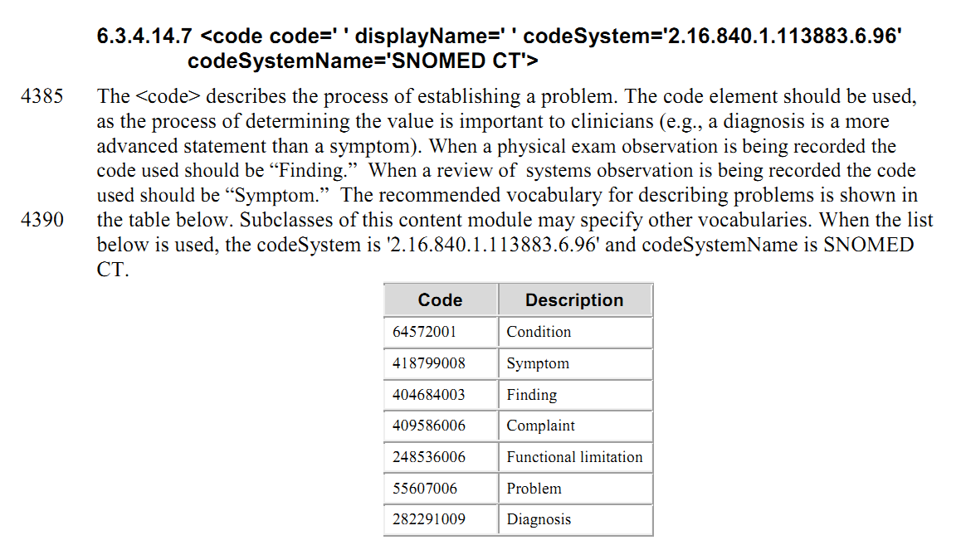

再来看看IHE中的Concern Entry是怎么样规定的

6.3.4.11中 可以看出这里的concern借用了HL7 Patient Care Technical Committee定义模型中的”Concern”，concern关注的对象可以是疾病problem、耐受不良/过敏allergy 或其他。

This event (moodCode='EVN') represents an act (<act classCode='ACT') of being concerned about a problem, allergy or other issue. The <effectiveTime> element describes the period of concern. The subject of concern is one or more observations about related problems (see 1.3.6.1.4.1.19376.1.5.3.1.4.5.2) or allergies and intolerances (see 1.3.6.1.4.1.19376.1.5.3.1.4.5.3). Additional references can be provided having additional information related to the concern. The concern entry allows related acts to be grouped. This allows representing the history of a problem as a series of observation over time, for example.

接着看看HITSP C83里面是怎么处理既往病史的

2.2.1.4中 既往病史包含病人过去所患疾病的信息

The History of Past Illness Section contains data about problems the patient suffered in the past.

其中提到应包含Condition模块中的条目

那么condition模块又是什么样的呢

找到2.2.2.7 Condition

Within a CDA document, the following information maps to the HITSP/C154 Data Dictionary. See the HL7 Continuity of Care Document Section 3.5 for constraints applicable to these data elements.

也就是说HITSP C154数据字典中规定的Condition模块所包含的数据元均使用此条目模板来表达。

在这里又与CCD的problem act结合起来。

问题：如何处理标志位的问题 没有的情况该如何处理

为了去理解concern

查阅V3标准文件 在Patient care域找到了如下的描述。

html/domains/uvpc/uvpc.html

|  |
| --- |
| In the context of HL7, a "Concern" is worry about a state or process that has the potential to require intervention or management. A problem list is an example of a list of concerns. |

也就是说concern其实就是说 对可能需要进行干预或者管理的一种状态或者过程的担心关心。

|  |
| --- |
| A problem list is an example of a list of concerns.  For example, diabetes may be on the problem list. However, the scope of responsibility for an endocrinologist might be only the diabetes and not the other problems. Diabetes is then identified as the reason for the Care Provision. The expectation of the endocrinologist may only include recommendations for a modification to the diabetes care plan. This specific diabetes care plan modification is then a component of the Care Provision scope of responsibility. |

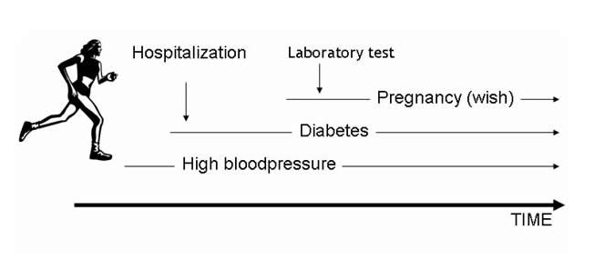

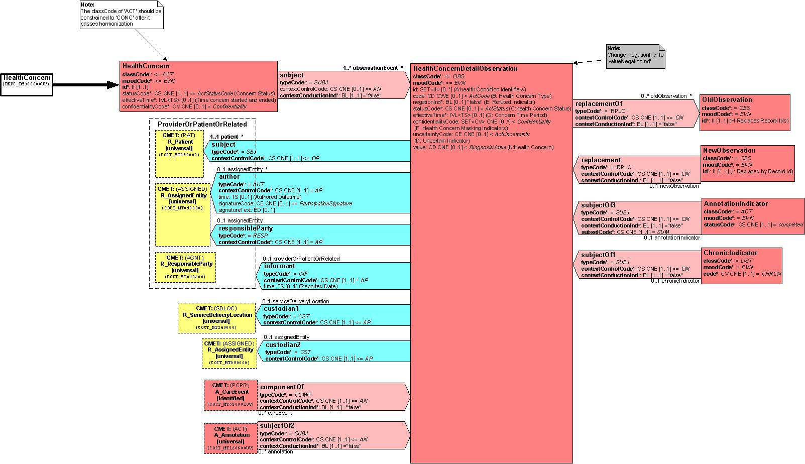但problem是什么呢？

在<如何教书写好的病历>台大医院病历室 吴宽墩

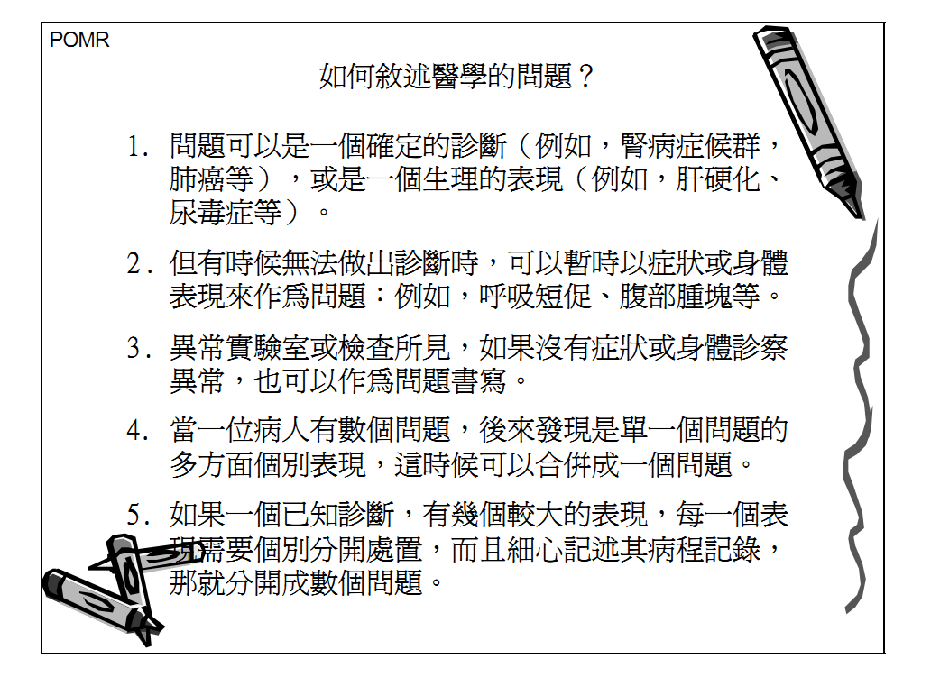

|  |  |  |  |
| --- | --- | --- | --- |
| HDSD00.01.024 | DE02.10.062.00 | 手术史标志 | 标识本人既往有无手术经历 |
| HDSD00.01.025 | DE02.10.061.00 | 手术史 | 对本人既往接受手术操作详细情况的描述 |
| HDSD00.01.026 | DE06.00.095.00 | 手术操作日期时间 | 对本人实施手术操作时的公元纪年日期时间 |

参考标准

IHE

CCD

HITSP C83 C80 C154

台湾IG

澳大利亚IG

首先，在HITSP C154中

2.1.2.17中有PROCEDURE模块，

|  |
| --- |
| This module contains a coded entry indicating a procedure performed on a patient. |

由此可以看出此模块包含的是病人所有做过的手术/操作(范围更广)

详细查看，有哪些数据元呢。

包括操作编号、操作代码、操作具体描述、操作的日期时间、操作的提供者、身体部位。

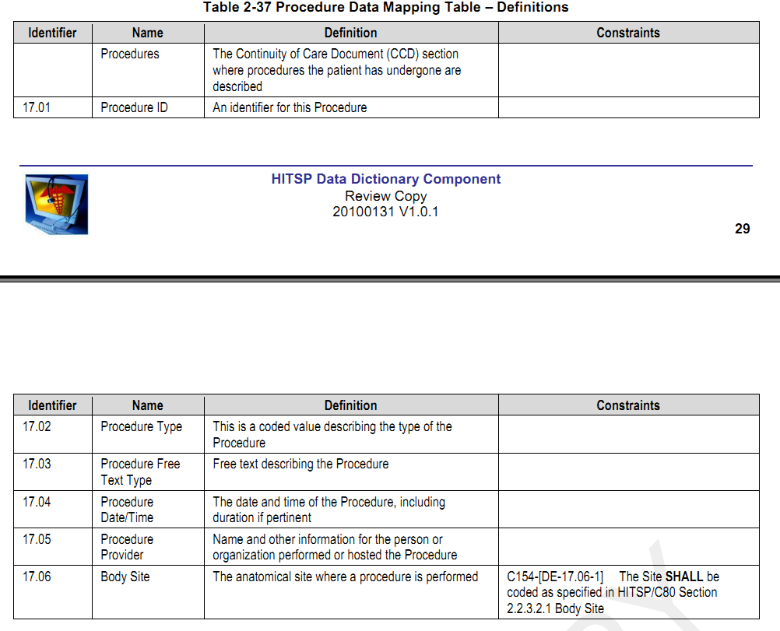

在CCD中

3.14 Procedures

|  |
| --- |
| This section defines all interventional, surgical, diagnostic, or therapeutic procedures or treatments pertinent to the patient historically at the time the document is generated. The section may contain all procedures for the period of time being summarized, but should include notable procedures.  NOTE :  ASTM CCR’s notion of “procedure” is broader than that specified by the HL7 Version 3 Reference Information Model (RIM). Therefore this section uses several RIM classes (Act, Observation, Procedure) to represent CCR’s procedure objects. |

在IHE PCC中

6.3.3.2.9

List of Surgeries Section 1.3.6.1.4.1.19376.1.5.3.1.3.11 继承了CCD 3.14

其中这样描述此章节

病人既往接受的诊断性和治疗性手术过程和相关的麻醉技术的叙述。

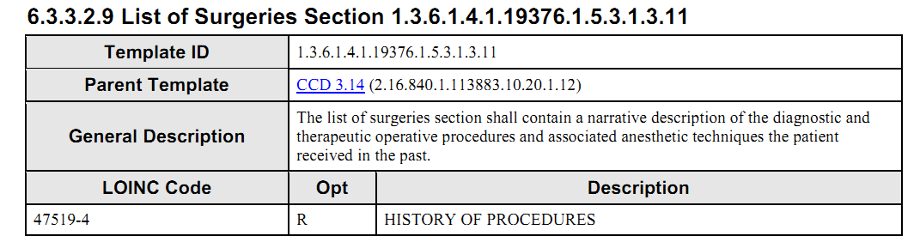

6.3.3.2.10

Coded List of Surgeries Section 1.3.6.1.4.1.19376.1.5.3.1.3.12

可以看出它可以表示手术以及手术报告的引用等信息

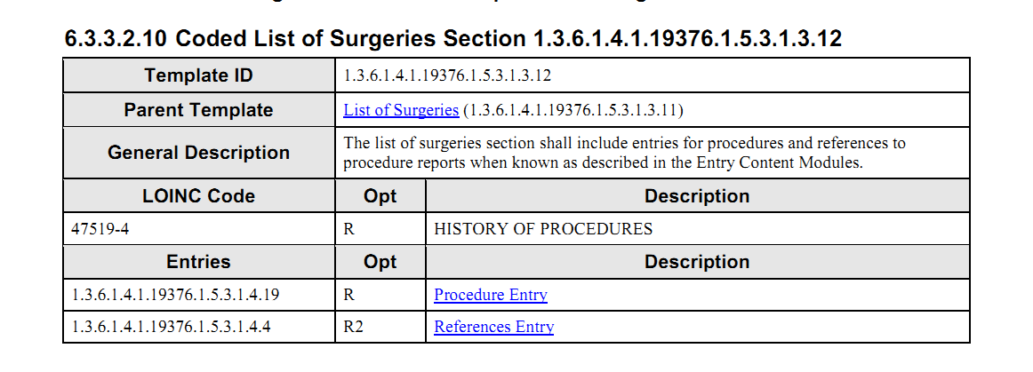

上图中1.3.6.1.4.1.19376.1.5.3.1.4.19 procedure entry在PCC中找不到，

|  |
| --- |
| Procedure Entry 1.3.6.1.4.1.19376.1.5.3.1.4.19  The procedure entry is used to record procedures that have occured, or which are planned for in the future.  Standards  CCD ASTM/HL7 Continuity of Care Document  Uses  See Templates using Procedure Entry  Specification  Procedure Entry Example <procedure classCode='PROC' moodCode='EVN|INT'>  <templateId root='1.3.6.1.4.1.19376.1.5.3.1.4.19'/>  <templateId root='2.16.840.1.113883.10.20.1.29'/><!-- see text of section 0 -->  <templateId root='2.16.840.1.113883.10.20.1.25'/><!-- see text of section 0 -->  <id root='' extension=''/>  <code code='' codeSystem='2.16.840.1.113883.5.4' codeSystemName='ActCode' />  <text><reference value='#xxx'/></text>  <statusCode code='completed|active|aborted|cancelled'/>  <effectiveTime>  <low value=''/>  <high value=''/>  </effectiveTime>  <priorityCode code=''/>  <approachSiteCode code='' displayName='' codeSystem='' codeSystemName=''/>  <targetSiteCode code='' displayName='' codeSystem='' codeSystemName=''/>  <author />  <informant />  <entryRelationship typeCode='COMP' inversionInd='true'>  <act classCode='ACT' moodCode=''>  <templateId root='1.3.6.1.4.1.19376.1.5.3.1.4.4.1'/>  <id root='' extension=''/>  </act>  </entryRelationship>  <entryRelationship typeCode='RSON'>  <act classCode='ACT' moodCode='EVN'>  <templateId root='1.3.6.1.4.1.19376.1.5.3.1.4.4.1'/>  <id root='' extension=''/>  </act>  </entryRelationship>  </procedure>    <procedure classCode='PROC' moodCode='EVN|INT'>  This element is a procedure. The classCode shall be 'PROC'. The moodCode may be INT to indicated a planned procedure or EVN, to  describe a procedure that has already occurred.  <templateId root='1.3.6.1.4.1.19376.1.5.3.1.4.19'/>  The templateId indicates that this <procedure> entry conforms to the constraints of this content module. NOTE: When the  procedure is in event mood (moodCode='EVN'), this entry conforms to the CCD template 2.16.840.1.113883.10.20.1.29, and when in  intent mood, this entry conforms to the CCD template 2.16.840.1.113883.10.20.1.25.  <id root=' ' extension=' '/>  This required element shall contain an identifier for the procedure. More than one procedure identifier may be present.  <code code=' ' displayName=' ' codeSystem=' ' codeSystemName=' ' />  This element shall be present, and should contain a code describing the type of procedure.  <text><reference value='#xxx'/></text>  The <text> element shall contain a reference to the narrative text describing the procedure.  <statusCode code='completed|active|aborted|cancelled'/>  The <statusCode> element shall be present when used to describe a procedure event. It shall have the value 'completed' for  procedures that have been completed, and 'active' for procedures that are still in progress. Procedures that were stopped prior  to completion shall use the value 'aborted', and procedures that were cancelled before being started shall use the value  'cancelled'.  <effectiveTime><low value=' '/><high value=' '/></effectiveTime>  This element should be present, and records the time at which the procedure occurred (in EVN mood), or the desired time of the  procedure in INT mood.  <priorityCode code=' '/>  This element shall be present in INT mood when effectiveTime is not provided, it may be present in other moods. It indicates  the priority of the procedure.  <approachSiteCode code=' ' displayName=' ' codeSystem=' ' codeSystemName=' '/>  This element may be present to indicate the procedure approach.  <targetSiteCode code=' ' displayName=' ' codeSystem=' ' codeSystemName=' '/>  This element may be present to indicate the target site of the procedure.  <entryRelationship typeCode='COMP' inversionInd='true'>  This element may be present to point the encounter in which the procedure was performed, and shall contain an internal  reference to the encounter. See Internal References for more details.  <entryRelationship typeCode='RSON'>  A <procedure> act may indicate one or more reasons for the procedure. These reasons identify the concern that was the reason  for the procedure via an Internal Reference to the concern. The extension and root of each observation present must match the  identifier of a concern entry contained elsewhere within the CDA document. |

在HITSP C83中，

2.2.1.8

此章节描述病人所接受的手术。

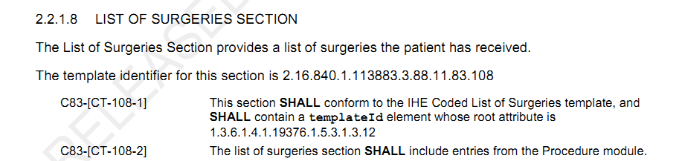

父模板是IHE的 coded list of surgeries

其中提到的entry模板如下；

2.2.2.17

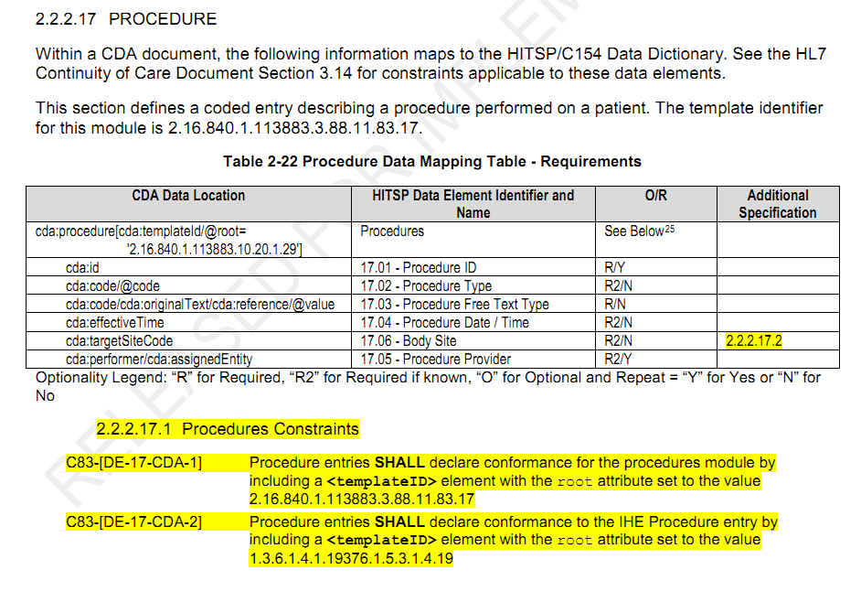

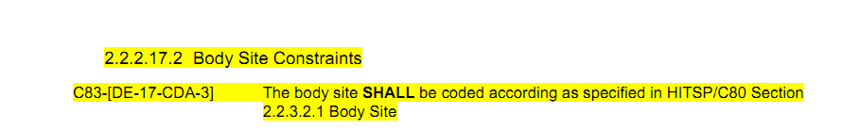

此模块表达了C154 Procedure模块所涉及的数据元。

在HL7 V3 RIM中

PROCEDURE的定义为

引用自HL7 V3 Ballot

|  |
| --- |
| Definition of Procedure:  An Act whose immediate and primary outcome (post-condition) is the alteration of the physical condition of the subject.  UsageNotes:  Applied to clinical medicine, procedure is but one among several types of clinical activities such as observation, substance-administrations, and communicative interactions (e.g. teaching, advice, psychotherapy, represented simply as Acts without special attributes). Procedure does not subsume those other activities nor is Procedure subsumed by them. Notably Procedure does not comprise all Acts of whose intent is intervention or treatment. Whether the bodily alteration is appreciated or intended as beneficial to the subject is likewise irrelevant: what counts is that the Act is essentially an alteration of the physical condition of the subject. |

这种情况下可以理解为只表示surgical procedure外科手术。

在SNOMED CT中 procedure定义为

引自Principles of Health Interoperability HL7 and SNOMED

|  |
| --- |
| In SNOMED CT the definition of a procedure is broader than the definition in the HL7 RIM. In SNOMED a procedure is broadly defined as including any type of action done intentionally as part of the process of delivering health care, including history taking, physical examination, testing, imaging, surgical procedures, disease-specific training and education, counseling, and administrative procedures (in HL7, the term procedure is limited in the main to surgical procedures). |

在HL7 V3 RIM中Observation的定义为

|  |
| --- |
| Definition of Observation:  An act that is intended to result in new information about a subject.  UsageNotes:  The main difference between Observations and other Acts is that Observations have a value attribute. The code attribute of Observation and the value attribute of Observation must be considered in combination to determine the semantics of the observation.  Structurally, many observations are name-value-pairs, where the Observation.code (inherited from Act) is the name and the Observation.value is the value of the property. Such a construct is also known as a "variable" (a named feature that can assume a value); hence, the Observation class is always used to hold generic name-value-pairs or variables, even though the variable valuation may not be the result of an elaborate observation method. It may be a simple answer to a question or it may be an assertion or setting of a parameter.  As with all Act statements, Observation statements describe what was done, and in the case of Observations, this includes a description of what was actually observed ("results" or "answers"); and those "results" or "answers" are part of the observation and not split off into other objects.  The method of action is asserted by the Observation classCode or its subclasses at the least granular level, by the Observation.code attribute value at the medium level of granularity, and by the attribute value of observation.methodCode when a finer level of granularity is required. The method in whole or in part may also appear in the attribute value of Observation.value when using coded data types to express the value of the attribute. Relevant aspects of methodology may also be restated in value when the results themselves entail a methodology.  An observation may consist of component observations each having their own Observation.code and Observation.value. In this case, the composite observation may not have an Observation.value for itself. For instance, a white blood cell count consists of the sub-observations for the counts of the various granulocytes, lymphocytes and other normal or abnormal blood cells (e.g., blasts). The overall white blood cell count Observation itself may therefore not have a value by itself (even though it could have one, e.g., the sum total of white blood cells). Thus, as long as an Act is essentially an Act of recognizing and noting information about a subject, it is an Observation, regardless of whether it has a simple value by itself or whether it has sub-observations.  Even though observations are professional acts (see Act) and as such are intentional actions, this does not require that every possible outcome of an observation be pondered in advance of it being actually made. For instance, differential white blood cell counts (WBC) rarely show blasts, but if they do, this is part of the WBC observation even though blasts might not be predefined in the structure of a normal WBC.  Clinical documents commonly have 'Subjective' and 'Objective' findings, both of which are kinds of Observations. In addition, clinical documents commonly contain 'Assessments,' which are also kinds of Observations. Thus, the establishment of a diagnosis is an Observation. |

<ftp://ftp.ihe.net/Cardio/Year6-2010-2012/CIRC/CDAR2_IG_PROCNOTE_DSTU_R1_2010JUL.pdf>

|  |  |  |  |
| --- | --- | --- | --- |
| HDSD00.01.025 | DE02.10.061.00 | 手术史 | 对本人既往接受手术操作详细情况的描述 |

对于此处手术操作的理解 应该只是指对身体的物理状态发生改变的行为。

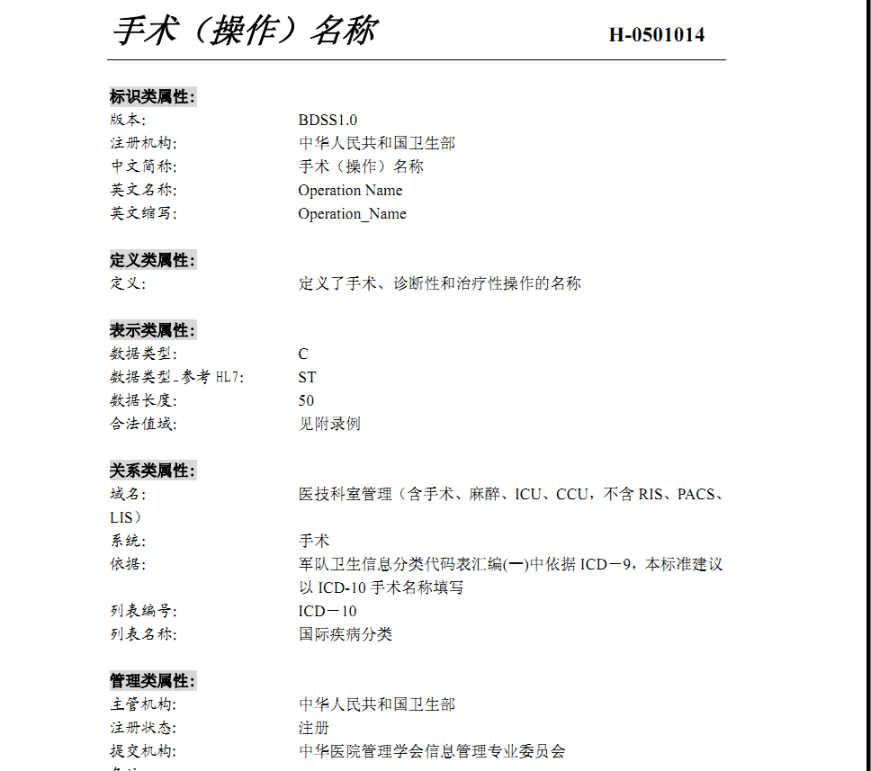

关于标志位的表达

Information technology solutions store and manage data, but sometimes data are not available: an item may be unknown, not relevant, or not computable or measureable. In HL7, a *flavor* of null, or nullFlavor, describes the reason for missing data.

For example, if a patient arrives at an Emergency Department unconscious and with no identification, we would use a null flavor to represent the lack of information. The patient’s birth date would be represented with a null flavor of “NAV”, which is the code for “temporarily unavailable”. When the patient regains consciousness or a relative arrives, we expect to know the patient’s birth date.

Figure : nullFlavor example

<birthTime nullFlavor=”NAV”/> <!--coding an unknown birthdate-->

Use null flavors for unknown, required, or optional attributes:

NI No information. This is the most general and default null flavor.

NA Not applicable. Known to have no proper value (e.g., last menstrual period for a male).

UNK Unknown. A proper value is applicable, but is not known.

ASKU Asked, but not known. Information was sought, but not found (e.g., the patient was asked but did not know).

NAV Temporarily unavailable. The information is not available, but is expected to be available later.

NASK Not asked. The patient was not asked.

MSK There is information on this item available but it has not been provided by the sender due to security, privacy, or other reasons. There may be an alternate mechanism for gaining access to this information.

This above list contains those null flavors that are commonly used in clinical documents. For the full list and descriptions, see the nullFlavor vocabulary domain in the CDA Normative Edition[1].

Any SHALLconformance statement may use nullFlavor, unless the attribute is required or the nullFlavor is explicitly disallowed. SHOULD and MAY conformance statement may also use nullFlavor.

Figure : Attribute required

1. SHALL contain exactly one [1..1] **code/@code**="11450-4" Problem List (CodeSystem: LOINC 2.16.840.1.113883.6.1) (CONF:7878)

or

2**.** SHALL contain exactly one [1..1] **effectiveTime/@value** (CONF:5256).

Figure : Allowed nullFlavors when element is required (with xml examples)

1. SHALL contain at least one [1..*] id

2. SHALL contain exactly one [1..1] code

3. SHALL contain exactly one [1..1] effectiveTime

<entry>

<observation classCode="OBS" moodCode="EVN">

<id nullFlavor="**NI**"/>

<code nullFlavor="**OTH**">

<originalText>New Grading system</originalText>

</code>

<statusCode code="completed"/>

<effectiveTime nullFlavor="**UNK**"/>

<value xsi:type="CD" nullFlavor="NAV">

<originalText>Spiculated mass grade 5</originalText>

</value>

</observation>

</entry>

Figure : nullFlavor explicitly disallowed

1.SHALL contain exactly one [1..1] **effectiveTime** (CONF:5256).

a. SHALL NOT contain [0..0] nullFlavor (CONF:52580).

### Unknown Information

If a sender wants to state that a piece of information is unknown, the following principles apply:

1. If the sender doesn’t know an attribute of an act, that attribute can be null.

Figure : Unknown medication example

<entry>

**<text>patient was given a medication but I do not know what it was</text>**

<substanceAdministration moodCode="EVN" classCode="SBADM">

<consumable>

<manufacturedProduct>

<manufacturedLabeledDrug>

<code **nullFlavor="NI"**/>

</manufacturedLabeledDrug>

</manufacturedProduct>

</consumable>

</substanceAdministration>

</entry>

2. If the sender doesn’t know if an act occurred, the nullFlavor is on the act (detail could include specific allergy, drug, etc.).

Figure : Unkown medication use of anticoagulant drug example

<entry>

<substanceAdministration moodCode="EVN" classCode="SBADM" **nullFlavor="NI">**

**<text>I do not know whether or not patient received an anticoagulant**

**drug</text>**

<consumable>

<manufacturedProduct>

<manufacturedLabeledDrug>

**<code code="81839001" displayName="anticoagulant drug"**

**codeSystem="2.16.840.1.113883.6.96"**

**codeSystemName="SNOMED CT"/>**

</manufacturedLabeledDrug>  
 </manufacturedProduct>  
 </consumable>  
 </substanceAdministration>  
</entry>

3. If the sender wants to state ‘no known’, a negationInd can be used on the corresponding act (substanceAdministration, Procedure, etc.)

Figure : No known medications example

<entry>

<substanceAdministration moodCode="EVN" classCode="SBADM" **negationInd=”true”>**

**<text>No known medications</text>**

<consumable>

<manufacturedProduct>

<manufacturedLabeledDrug>

**<code code="410942007" displayName="drug or medication"**

**codeSystem="2.16.840.1.113883.6.96"**

**codeSystemName="SNOMED CT"/>**

</manufacturedLabeledDrug>

</manufacturedProduct>

</consumable>

</substanceAdministration>

</entry>

Previously CCD, IHE, and HITSP recommended using specific codes to assert no known content, for example 160244002 No known allergies or 160245001 No current problems or disability. Specific codes are still allowed; however, use of these codes is not recommended.

|  |  |  |
| --- | --- | --- |
| HDSD00.01.030 | DE06.00.106.00 | 输血史标志 |
| HDSD00.01.031 | DE06.00.107.00 | 输血原因 |
| HDSD00.01.032 | DE06.00.105.00 | 输血日期时间 |

参考标准

IHE PCC2011-09-02

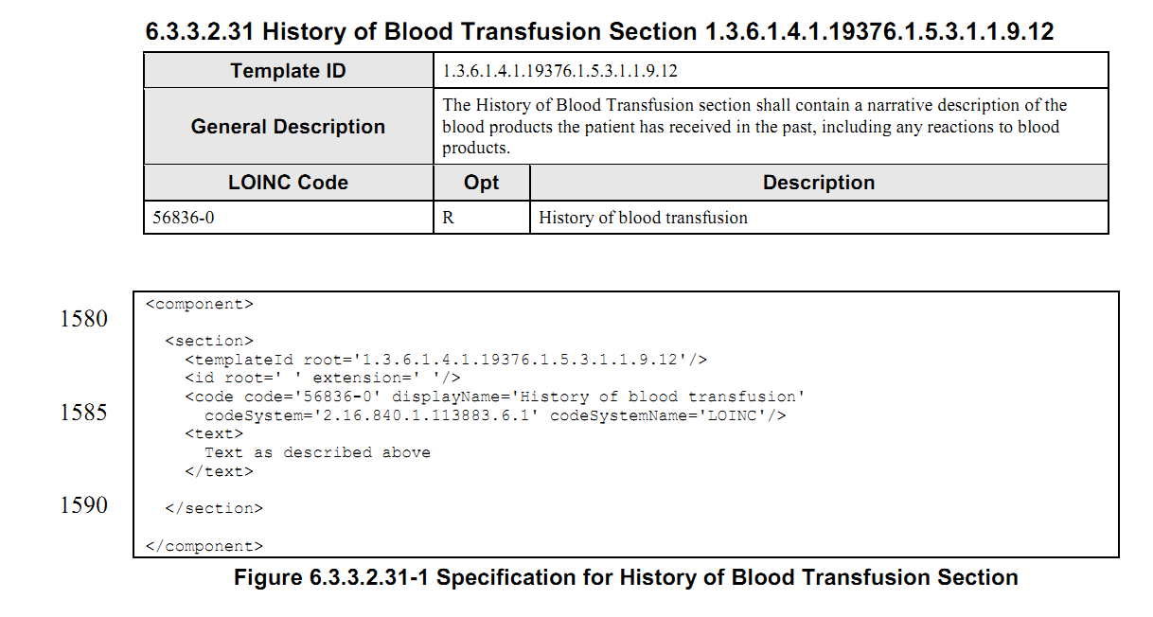

在LOINC中

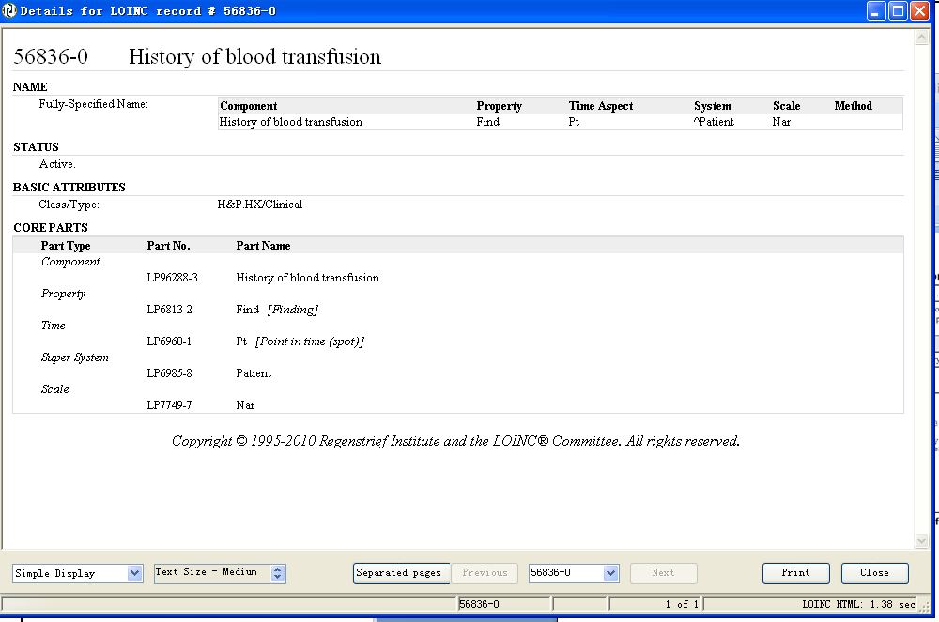

|  |  |  |
| --- | --- | --- |
| HDSD00.01.027 | DE02.10.069.00 | 外伤史标志 |
| HDSD00.01.028 | DE02.10.068.00 | 外伤名称 |
| HDSD00.01.029 | DE02.10.067.00 | 外伤发生时间 |

外伤

|  |  |
| --- | --- |
| Traumatic injury | 417746004 |

SNOMED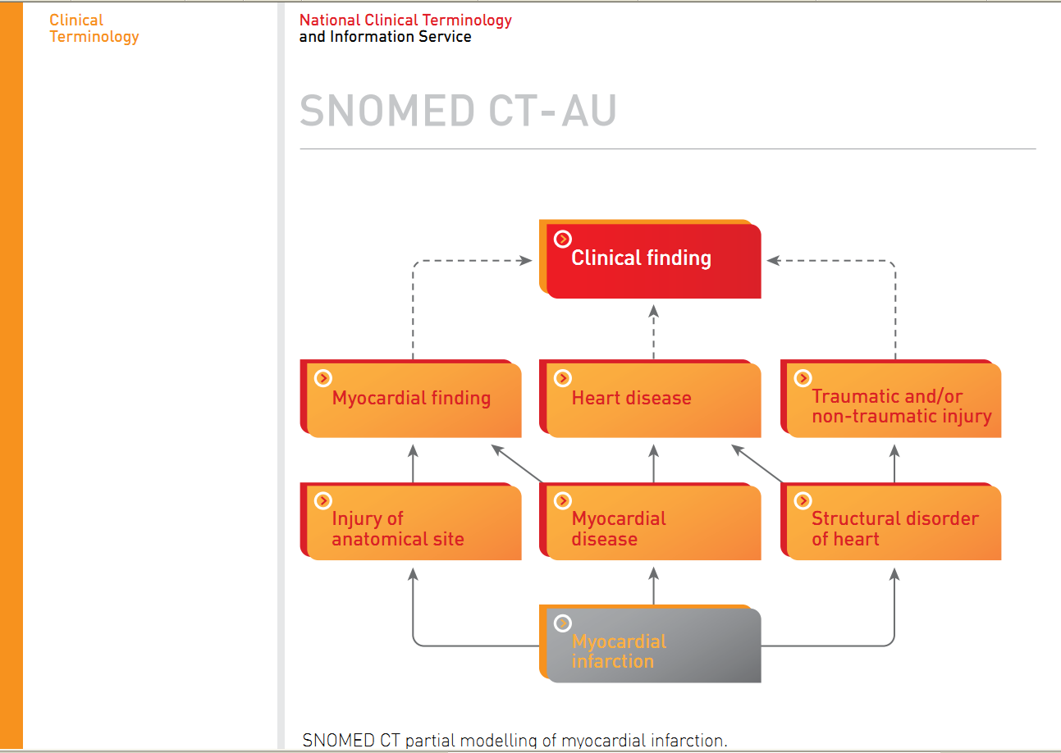

在LOINC中检索 trauma

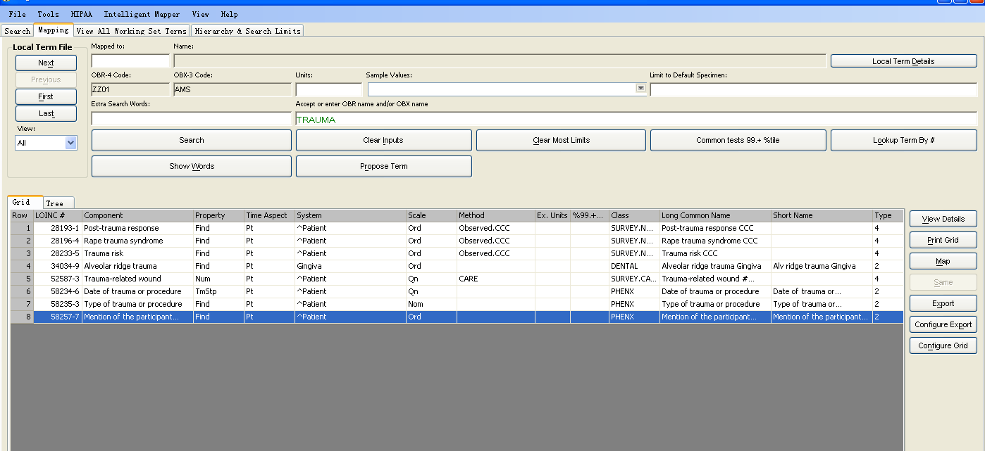

检索injury得到

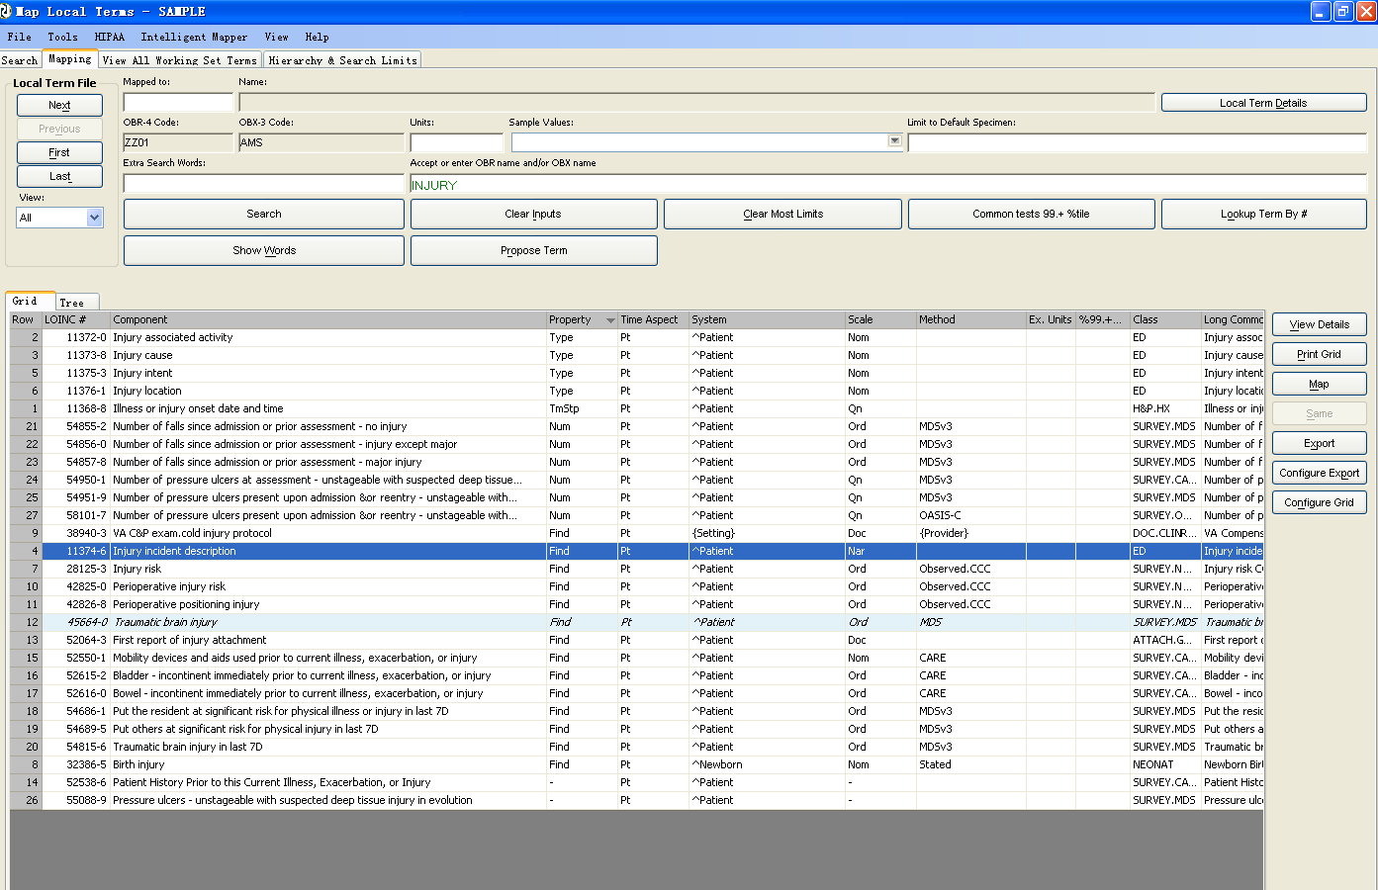

在IHE PCC2011-09-02中

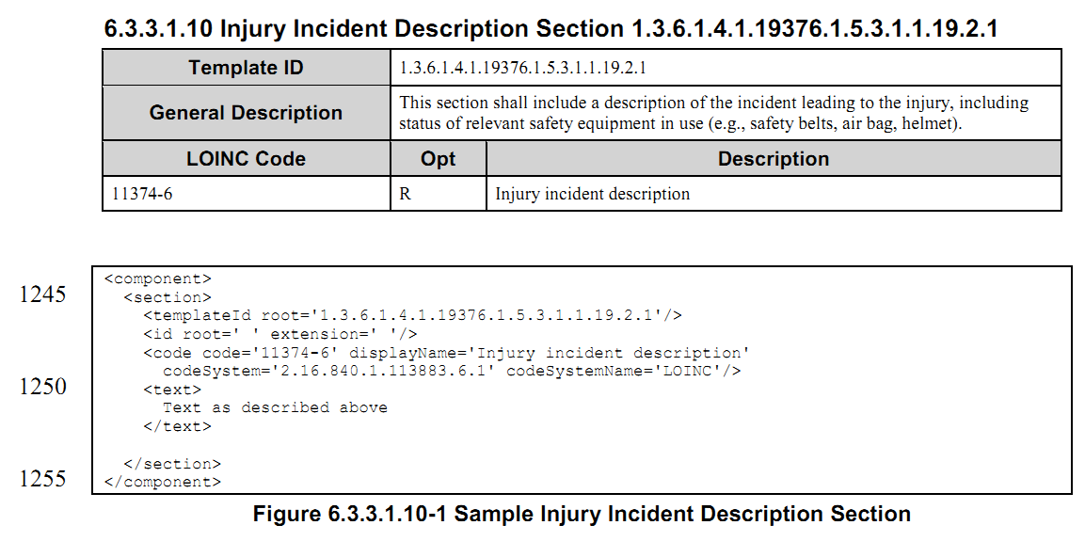

|  |  |  |
| --- | --- | --- |
| HDSD00.01.033 | DE02.10.095.00 | 家族性疾病名称代码 |
| HDSD00.01.034 | DE02.10.024.00 | 患者与本人关系代码 |
| HDSD00.01.035 | DE02.10.026.00 | 遗传性疾病史 |

参考标准

HITSP C154 V1.0.1_2010

CCD

HITSP C83V2.0_2010

IHE PCC_2010

在HITSP C154 V1.0.1_2010中，Family History存在如下数据元

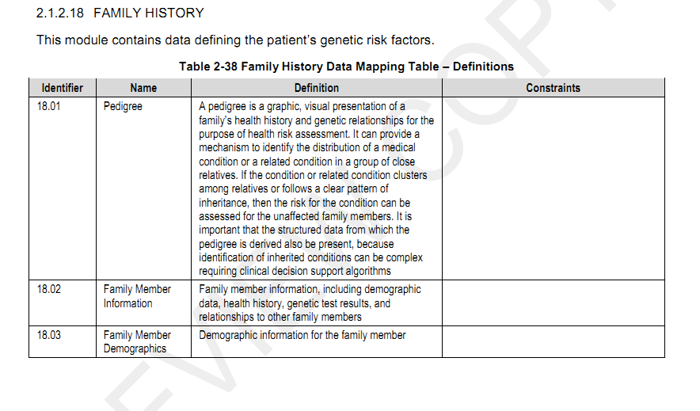

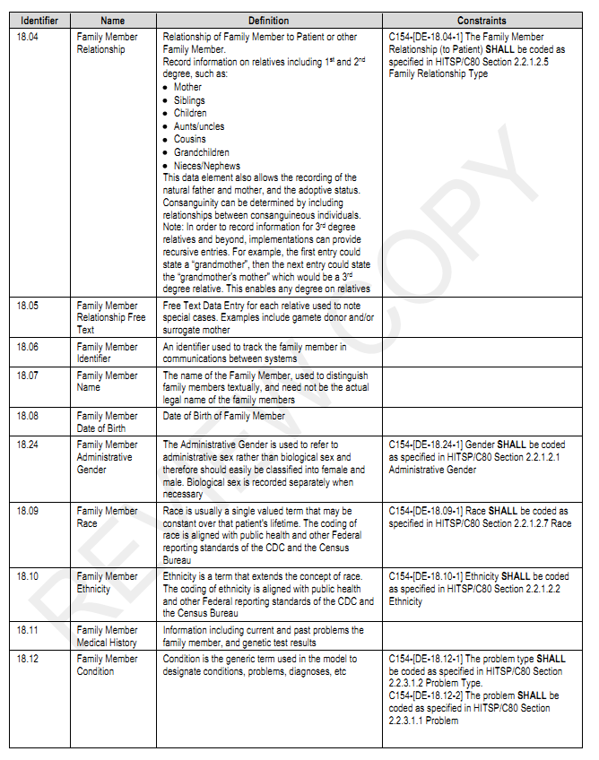

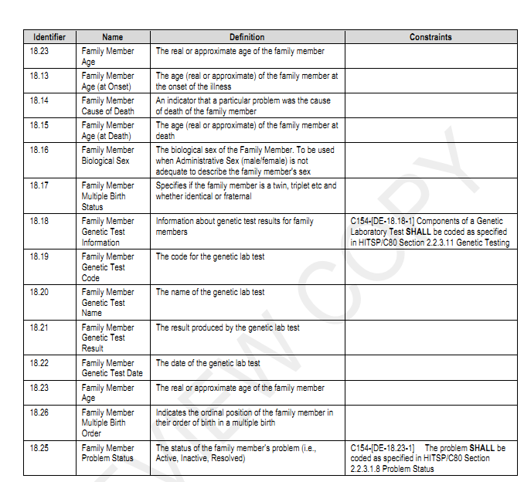

在CCD中

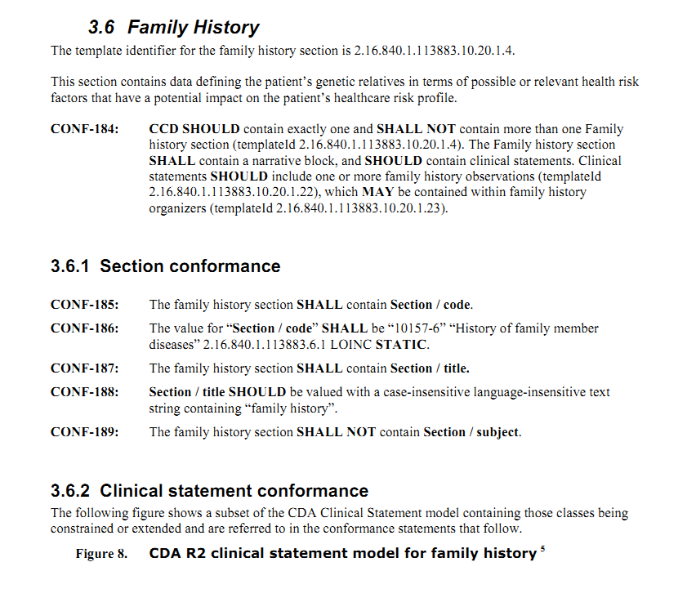

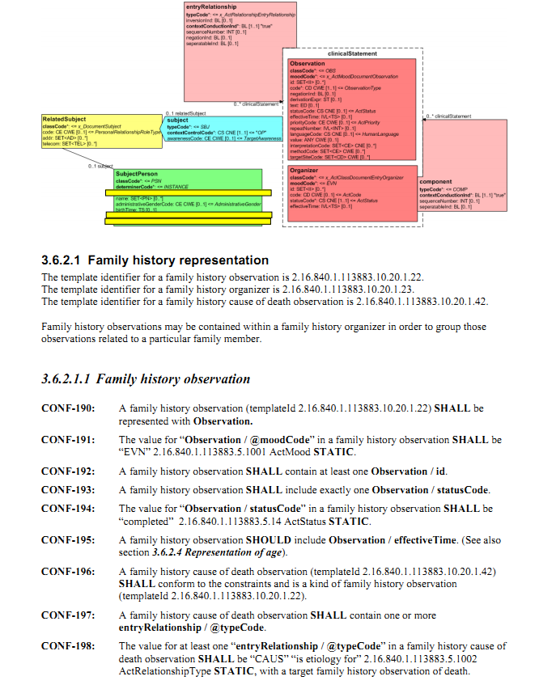

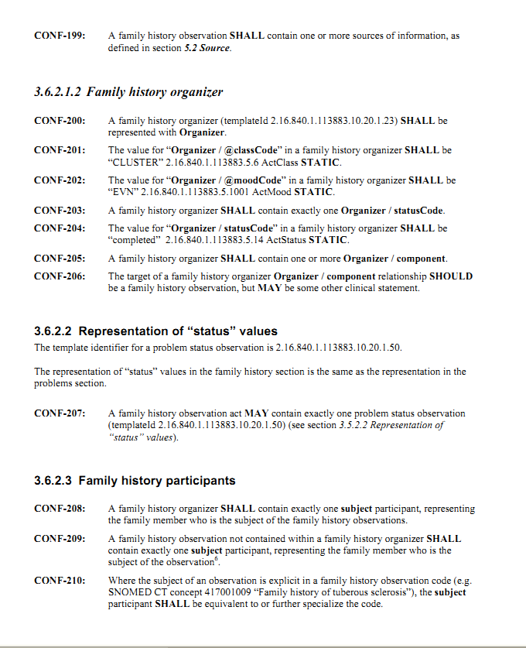

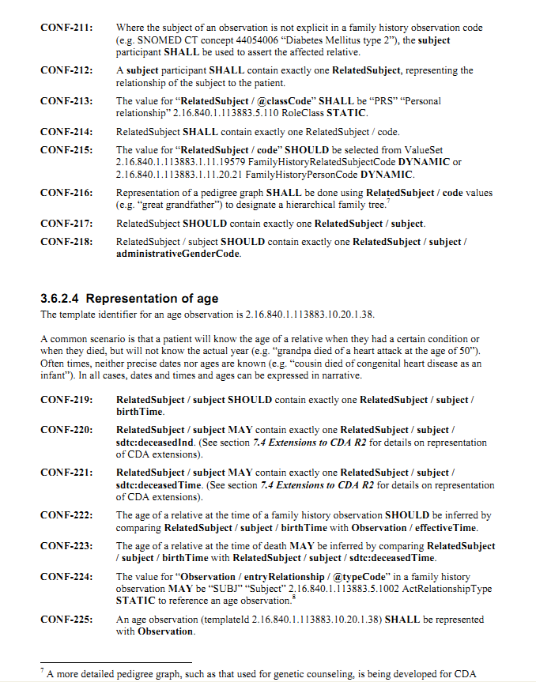

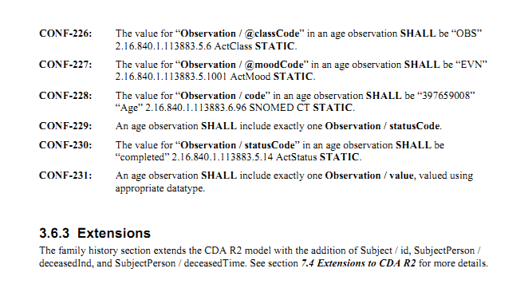

在HITSPC83_2010中，

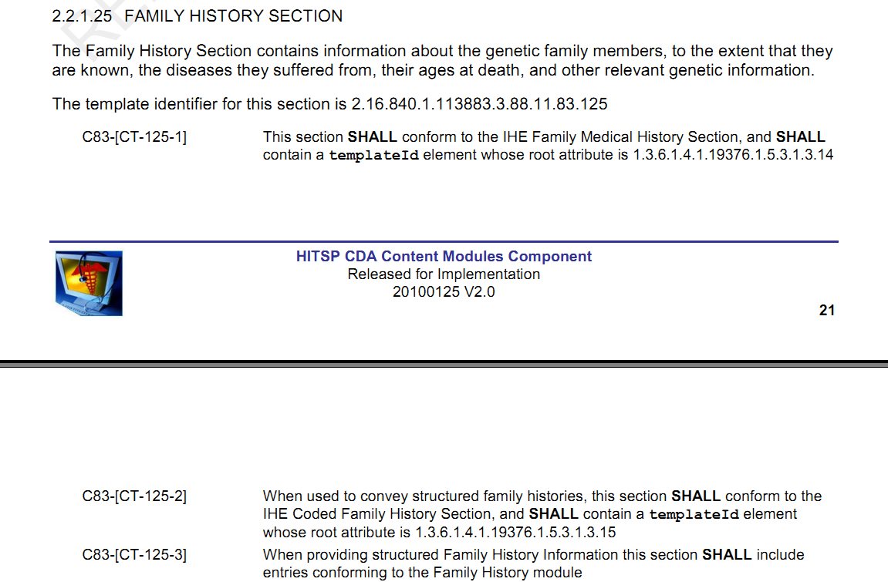

同时，上面提到的Family History module如下

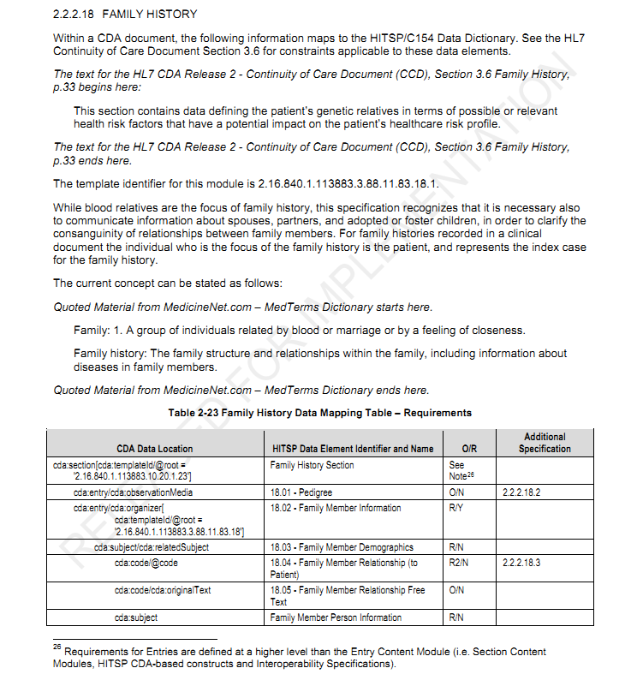

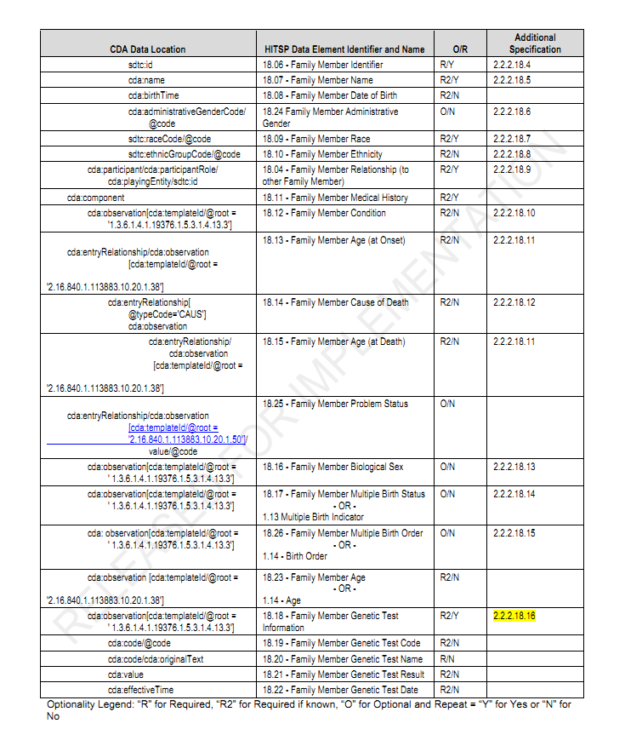

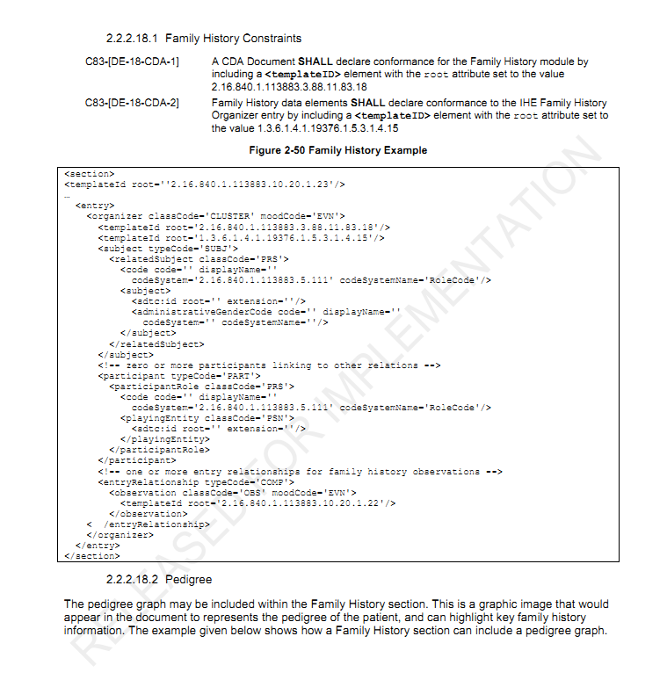

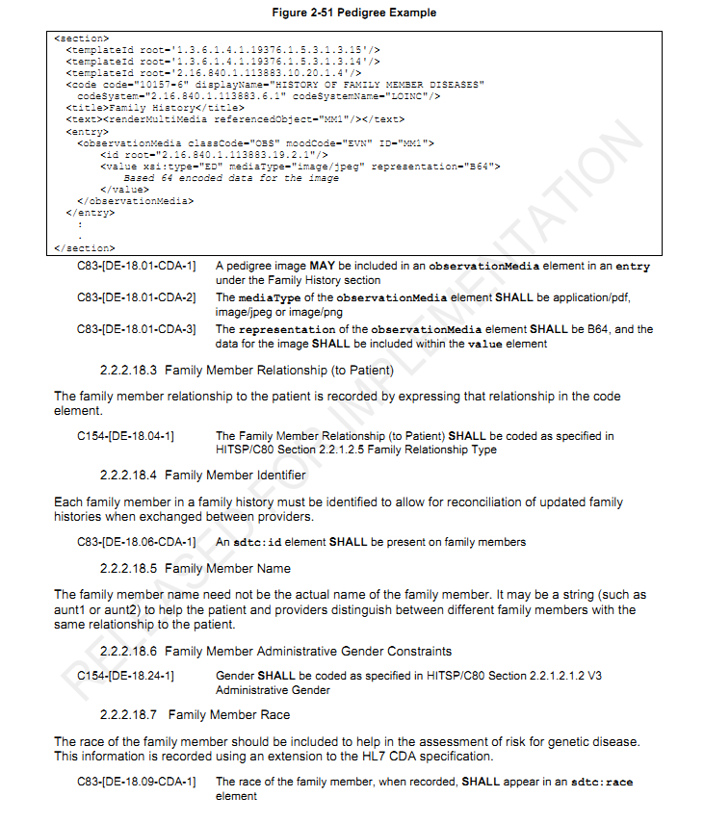

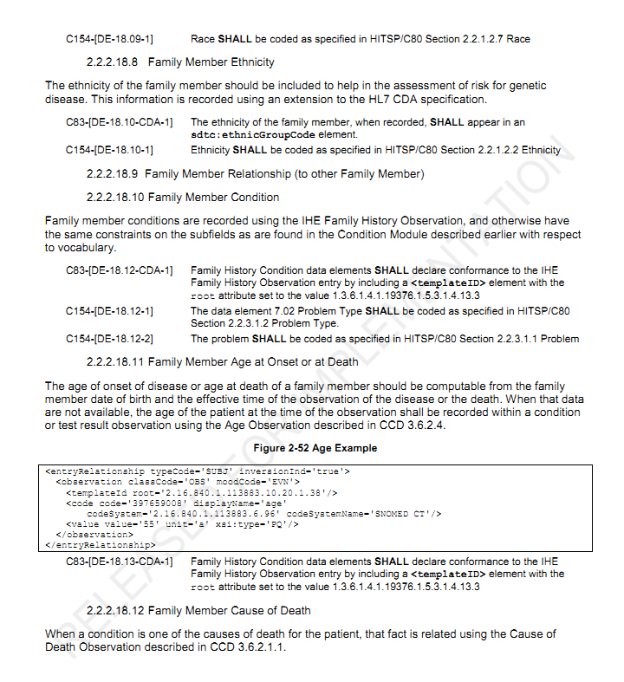

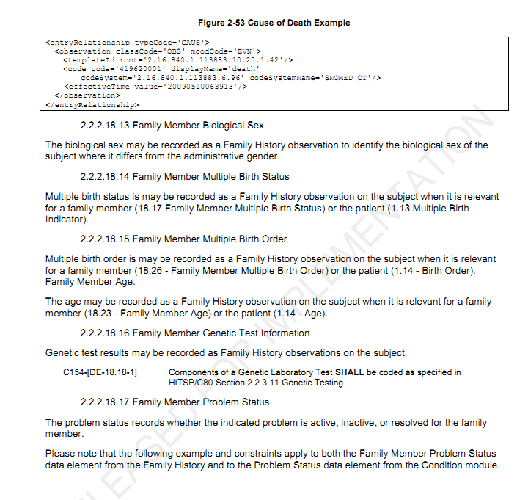

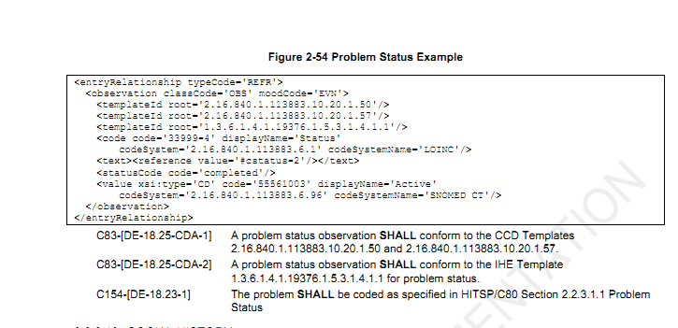

在IHE PCC中

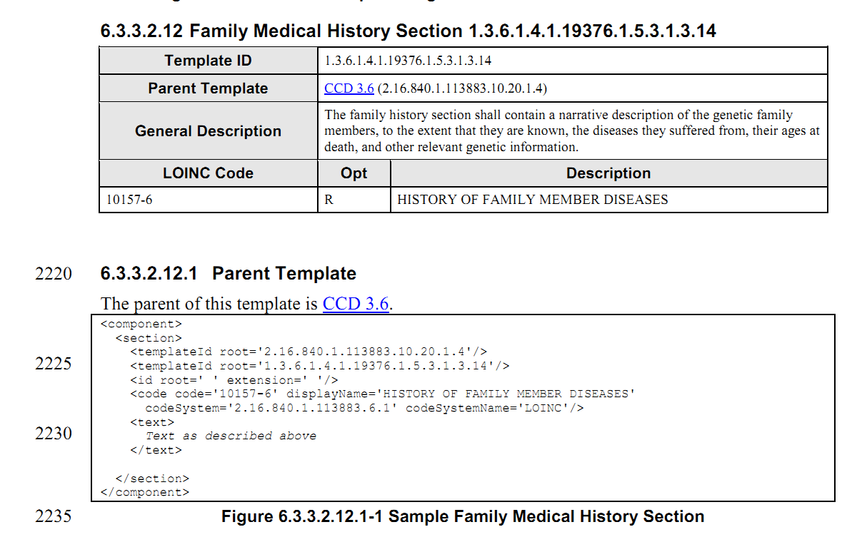

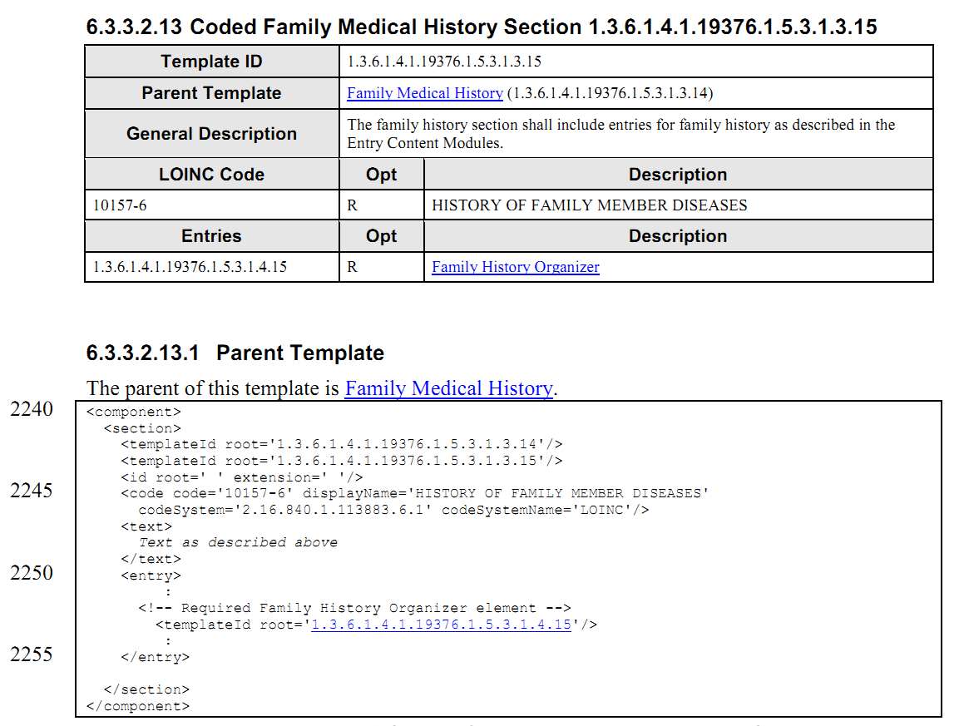

其中的Family History Organizer条目模板如下

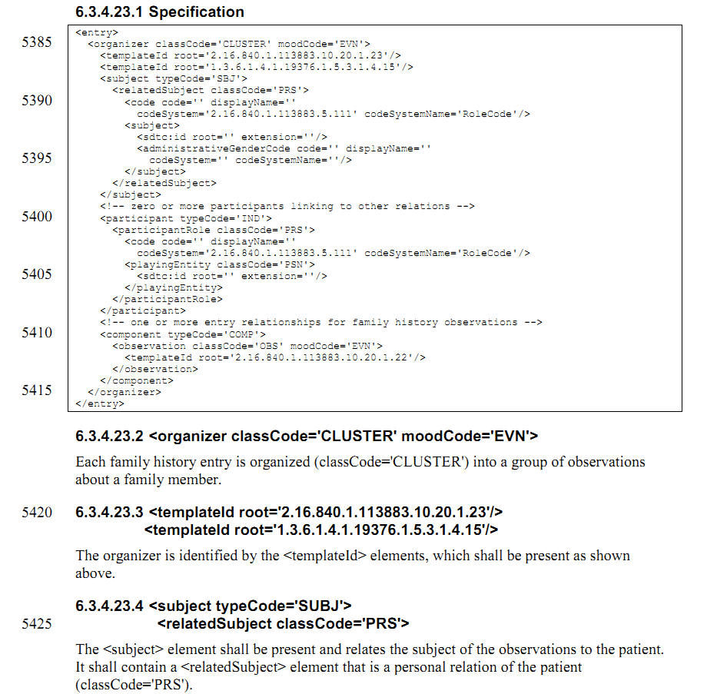 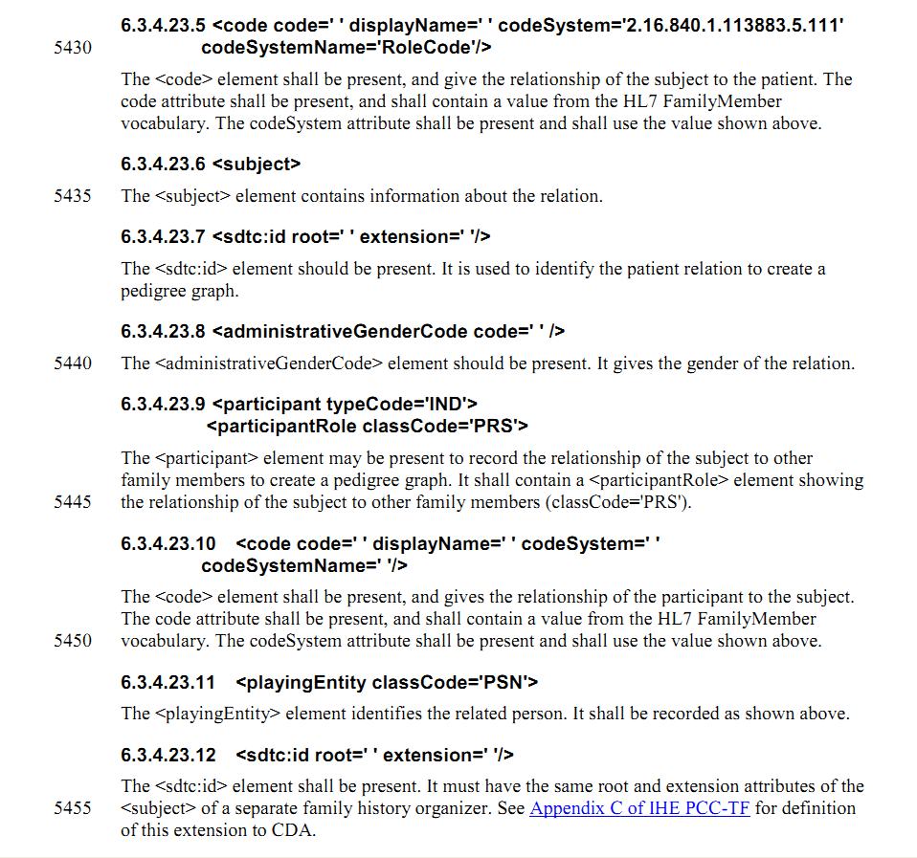

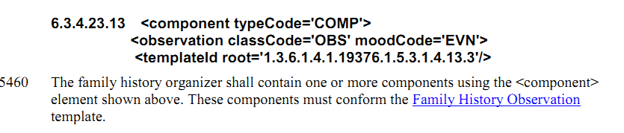

但是却在V6.0_2010的版本中找不到Family History Observation的连接

在2011-09-02的版本中

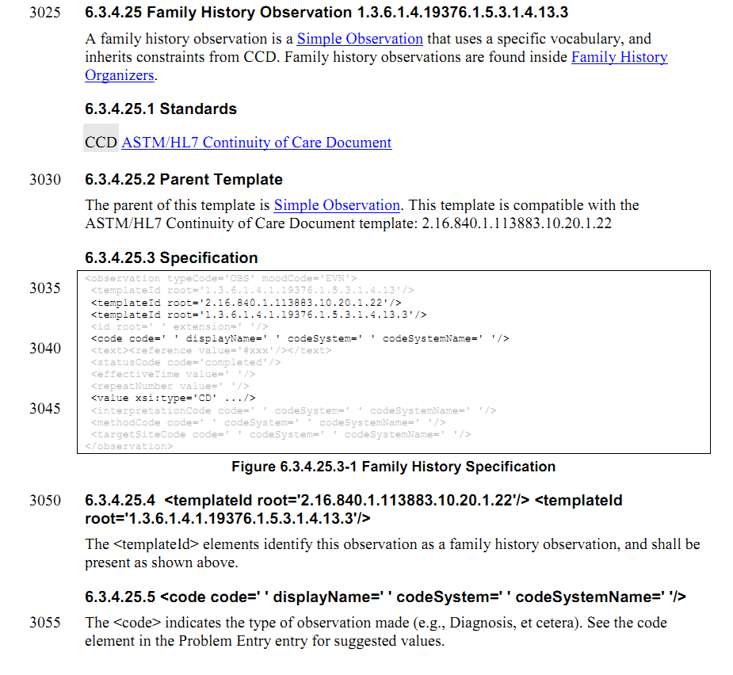

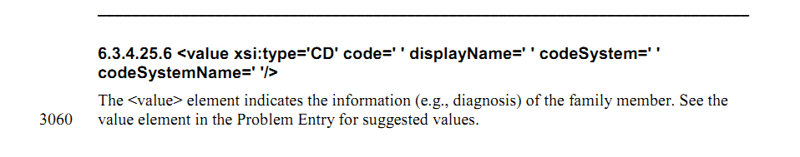

在此版本中却找不到Family History Organizers的连接 只能将这二者合二为一。

前面讲遗传病史与家族病史放在一起，着实有些不妥，但是目前还没有找到好的办法。

|  |  |  |
| --- | --- | --- |
| HDSD00.01.036 | DE05.10.006.00 | 残疾情况代码 |

参考标准

HITSP C154

CCD final

HITSPC83

在C154中，

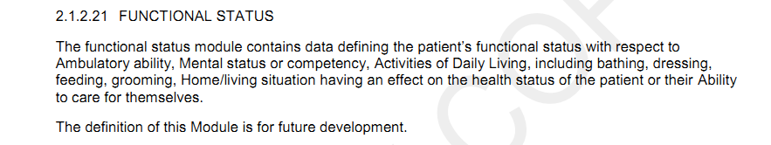

在CCD中

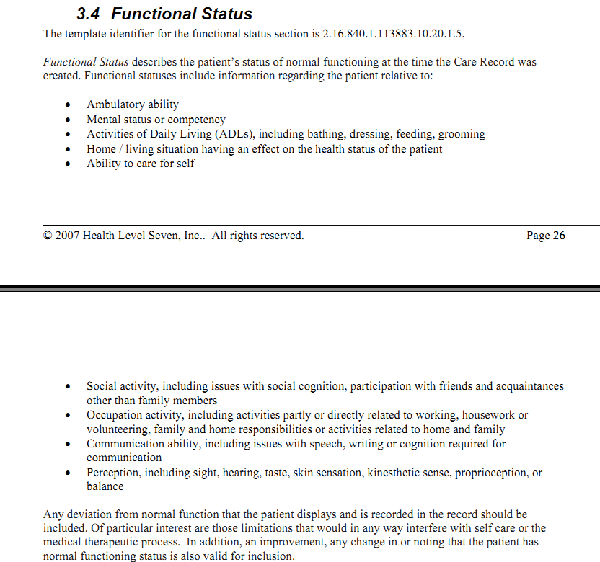

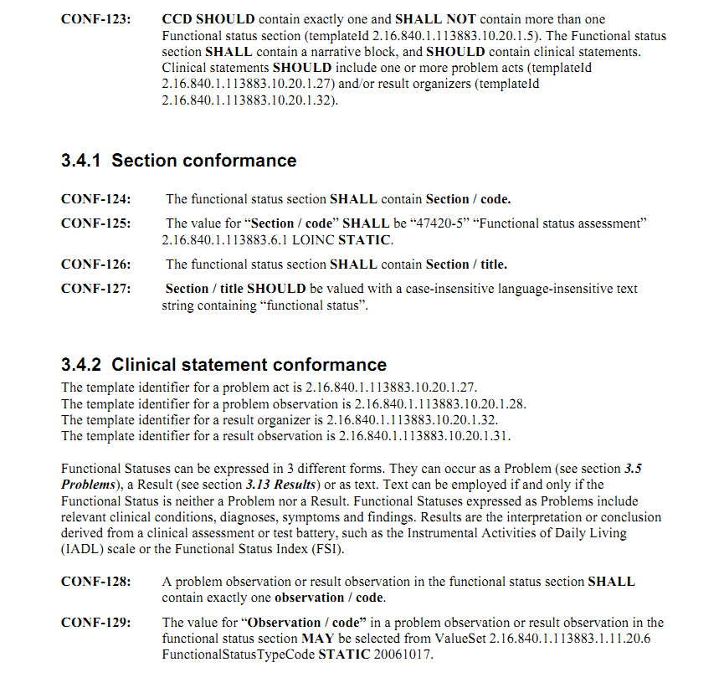

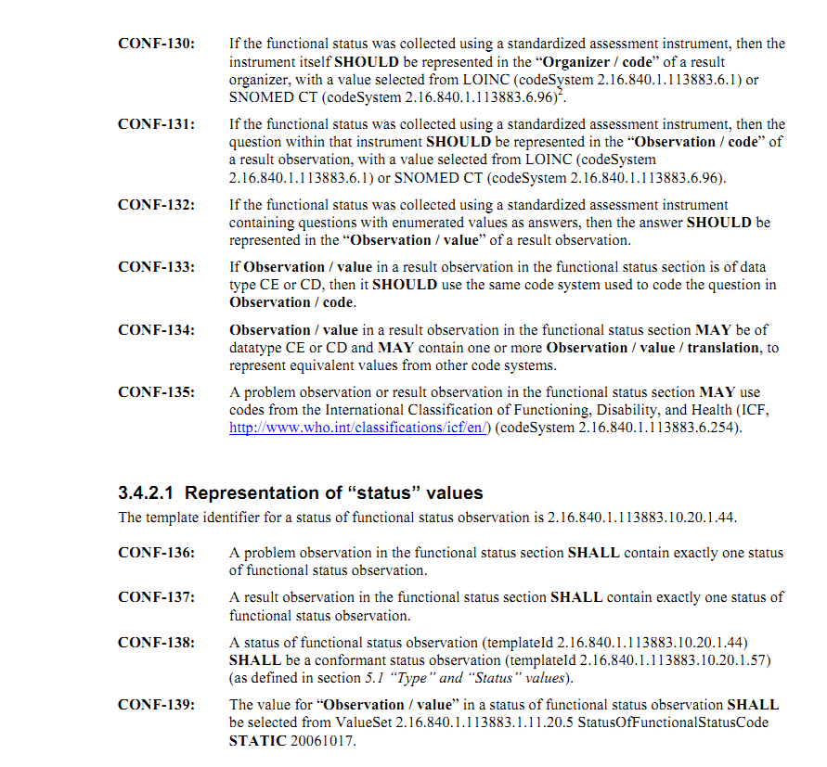

在HITSPC83中

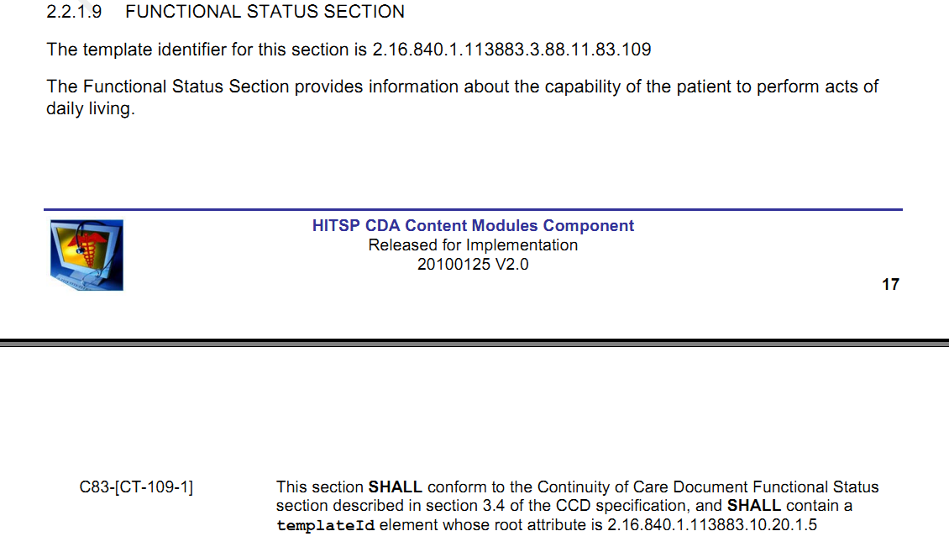

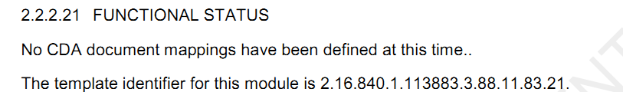

在IHE PCC201008/30中，

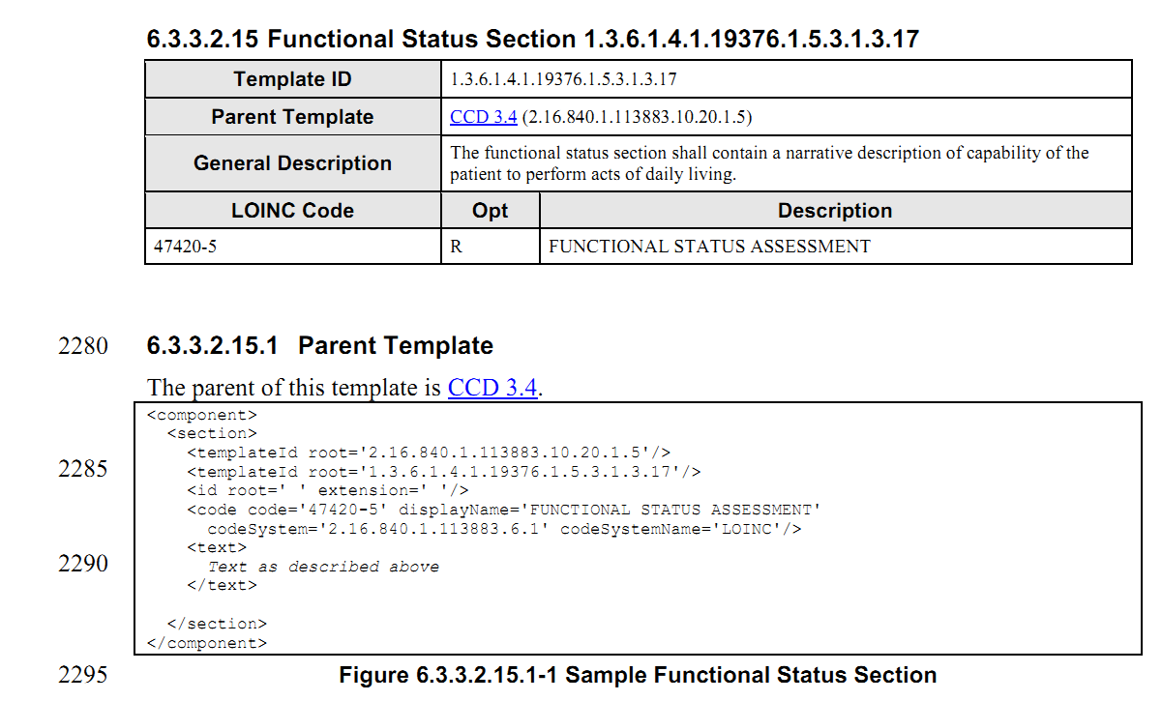

无entry条目

但是在IHE PCC 201109/02中增加了如下

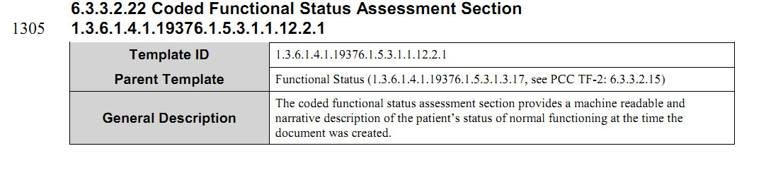

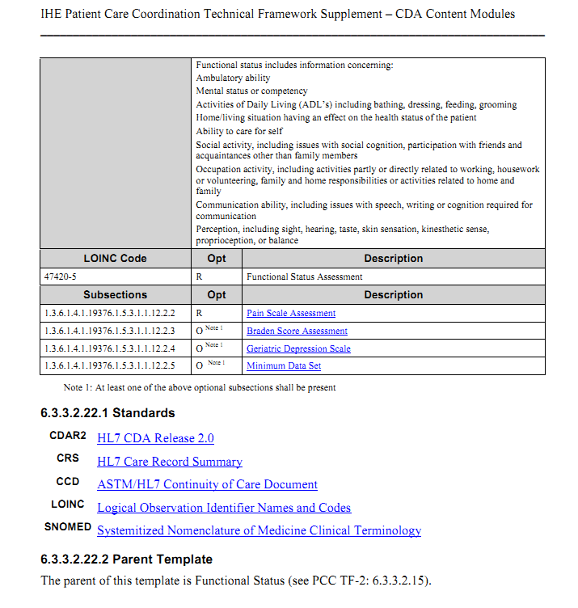

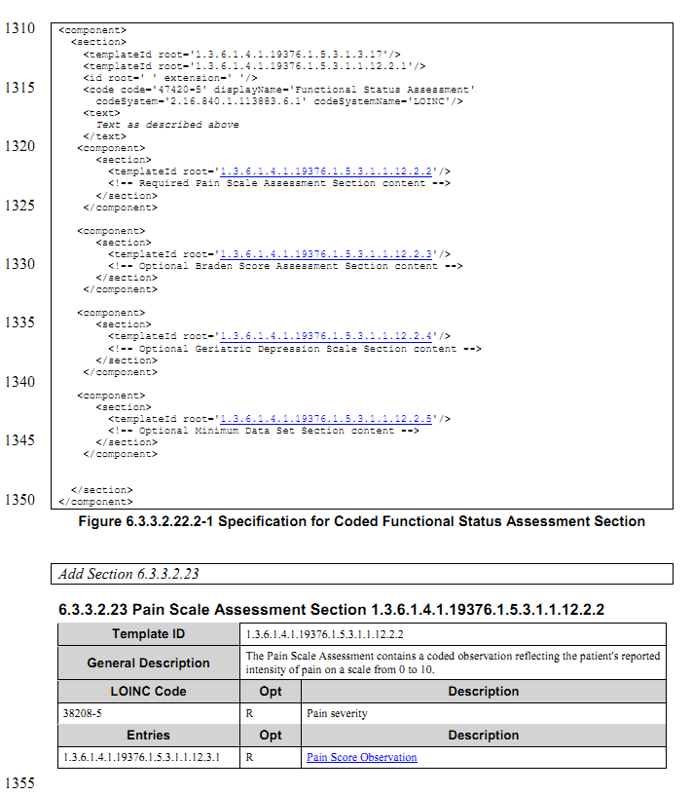

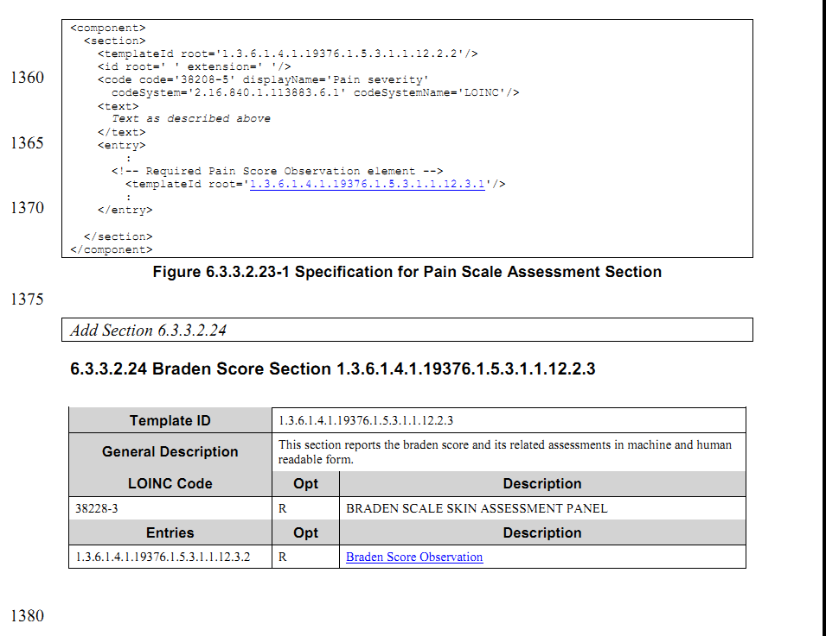

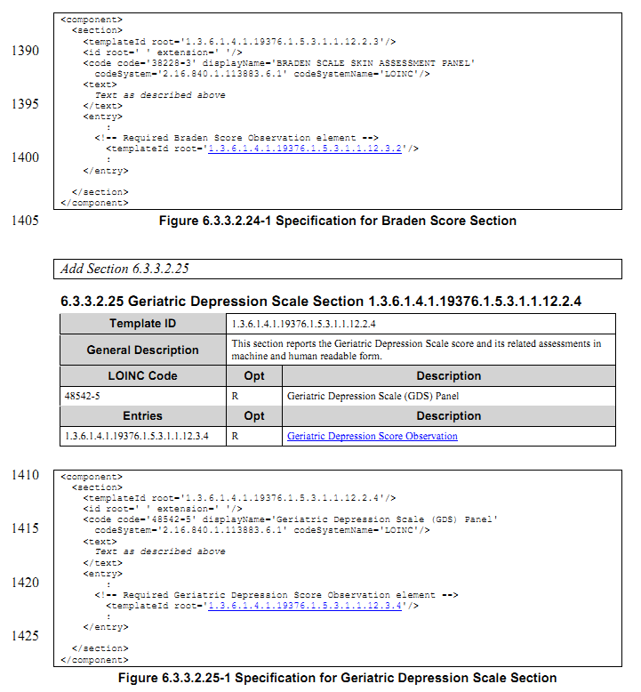

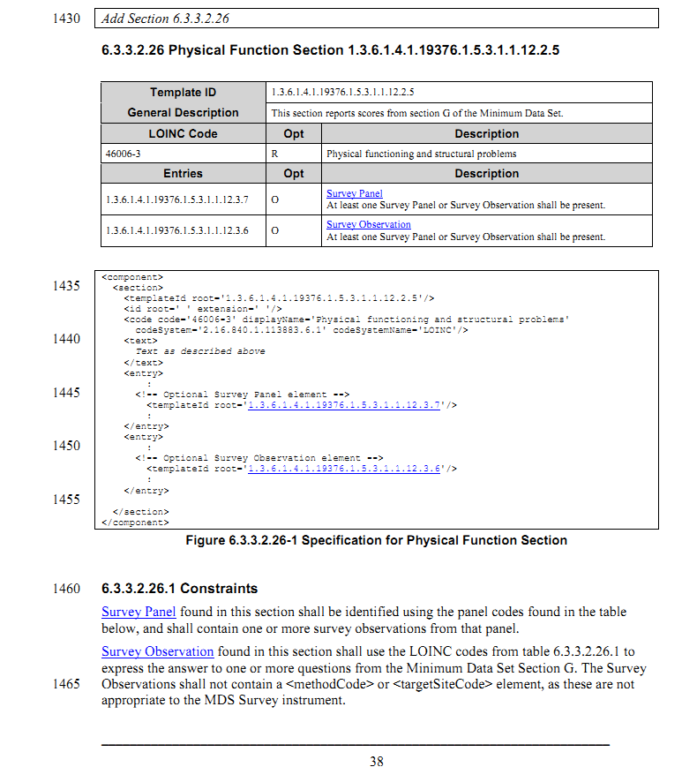

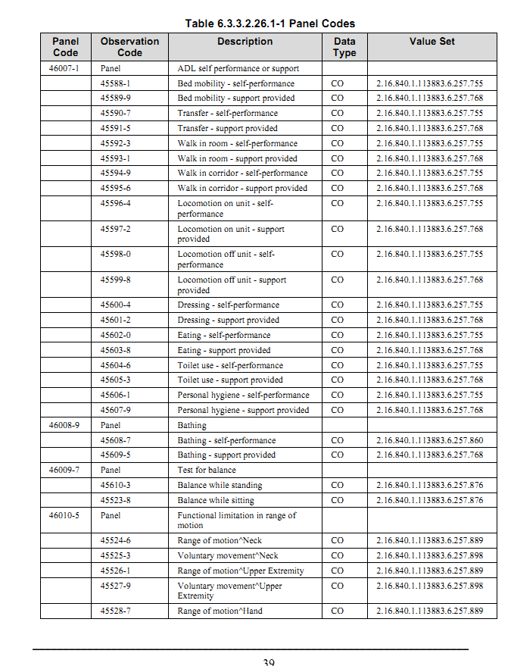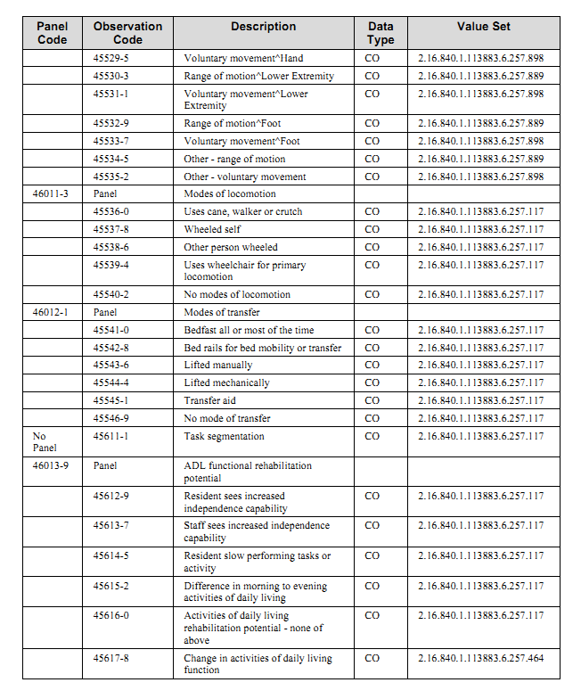

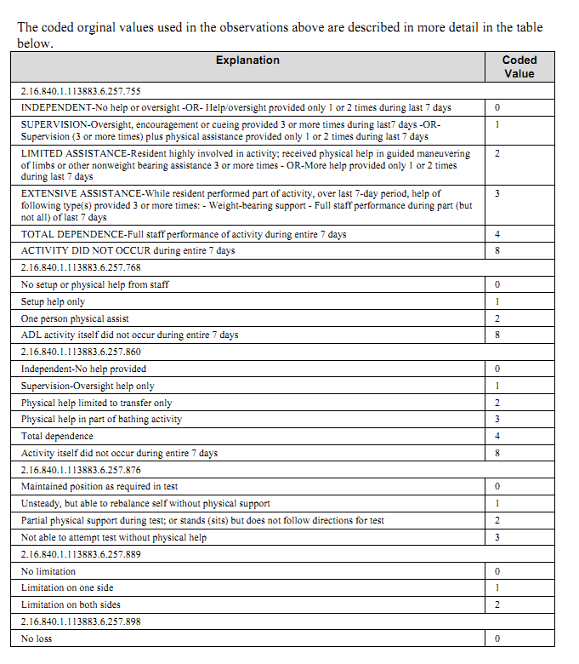

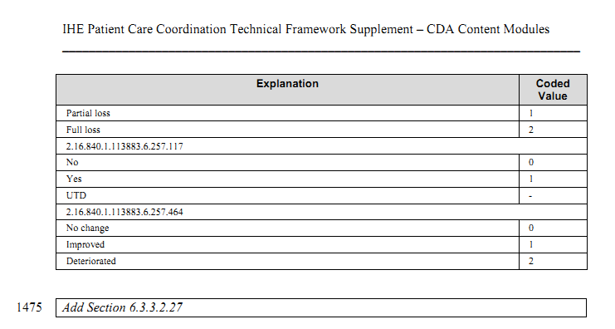

1. *Clinical Document Architecture (CDA Release 2)* <http://www.hl7.org/implement/standards/cda.cfm>